


Tender technical
requirements and
conditions
State Phytosanitary Register in
Moldova

 | Ústřední kontrolní a zkušební ústav zemědělský  Hroznová 63/2  603 00 Brno, Czech Republic | Ing. Vojtěch Řehák  IT architect vojtech.rehak@vievit.com  Bohumínská 778  712 00 Ostrava, Czech Republic

Table of Contents
1 Introduction 5
1.1 Purpose of the Document 5
1.2 Scope of the Tender 5
1.3 Definitions and Acronyms 5
2 Business and Regulatory Requirements 8
2.1 Business overview 8
2.2 Local Situation Overview 10
2.3 Compliance with EU and National Regulations 11
3 Overview of the Register State Phytosanitary System 15
3.1 Organizational Overview 15
3.2 System-to-Be General Overview 16
3.2.1 Objectives and Goals 16
3.2.2 Integration Overview (Summary) 17
3.2.3 Architecture within e-ANSA Infrastructure 18
3.2.4 Operator Registration and Identity Management 19
4 System Modules - Specific Descriptions 23
4.1 National Catalogue of Varieties (NCV) 23
4.1.1 Relevant Business Processes 24
4.1.2 Architecture of the System 33
4.1.3 Data Drafts (Entity Relationship Model) 38
4.1.4 Functional Requirements 38
4.2 Plant Reproductive Material Management System 40
4.2.1 Relevant Business Processes 42
4.2.2 Architecture of the System 54
4.2.3 Data Drafts (Entity Relationship Model) 60
4.2.4 Functional Requirements 60
4.2.5 Non-Functional Requirements 63
4.3 Phytosanitary Control System 65
4.3.1 Relevant Business Processes 67
4.3.2 Architecture of the System 80
4.3.3 Data Drafts (Entity Relationship Model) 85
4.3.4 Functional Requirements 85
4.3.5 Non-Functional Requirements 87
4.4 Plant Health Surveillance System 91
4.4.1 Business Structure of the System 91
4.4.2 Architecture of the System 93
4.4.3 Data Drafts (Entity Relationship Model) 99
4.4.4 Functional Requirements 100
4.4.5 Non-Functional Requirements 103
4.5 Phytosanitary Portal 104
4.5.1 Business Structure of the System 104
4.5.2 Architecture of the System 109
4.5.3 Data Drafts (Entity Relationship Model) 113
4.5.4 Functional Requirements 117
4.5.5 Non-Functional Requirements 118
5 Cross-System Functional Requirements 119
5.1 Integration with External Systems 119
5.2 Security, Authentication, and User Access Management 121
5.3 Configurable Checklists for Field Inspection and Controls 122
5.3.1 Purpose and Scope 122
5.3.2 Checklist Configuration and Management 122
5.3.3 Use in Inspection Workflows 123
5.3.4 System Requirements 123
5.4 User Interface and Multilingual Support 123
5.4.1 Language Requirements 123
5.4.2 Extensibility 124
6 Non-Functional and System-Wide Requirements 125
6.1 Architecture and Hosting 125
6.2 Performance and Availability 126
6.3 Security and Data Protection 128
6.4 Auditability and Traceability 129
6.5 Compliance 130
7 Implementation and Deployment Plan 132
7.1 System Deployment Strategy 132
7.1.1 Hosting Model and Environments 132
7.1.2 Access and Security Conditions 132
7.2 Data Migration and Validation 133
7.2.1 Data Sources 133
7.2.2 Migration Scope 133
7.2.3 Migration Responsibility 133
7.2.4 Validation Approach 134
7.2.5 Migration Timing 134
7.3 Access and Security Conditions 134
7.4 Training and Handover 135
8 Project Management and Tender Conditions 136
8.1 Vendor Eligibility and Experience 136
8.2 Licensing and Maintenance 136
8.3 Evaluation and Award Criteria 136

Introduction

Purpose of the Document
The purpose of this document is to define the business and technical requirements for the development and implementation of the State Phytosanitary Register for the Republic of Moldova. This Terms of Reference (ToR) serves as the primary guideline for potential vendors during the procurement process and will also act as the contractual basis for the project’s execution and quality assurance.
The document outlines:
- The strategic objectives of the project;
- The functional and non-functional requirements of the system;
- Expected deliverables;
- System architecture and integration expectations;
- High-level roles and collaboration expectations between stakeholders.
The ToR ensures that vendors understand the full scope of work, expected outcomes, and performance standards required for successful implementation. It provides clarity to all stakeholders and forms the foundation for planning, implementation, testing, and future system expansion.

Scope of the Tender
The primary objective of the project is to design, develop, and implement a digital State Phytosanitary Register that supports the efficient management of phytosanitary processes in the Republic of Moldova, ensuring alignment with European Union regulations and international standards.
The system aims to:
- Digitize the processes related to phytosanitary certificates, plant passports, import/export inspections, seed and planting material control, and monitoring of regulated pests;
- Ensure traceability and integrity of phytosanitary data across the entire lifecycle;
- Support risk analysis and strategic decision-making through data analytics and reporting functionalities;
- Improve service delivery and transparency for stakeholders, including farmers, importers, exporters, and regulatory bodies;
- Ensure compliance with EU phytosanitary and seed certification directives and regulations;
- Provide a modular and scalable system architecture to accommodate future regulatory or operational needs.

Definitions and Acronyms
Term | Meaning
AAA | Authentication, Authorization, and Audit – security mechanisms ensuring controlled system access.
ACL | Access Control List – defines user roles and permissions.
AES | Advanced Encryption Standard – secure encryption for data storage and communication.
AGEPI | State Agency on Intellectual Property of Moldova.
ANSA | National Food Safety Agency – responsible for food safety, phytosanitary and seed regulations.
API | Application Programming Interface – enables integration with internal/external systems.
AR | Architecture Requirement – non-functional constraints guiding system structure and interactions.
ArchiMate | Modeling notation used for software and business architecture diagrams.
CEFTA | Central European Free Trade Agreement.
CMS | Content Management System – used for managing digital content in the phytosanitary domain.
CRM | Customer Relationship Management – system for managing user and stakeholder interactions.
DB | Database – structured data storage used across modules.
DCR | Document Change Request – record for tracking system/documentation modifications.
e-ANSA | Moldova’s digital platform for phytosanitary and seed certification processes.
eGov Infrastructure | National digital backbone for public services (e.g., mPass, mSign).
ePHYTO | Electronic phytosanitary certificate used in international trade (XML format).
EPPO | European and Mediterranean Plant Protection Organization – plant protection standards.
EU | European Union – political and regulatory union relevant for alignment.
EUROPHYT | EU system for reporting plant health interceptions at borders.
FOD | Front Office Digitization – modernization of user-facing services.
FR | Functional Requirement – required system capabilities or behavior.
GDPR | General Data Protection Regulation – EU data privacy regulation.
GIS | Geographic Information System – for spatial mapping and inspection planning.
GMO | Genetically Modified Organism – regulated seeds/plants.
GPS | Global Positioning System – used in geolocation and tracking.
GUI | Graphical User Interface – system’s visual interface.
HO | Harmful Organism – pest or disease requiring regulation.
ISTA | International Seed Testing Association – global seed testing standards.
IT | Information Technology – system infrastructure and support services.
JSON | JavaScript Object Notation – lightweight data exchange format.
LIMS | Laboratory Information Management System – manages lab data and workflows.
OECD | Organisation for Economic Co-operation and Development – oversees international seed trade schemes.
PHSS | Plant Health Surveillance System – monitors harmful organisms and health risks.
PhytoPortal | Web portal for content editing and monitoring in phytosanitary domains.
PKI | Public Key Infrastructure – encryption and digital certificate framework.
Plant Passport | Document ensuring traceability of plant material within the EU.
PR | Performance Requirement – defines system efficiency and scalability.
RBAC | Role-Based Access Control – security model assigning user permissions.
REST | Representational State Transfer – standard for web service communication.
RSF | Register State Phytosanitary – official phytosanitary certificate and inspection registry.
SLA | Service Level Agreement – expected support, uptime, and service performance.
PRMMS | Plant Reproductive Material Management System – plant reproductive material certification and traceability module.
SOAP | Simple Object Access Protocol – structured web service communication.
SQL | Structured Query Language – for managing relational databases.
TRACES | EU platform for cross-border certification (Trade Control and Expert System).
URI | Uniform Resource Identifier – unique reference to a system resource.
XML | Extensible Markup Language – data structure format for system integration.
ZOI | Zone of Influence – defined area under inspection or certification control.

Business and Regulatory Requirements

Business overview
The implementation of the State Phytosanitary Register marks a major step in strengthening Moldova’s ability to manage plant health, seed certification, and phytosanitary compliance. The system is designed to support Moldova’s alignment with European Union legislation and standards, reflecting its progress as an EU candidate country and its ambition to modernize regulatory infrastructure in the agricultural sector.
The primary purpose of the system is to provide comprehensive digital tools that enable the National Food Safety Agency (ANSA) and other stakeholders to efficiently manage key phytosanitary and seed-related processes. These include seed certification and inspection, plant health surveillance, issuance of phytosanitary certificates and plant passports, as well as the registration and maintenance of approved plant varieties.
The solution is composed of five integrated modules, each addressing a critical aspect of phytosanitary oversight:
- Plant Reproductive Material Management System (PRMMS): Supports the registration, inspection, and certification of seed producers and multipliers, covering both domestic and export markets. Enables inspectors to manage field visits, generate reports, and follow structured inspection workflows through digital forms and checklists.
- Phytosanitary Control System (PCS): Handles the digitization of border inspections and the issuance of phytosanitary certificates and plant passports. Ensures compliance with national and EU-level import/export regulations, supporting trade facilitation and plant health protection.
- Plant Health Surveillance System (PHSS): Enables monitoring of harmful organisms and detection of plant disease outbreaks. Provides surveillance, sampling, and reporting functionalities to support proactive response and risk management strategies.
- Phytosanitary Portal: Serves as a user-facing content management system for accessing legislation, public records, announcements, and key functionalities. Offers intuitive access to data and services for operators, inspectors, authorities, and the public.
- National Catalogue of Varieties (NCV): Maintains an official list of plant varieties registered and approved for cultivation, certification, and commercialization in Moldova. Ensures traceability, legal compliance, and supports integration with EU and international catalogues (e.g., EU Common Catalogue, OECD, ISTA).
The system is modular, scalable, and built for interoperability. It will integrate with national platforms such as e-ANSA and comply with Moldova’s eGovernment framework by utilizing all relevant mServices:
- mPass (secure user authentication),
- mSign (electronic signature for document validation),
- mLog (system-wide logging and audit trail),
- mNotify (notifications via email, SMS, and in-app messages),
- mConnect (interoperability platform for system integration),
- mPay (online payments for public services),
- mDelivery (official document delivery through postal services), and
- mPower (authorization and delegation management through digital signatures).
- mCabinet (personalized digital workspace for users to access issued documents, track service statuses, and manage interactions with public authorities).
These integrations will ensure secure access, seamless data exchange, traceability, and reliable public service delivery in accordance with Moldova’s national digital infrastructure standards and Law No. 142/2018 on Interoperability.
From a business perspective, the system addresses the following goals:
- Legal Entity Registration: Registers and maintains records of all relevant legal entities involved in seed production, trade, inspection, or phytosanitary activities.
- Process Traceability and Oversight: Enables transparent tracking of certification, inspection, surveillance, and passport issuance processes.
- Regulatory Compliance: Supports implementation of Moldovan and EU phytosanitary and seed-related laws, and ensures adherence to international frameworks including TRACES NT, ePHYTO, OECD, and ISTA.
- Data Accessibility and Operational Insights: Offers stakeholders real-time access to regulatory data, statistics, and inspection records to support informed decisions and compliance verification.
- Market Access Facilitation: Ensures that plant products and seeds can be certified and exported in compliance with destination market requirements, enhancing Moldova’s position in international trade.
The system is designed to be intuitive for various user groups:
- Operators (e.g., farmers, seed producers) will manage registrations, certification applications, and monitor inspection outcomes through user-friendly interfaces.
- Inspectors and Laboratory Personnel will use structured tools for field visits, data entry, and laboratory coordination.
- Regulatory Authorities will oversee workflows, approve applications, and generate analytics for policy support.
- The Public will access regulatory records, registered varieties, and updates via the Phytosanitary Portal.
This digital transformation is essential for building institutional capacity, supporting sustainable agriculture, and preparing Moldova for deeper EU integration.

Local Situation Overview
The State Phytosanitary Register will be developed and operated under the authority of the National Food Safety Agency (ANSA) and deployed within the existing e-ANSA infrastructure. Technical hosting, security, and availability will be ensured by STISC, Moldova’s central government IT infrastructure provider. The system will be built in full compliance with the national eGovernment standards, including the interoperability, authentication, logging, notification, and service delivery frameworks defined by mGov.
Currently, Moldova’s phytosanitary and seed-related processes are distributed across multiple departments and are largely managed through manual, paper-based methods, basic Excel records, and fragmented legacy systems. Only a basic version of the Phytosanitary Register exists today, used primarily for issuing phytosanitary certificates. This system will be replaced by a modernized, integrated solution as part of the new Phytosanitary Control System (PCS).
The remaining key modules - Plant Reproductive Material Management System (PRMMS), Plant Health Surveillance System (PHSS), National Catalogue of Varieties (NCV), and the Phytosanitary Portal - do not currently exist in any digital form and will be developed from scratch.
This fragmented environment has led to:
- Redundant data entry and administrative inefficiencies.
- Inconsistent inspection and certification records across regions.
- Limited ability to track plant health risks or issue timely alerts.
- Minimal integration with border and trade systems, creating obstacles for exporters.
In addition, existing processes at border control points are still performed manually, making it difficult to track incoming plant materials, validate supporting documents, or ensure real-time compliance with import regulations.
The new system must respond to these gaps by providing:
- Centralized data management and standardized digital workflows across all modules.
- Support for inspectors in the field through mobile-friendly interfaces and dynamic checklists.
- Tools for laboratory coordination via future integration with LIMS.
- Direct interaction channels for operators (e.g., seed producers, exporters) through e-ANSA and user-facing portals.
- Secure document access and notifications via integrated mServices like mCabinet, mNotify, and mSign.
This modernization effort is driven by both internal needs for efficiency and transparency, and by Moldova’s commitment to align with EU regulatory frameworks. Legal compliance with Law No. 142/2018 on interoperability, as well as sector-specific laws on seeds, plant protection, and state inspections, provides the foundation for this reform.
Key institutional stakeholders involved in the system’s operation and governance include:
- ANSA – Overall owner of the system and responsible authority.
- STISC – Ensures system hosting, infrastructure security, and backup services.
- mGov – Provides the national eGovernment framework, including mPass, mSign, mCabinet, and related services.
- Inspectors and Methodologists – Define, execute, and validate inspections, certifications, and operational workflows.
- Operators (e.g., seed producers, exporters, plant nurseries) – Main users of PRMMS and PCS.
- Laboratory Staff - Will interact with the system for sample processing and result reporting once LIMS integration is established.

Compliance with EU and National Regulations
The development of the State Phytosanitary Register is guided by the need to align with both European Union legislation and national legal frameworks governing seed certification, phytosanitary control, and plant health protection.
As Moldova progresses in its EU accession path, it is essential that the system ensures full traceability, transparency, and legal compliance with the core principles of the EU acquis communautaire in agriculture and food safety. This includes the ability to issue standardized phytosanitary certificates, manage plant passports, perform risk-based inspections, and ensure varietal purity and market access for plant material.
The system is also designed to fulfill requirements defined in the national legal framework, ensuring that Moldovan institutions can enforce policies effectively and provide reliable services to citizens and businesses.
A. European Union Legal Framework
The system must support Moldova’s gradual alignment with the EU’s legal framework, particularly in areas related to plant health, certification, traceability, and official controls:
- Regulation (EU) 2016/2031 – Establishes protective measures against plant pests and underpins plant passport rules and phytosanitary certificates.
- Regulation (EU) 2017/625 – Introduces a unified system of official controls across all agri-food sectors, including inspections, border checks, and operator controls.
- Regulation (EU) 2019/2072 – Specifies Union quarantine pests, protected zone pests, and movement requirements for regulated plants and products.
- Implementing Regulation (EU) 2020/1770 – Mandates traceability codes in plant passports to enhance internal market monitoring.
- Implementing Regulations (EU) 2019/66 and 2020/887 – Define control obligations for operators and post-import physical checks of plants.
- Delegated Regulation (EU) 2019/829 – Permits limited introduction of pests/plants for research and breeding.
- Implementing Regulation (EU) 2017/2313 – Specifies the format of plant passports.
- Regulation (EU) 2019/1715 – Establishes the IMSOC system to integrate TRACES, ePHYTO, EUROPHYT, etc.
- Council Directive 2002/53/EC – On the Common Catalogue of Agricultural Plant Varieties, linked to the NCV module.
- Council Directive 2002/55/EC – On marketing of vegetable seed within the EU.
- Regulation (EC) No 2100/94 – Introduces EU-wide plant variety rights.
- Commission Regulation (EC) No 637/2009 – On the suitability of plant variety denominations.
- Directive 2008/90/EC, Directive 2014/96/EU, and Directive 2014/98/EU – Establish standards for fruit plant propagation material, passporting, and certification.
- Regulation (EU) 2021/690 – Establishes the Single Market Programme supporting plant health and certification.
- OECD Seed Schemes – Provide frameworks for varietal certification of internationally traded seeds.
- ISTA Rules – Define internationally accepted standards for seed testing and laboratory accreditation.
- TRACES NT & ePHYTO (IPPC) – The system must support both platforms for cross-border certification and XML-based data exchange.
B. Moldovan Legal Framework
The following national laws define the legal environment for seed management, plant health, operator control, and digital registers:
- Law No. 68/2013 on Seeds
- Law No. 119/2004 on Plant Protection Products and Fertilizers
- Law No. 422/2023 on Measures for the Protection against Harmful Organisms to Plants
- Law No. 39/2008 on Plant Variety Rights
- Law No. 235/2006 on Regulating Entrepreneurial Activity
- Law No. 131/2012 on State Control
- Law No. 71/2007 on Registers
- Law No. 142/2018 on Interoperability and Data Exchange
- Law No. 152/2022 on Genetically Modified Organisms
- Law No. 185/2017 on Legislative Alignment
- Law No. 220/2007 on Legal Entity Registration
- Law No. 235/2011 on Accreditation and Conformity Assessment
- Law No. 728/1996 on Fruit Growing
- Law No. 658/1999 on Walnut Crops
- Law No. 57/2006 on Vineyards and Wine
These laws govern core processes such as inspections, certification, laboratory testing, registration of varieties, and the structure and use of national registers.
C. Supplementary Regulations and Implementing Acts
The following Government Decisions, ANSA Orders, and Technical Procedures establish detailed implementation rules, quality standards, and inspection methodologies:
Government Decisions
- GD No. 43/2013 - Testing and registration of plant varieties in the National Catalogue
- GD No. 94/2024 – Fruit propagation & planting material
- GD No. 464/2018 – State Register of Controls
- GD No. 415/2013 – Fruit plant certification
- GD No. 600/2014 – Straw cereal seed quality
- GD No. 915/2011 – Oilseed and fiber seed standards
- GD No. 1211/2008 – Maize and sorghum seed requirements
- GD No. 713/2013 – Vegetable seed and seedlings
- GD No. 90/2019 – Service tariff methodology
- GD No. 158/2007 – Paid services under the Ministry of Agriculture
- GD No. 1280/2018 – Risk-based inspection methodology
- GD No. 14/2023 – ANSA structure and responsibilities
- GD No. 82/2021 – Registers and information systems
- GD No. 970/2014 – One-stop shop for phytosanitary certificates
- GD No. 418/2009 – Vine propagating material
- GD No. 598/2012 – Ornamental plant propagation material
- GD No. 836/2011 – Fodder and picnicking plant seeds
- GD No. 189/2010 – Seed potatoes
- GD No. 257/2019 – Seed import model acts
- GD No. 679/2024 – Regulation on movement and protected zones
- GD No. 558/2018 – Emergency pest measures
ANSA Orders and Internal Procedures
- Order No. 524/2019, 122/2022, 120/2017, 127/2023, 120/2017, 4/2019
- Procedure: PS/FS-MSR-02/02 – Seed multiplication declaration
- Procedure: PS-(D03/03A)-01/02 – Field inspection
- Procedure: PS/FS-MSD-04/02 – Registration of seed operators
- Procedure: PS/FS-MS-03/02 – Certification of vineyard seedlings
- Procedure: PS(D-03/1B)-01/01 – Warning bulletin preparation (To be repealed)
- General Procedure 18/01 (2021) – Use of State Register of Controls
- Procedure: PO-01/03 – Certification of fruit seedlings
- Procedure: PS/FS-MS-04/02 – Export certification of propagating material
- Procedure: PS/FS-MSD-01/01 – Registration and supervision of plant health operators
- Procedure: PS/FS-MSD-06/01 – Certification of plant products of plant origin for export and re-export
- Procedure: PS/FS-AI-01/01 – Control of phytosanitary compliance of wooden packaging material used in international trade
- Procedure: PS/FS-MSD-05/01 – Establishment and/or maintenance of status for places and/or production areas free from harmful organisms
These procedures and decisions form the operational core for how ANSA conducts seed control, issues certificate, perform field inspections, and monitors plant health. They are also a direct input for configuring workflows and permissions in the digital system.

Overview of the Register State Phytosanitary System

Organizational Overview
The successful implementation of the State Phytosanitary Register relies on coordinated cooperation between governmental institutions in Moldova and the Czech Republic, supported by international donors, technical experts, and national IT infrastructure bodies. This chapter outlines the organizational structure and responsibilities of key project stakeholders involved in strategic governance, implementation, and technical delivery.
A. Governance, Coordination, and Funding
At the program level, the initiative is governed and funded through Czech development cooperation, with oversight from the Ministry of Foreign Affairs of the Czech Republic (MFA CZ) and operational management by the Czech Development Agency (CDA). The Czech Embassy in Chișinău acts as an in-country representative, supporting coordination with Moldovan institutions and ensuring program alignment with Czech foreign assistance objectives.
On the Moldovan side, the Government of the Republic of Moldova, represented by the Ministry of Agriculture and Food Industry (MAIA) and the National Food Safety Agency (ANSA), leads implementation and policy oversight.
B. Czech Expertise and Project Management
Technical leadership and sectoral expertise are provided by the Central Institute for Supervising and Testing in Agriculture (ÚKZÚZ) under the Ministry of Agriculture of the Czech Republic. ÚKZÚZ is responsible for:
- Expert contributions in seed certification, plant health inspection, variety registration, and laboratory diagnostics.
- Providing institutional templates and international best practices aligned with EU standards.
- Supporting capacity building and knowledge transfer to Moldovan counterparts.
Within ÚKZÚZ, relevant divisions include:
- Division for Seeds, Planting Material, and Plant Health
- Division for Import and Export
- National Reference Laboratory (Brno, Opava, Olomouc)
- Department for International Certification and Logistics
- Department for Communication and Foreign Cooperation
Project coordination is jointly supported by ÚKZÚZ's internal administrative office and its contracted consultants and analysts responsible for technical specifications, diagnostics, and IT architecture.
C. Moldovan Regulatory and Technical Institutions
The central institution responsible for implementation in Moldova is the National Food Safety Agency (ANSA). ANSA oversees inspection, certification, operator registration, and system use across all modules of the Phytosanitary Register.
Key ANSA departments include:
- Directorate for Phytosanitary Control
- Directorate for Plant Protection
- Directorate for Information Technologies
- Subordinate territorial inspectorates
- Central Phytosanitary Laboratory (CPL), with technical staff and laboratory heads
Supporting institutions include:
- MAIA (Ministry of Agriculture): provides legal alignment and strategic policy guidance.
- STISC (Government IT Service): ensures infrastructure, hosting, cybersecurity, and integration with national mServices (mPass, mSign, etc.).
- eGov Agency (AGE): provides national digital standards and platform coordination.
- AlfaSoft: technical developer of the e-ANSA platform.
- USAID / MISRA / Cadmus Group: external donors and advisors (selected areas only).

System-to-Be General Overview

Objectives and Goals
The State Phytosanitary Register (RSF) project is guided by a set of clearly defined and confirmed objectives and goals. These reflect the agreed system scope, institutional needs, and regulatory expectations outlined throughout this Terms of Reference.
The objectives of the RSF are as follows:
- Ensure compliance with applicable EU and national regulations and standards. For reference, compliance details are described in Chapter 2.3 "Compliance with EU and National Regulations."
- Digitise key regulatory processes through the implementation of five main system modules:
  - National Catalogue of Varieties (NCV),
  - Plant Reproductive Material Management System (PRMMS),
  - Phytosanitary Control System (PCS),
  - Plant Health Surveillance System (PHSS) and
  - Phytosanitary Portal.
- Unify and standardise operator registration, inspection, authorisation, and certification workflows within a single integrated platform under ANSA’s authority.
- Enable interoperability with Moldova’s national digital infrastructure (e.g. mPass, mSign, mNotify, mLog, mPay, mConnect), supporting secure identity, communication, auditing, and optional payments.
- Improve usability for key stakeholders, including operators, inspectors, ANSA administrators, and the general public, through streamlined user journeys and multilingual interface support.
- Support readiness for future expansion, including the ability to integrate with external systems (e.g. LIMS, TRACES NT, ePHYTO, and EU catalogues) in later project phases. While such integrations are not in scope at present, the RSF will be designed with flexibility to accommodate them when needed.
- Build institutional capacity by supporting digital transformation, reducing administrative burden, and enabling better planning and supervision based on real-time data.
- Uphold data security, auditability, and legal validity, using role-based access control, secure digital signatures, audit logs, and data encryption in line with national and EU practices.
These objectives form the foundation for system design, development, and deployment, ensuring that the RSF delivers measurable benefits, remains legally and operationally compliant, and meets Moldova’s strategic needs.

Integration Overview (Summary)
The State Phytosanitary Register (RSF) is designed for full interoperability with Moldova’s national eGovernment ecosystem and with external systems relevant to international trade. All integrations shall follow the standards established by Law No. 142/2018 on data exchange and interoperability, and utilize the official APIs and protocols provided by the national eGovernment Agency (AGE).
National eGovernment Services Integration
The RSF system must support structured integration with Moldova’s core digital public services, referred to as mServices, using the following methods:
- mPass – Secure user authentication service, integrated via SOAP protocol.
- mSign – Digital document signing service for legally valid document workflows (SOAP).
- mNotify – Notification system for sending email, SMS, and app-based alerts (REST).
- mLog – Centralized logging and audit trail system (REST).
- mConnect – Main interoperability platform enabling data exchange with other government registries (SOAP).
- mPay – Online payment gateway for public services (SOAP).
- mDelivery – Official digital document delivery service (REST or SOAP as applicable).
- mPower – Authorization and delegation framework for service access control (REST).
- mCabinet – User-facing personal government portal workspace (REST).
All services require the use of PKI certificates issued by STISC. Configuration of testing and production environments for these integrations will be provided by AGE. The economic operator (vendor) is fully responsible for implementing and validating all mService integrations in coordination with AGE.
Not all services may be needed in the first release of every RSF module, but the system must be designed and modularized to allow for seamless activation and configuration of each mService in later phases without structural redesign.
e-ANSA Platform Integration
All RSF modules will be accessed exclusively through the e-ANSA platform. Authentication and authorization are delegated to e-ANSA, which itself must use mPass and mPower for security and role management. All user access to RSF is channeled via e-ANSA front-end, with centralized login and dashboard functionality.
Integration with International Systems
- TRACES NT – While Moldova does not yet issue phytosanitary certificates directly via TRACES, RSF must be prepared for future integration. Data exchange will be routed through mConnect using standard EU XML protocols.
- ePhyto Hub – RSF should be architecturally prepared for future integration with the IPPC’s ePhyto Hub, although this is not part of the current development phase.
- LIMS (Laboratory Information Management Systems) – Although not included in the current scope, the RSF must be designed to support future LIMS integration for data exchange on laboratory test results and sample tracking.

Architecture within e-ANSA Infrastructure
The State Phytosanitary Register (RSF) will be developed and deployed fully within the e-ANSA infrastructure, in compliance with Moldova’s national standards for digital systems. Hosting, security, and service continuity will be ensured through STISC, while access and operational governance will remain under ANSA.
Key Architecture Features:
- Central Access via e-ANSA
All users will access RSF through the e-ANSA portal. After signing in via mPass, they will be directed to the RSF interface based on their assigned roles. No direct access to RSF will be permitted outside of the e-ANSA authentication and portal structure.
- Three Environments
The system will be deployed in three technically isolated environments:
  - Development (used by the supplier),
  - Staging / UAT (used for final testing by ANSA),
  - Production (fully hosted by STISC and operated via ANSA).
- Secure Hosting via STISC
All production infrastructure will be located in STISC-managed environments. STISC will ensure data security, availability, daily backups, and compliance with government IT policy.
- mGov Service Integration
RSF will integrate directly or indirectly (via e-ANSA middleware) with key mServices such as mPass (login), mSign (document signing), mConnect (interoperability), mLog (audit trails), and others as needed.
- Component-Based System Design
RSF will be developed as a modular, service-oriented web system. All core modules (PRMMS, PCS, PHSS, NCV, and PP) will function as separate but interoperable components.

Operator Registration and Identity Management
The Register State Phytosanitary (RSF) system introduces a unified Operator Registration and Identity Management component, designed to serve as a shared foundation across all RSF modules. This functionality ensures that all users participating in regulated phytosanitary and seed-related activities are properly registered, uniquely identified and consistently managed across the digital ecosystem.
The RSF will provide a centralized operator profile used consistently across all core modules:
- National Catalogue of Varieties (NCV)
- Plant Reproductive Material Management System (PRMMS)
- Phytosanitary Control System (PCS)
- Plant Health Surveillance System (PHSS)
- Phytosanitary Portal (PP)
Operator registration applies to all individuals and legal entities engaged in activities regulated by ANSA. These operators represent a wide range of roles and responsibilities across the phytosanitary and seed sectors. To ensure full coverage and traceability, the RSF system supports registration for all relevant activity types, which may be subject to inspection, certification, or regulatory oversight depending on the applicable laws and procedures.
The following operator activity types are considered within the RSF scope:
- Shipping Center
- Commercialization of Plant Seeds and Propagating Material
- Collective Warehouse
- Exporter
- Importer
- Producer
- Manufacturer of Packaging (Wood Packaging Material – WPM)
- Producer of Organic Products
- Seed and Planting Material Producer
- Producer (Packaging, Treatment Services) – WPM
- Protected Land
- User of Plant Protection Products and Fertilizers
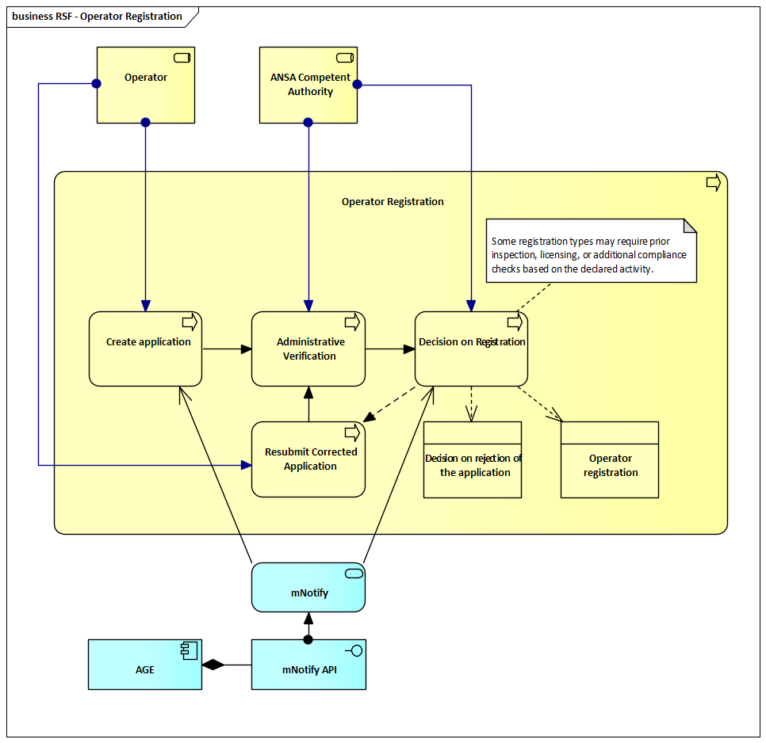
Steps in Operator Registration Process
1. Create Application
- The operator (individual or legal entity) initiates the registration by submitting an electronic application through the RSF system.
- Upon submission, the ANSA Competent Authority is automatically notified via the integrated mNotify system.
- The application includes:
  - Legal/fiscal identification details
  - Contact and operational information
  - Selected activity types (e.g., exporter, warehouse, producer)
  - Supporting documentation (e.g., company registration, facility details)
2. Administrative Verification
- The ANSA Competent Authority reviews the submitted application to ensure completeness, correctness, and compliance with applicable legal requirements.
- If information is missing or incorrect, the operator is requested to submit a corrected version of the application.
3. Resubmit Corrected Application (if applicable)
- If deficiencies are identified, the operator may resubmit a corrected application based on feedback from ANSA.
- The verification process is repeated upon resubmission.
4. Decision on Registration
- Based on the verified application, the ANSA Competent Authority issues a formal decision:
  - Approval results in successful operator registration and access to RSF modules
  - Rejection is issued with justification and guidance for potential reapplication
- All decisions are communicated to the operator through the integrated mNotify system, using the AGE and mNotify API notification infrastructure.
Note: Some registration types may require prior inspection, licensing, or additional compliance checks depending on the declared activity. In such cases, standardized checklists defined in Chapter 5.3 are used to support consistent evaluation and traceability during the registration process.
Note: While operator registration covers a wide range of activity types, it does not require additional modules or processes outside of the five RSF modules. Registration is limited to recording the declared activities within the unified RSF framework.

System Modules - Specific Descriptions

National Catalogue of Varieties (NCV)
The National Catalogue of Varieties (NCV) is a critical module that manages the official listing of plant varieties approved for cultivation, certification, and commercialization within Moldova. This module ensures compliance with national and EU seed regulations and facilitates integration with international variety listing frameworks such as the EU Common Catalogue, OECD certification schemes and ISTA standards. By digitizing the variety registration and approval processes, the NCV module enhances traceability, regulatory oversight and market access.
Core Functionalities:
- Variety Registration and Approval:
  - Digitizes the application, review, and approval process for new plant varieties.
  - Implements Distinctness, Uniformity, and Stability (DUS) and Value for Cultivation and Use (VCU) testing standards.
  - Ensures compliance with national and international certification protocols.
- Traceability and Compliance:
  - Maintains a real-time database of registered varieties, including their status, renewal, and performance records.
  - Supports variety performance tracking with historical data analysis and market impact assessment.
  - Ensures that only registered varieties can undergo seed certification and be marketed legally.
- Integration with Certification and Seed Systems:
  - Links with the Plant Reproductive Material Management System (PRMMS) to verify variety eligibility for certification.
  - Synchronizes with the OECD and ISTA certification schemes for international compliance and trade facilitation.
  - Automates validation processes for imported and exported seed varieties, ensuring regulatory compliance.
- Interoperability with External Systems:
  - Connects with the EU Common Catalogue to facilitate international variety recognition.
  - Integrates with governmental and cross-border platforms such as e-ANSA, CEFTA TRACES NT, and ePHYTO.
  - Supports interoperability with Moldova’s e-governance services (mPass, mSign, mPay).
- Reporting and Monitoring:
  - Provides detailed reporting tools for regulatory authorities, breeders, and seed producers.
  - Generates statistical insights on variety registration trends, performance, and market impact.
  - Enables data visualization for policy and decision-making by government agencies.
Benefits:
- Breeders and Operators:
  - Streamlines the variety registration and approval process, reducing administrative burdens.
  - Provides real-time access to variety status, performance data, and renewal deadlines.
  - Enhances access to international markets through regulatory alignment with the EU and OECD seed certification frameworks.
- Inspectors and Certification Authorities:
  - Allows for instant verification of variety registration status during inspections and certification procedures.
  - Supports mobile-enabled tools for field data entry and certification validation.
  - Enhances monitoring and enforcement of seed and variety-related regulations.
- Regulatory Authorities:
  - Strengthens compliance monitoring with national and EU seed laws.
  - Facilitates data-driven policy-making with advanced analytics and reporting tools.
  - Supports Moldova’s strategic alignment with EU regulations for variety certification and trade.
By modernizing variety registration and compliance processes, the NCV module significantly improves regulatory oversight, market access, and international trade alignment. It ensures seamless integration with existing phytosanitary and seed certification systems, supporting Moldova’s agricultural competitiveness and EU integration efforts.
Note: While no automation with EU/OECD/ISTA catalogues is required at this stage, the system must support manual cross-verification.
Note: In exceptional cases, ANSA may need to upload already-approved variety registrations directly into the system. Therefore, the module must be capable of skipping specific workflow steps or entire processes, based on user permissions and configuration.

Relevant Business Processes

Variety Registration
The Variety Registration process ensures that only plant varieties meeting national and international standards are approved for cultivation and trade. It supports compliance with Moldova’s legal framework, EU seed legislation, and OECD certification schemes, enabling officially listed varieties to be certified, marketed, and recognized internationally.
This process is executed through the National Catalogue of Varieties (NCV) module and involves coordination between the operator, NCV authority, and designated testing authorities responsible for conducting Distinctness, Uniformity, and Stability (DUS) and, where applicable, Value for Cultivation and Use (VCU) testing.
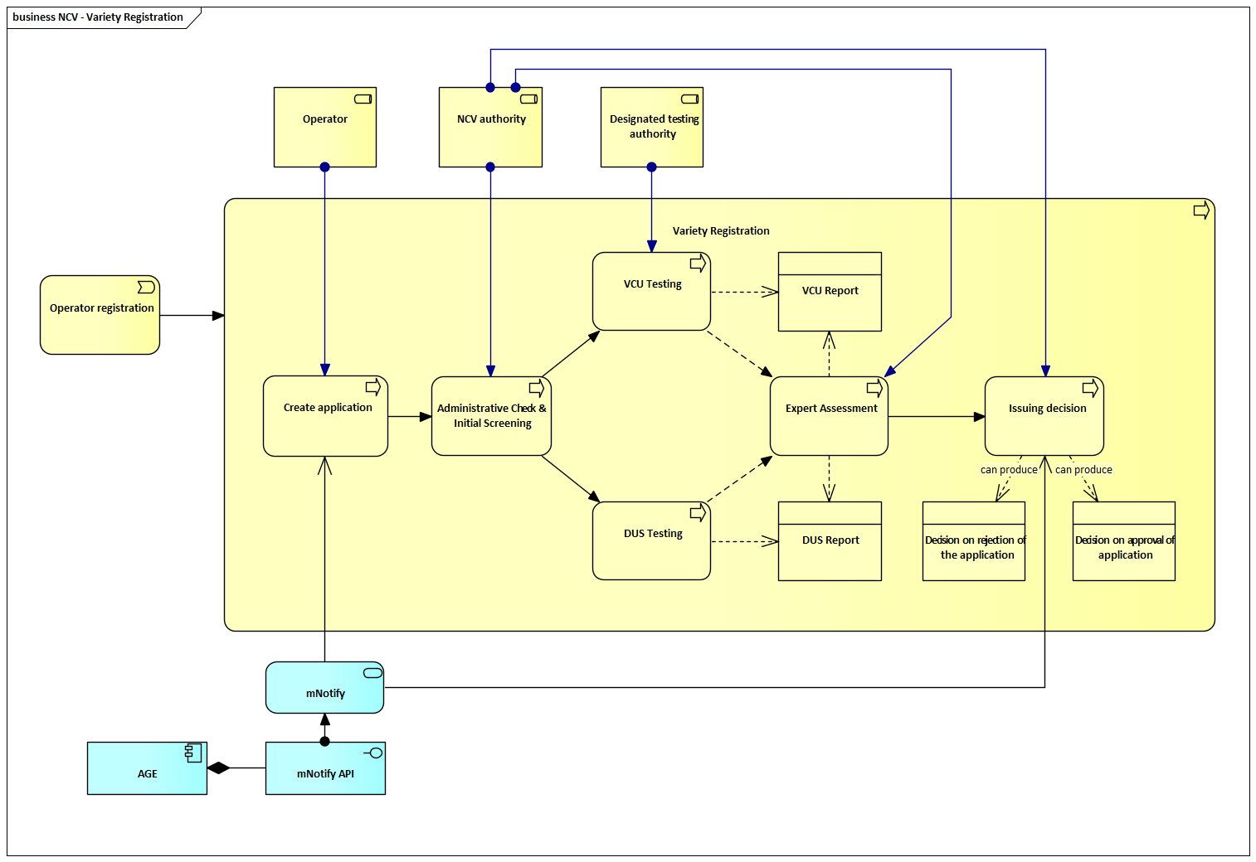
Steps in Variety Registration Process
1. Submission of Application
- The operator (breeder or applicant) submits an electronic application through the NCV system.
- Upon submission, the NCV authority is automatically notified via the integrated mNotify system.
- The application must include:
  - Proposed variety name and species
  - Breeding documentation and genetic description
  - Optional existing DUS results (if already available)
  - Request for DUS and/or VCU testing (if not provided)
- Prior registration in the Operator Registry is a prerequisite.
2. Administrative Check & Initial Screening
- The NCV authority performs a formal verification of the application to ensure completeness and compliance.
- Initial screening verifies that the proposed variety name does not conflict with existing entries and meets naming standards (e.g., uniqueness, suitability, and non-deceptiveness).
3. DUS and/or VCU Testing
- The NCV authority forwards the application to the designated testing authority, which conducts:
  - DUS Testing: To verify distinctness, uniformity, and stability of the variety.
  - VCU Testing (if applicable): For agricultural crops, to assess performance and value under local conditions.
- Testing may span multiple growing seasons.
- Upon completion, the testing authority submits a DUS Report and/or VCU Report.
4. Expert Assessment
- The NCV authority reviews the submitted reports and compiles an expert assessment based on the test data.
- This assessment forms the basis for the administrative decision.
5. Issuing Decision
- Based on the expert assessment, the NCV authority either:
  - Approves the variety, issuing a registration decision
  - Rejects the application, providing justification and guidance
- The decision is communicated to the operator via mNotify and AGE infrastructure.
6. Publication in the National Catalogue
• Approved varieties are added to the official National Catalogue of Varieties.
• Once listed, the variety becomes eligible for certified seed production, PRM labeling, and international certification (e.g., TRACES, OECD).
Additional Notes
- Only varieties listed in the NCV may be used for certified PRM production and export.
- The system enables harmonization with the EU Common Catalogue, supporting cross-border recognition.
- In certain cases, foreign DUS test reports (e.g., UPOV-compliant) may be accepted, subject to NCV authority approval.

Variety Approval and Official Listing
The Variety Approval and Official Listing process ensures that only plant varieties that have successfully completed technical evaluation and meet legal and regulatory conditions are granted official status in the National Catalogue of Varieties (NCV). This listing authorizes varieties to be used for seed certification, production, and trade, and is a prerequisite for their recognition in OECD schemes and export documentation.
This process is coordinated between the operator, the NCV authority, and designated testing institutions. It begins after submission of DUS and, where applicable, VCU test results, and concludes with an administrative decision, public notification, and formal listing of the variety in the NCV system. Only listed varieties may enter the seed certification process or be included in plant passports and export certificates.
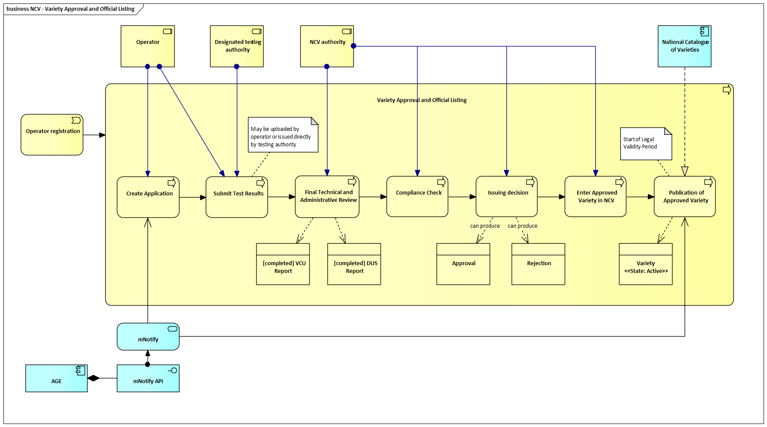
Steps in Variety Approval and Official Listing Process
1. Create Application
- Triggered by a registered operator (e.g., breeder, importer, distributor)
- The operator submits a formal application for a new plant variety to the NCV authority
- The application must include:
  - Variety description and breeding origin
  - Proposed variety name
  - Initial documentation relevant to DUS/VCU testing
- Prior registration in the Operator Registry is mandatory.
2. Submit Test Results
- DUS and/or VCU test results are submitted into the system
- Results may be:
  - Uploaded by the operator
  - Or submitted directly by the designated testing authority
- Foreign DUS results (e.g., UPOV-compliant) may be accepted, subject to NCV authority approval.
3. Final Technical and Administrative Review
- The NCV authority reviews the submitted application and results, ensuring:
  - Completeness and coherence of documentation
  - Acceptability and relevance of foreign test results
  - Compliance of the proposed name
- The review confirms presence of:
  - [Completed] DUS Report
  - [Completed] VCU Report (if required)
4. Compliance Check
- Legal assessment based on:
  - Law on Plant Varieties
  - EU Directive 2002/53/EC
  - OECD scheme eligibility (if international listing is planned)
- Confirms that the applicant has met all regulatory and ownership criteria.
5. Issuing Decision
- The NCV authority issues a formal administrative decision:
  - Approval, or
  - Rejection, with justification
- The result is communicated to the operator via mNotify and the AGE infrastructure.
- This decision becomes the legal basis for updating the catalogue.
6. Enter Approved Variety in NCV
- Upon approval, the variety is:
  - Registered in the NCV system
  - Assigned a unique variety ID and metadata
  - Status updated to “Approved”
7. Publication of Approved Variety
- The variety is published on the NCV public portal
- Publication marks the start of legal validit
- The variety is now available to PRM certification and export systems (e.g., PRMMS, TRACES)

8. Start of Legal Validity Period
- Once published, the variety is:
  - Legally certifiable and marketable
  - Linked to downstream seed and phytosanitary modules
- System updates the data state to:
  - Variety <<State: Active>>

Prolongation (Renewal) of Variety Registration
The Prolongation (Renewal) of Variety Registration process ensures that plant varieties listed in the National Catalogue of Varieties (NCV) continue to meet legal, technical, and market requirements after their initial registration period expires. Renewal of registration is essential for maintaining the variety’s eligibility for seed certification, production, trade, and its inclusion in plant passports and export documentation.
This process is coordinated between the operator, the NCV authority, the NCV evaluation panel, and, if needed, designated testing authorities. It is initiated prior to the expiration of the current registration and involves administrative review, expert assessment, and—in certain cases—additional testing. The process concludes with an administrative decision and updated publication in the NCV system. Only renewed varieties may continue to participate in regulated seed and planting material systems.
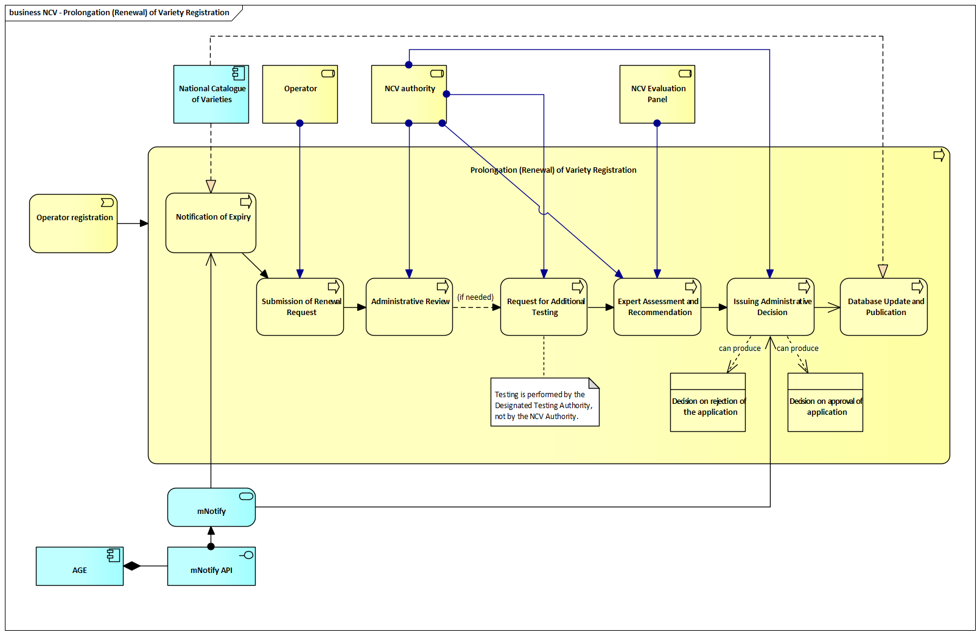
Steps in Prolongation (Renewal) of Variety Registration Process
1. Notification of Expiry
- The NCV system automatically monitors variety expiration dates and sends advance notifications to the variety holder (operator) at defined intervals (typically 12 and 6 months prior to expiry).
- Notifications include the renewal deadline, conditions, and instructions for submission.
- Messages are delivered via the integrated mNotify system and AGE notification infrastructure.
2. Submission of Renewal Request
- The operator submits a renewal request through the NCV module, including updated variety-related information such as:
  - Commercial and market performance
  - Agronomic relevance and adaptability
  - Changes in variety characteristics or ownership
  - Optional DUS/VCU test data, if relevant
3. Administrative Review
- The NCV authority verifies completeness, internal consistency, and formal compliance of the submitted renewal request and accompanying documents.
- This step also determines whether additional technical data is required.
4. Request for Additional Testing (if needed)
- If critical data is missing, outdated, or inconsistent, the NCV authority may request partial or complete retesting of the variety.
- Testing is performed by an officially recognized Designated Testing Authority, not by the NCV authority itself.
5. Expert Assessment and Recommendation
- The NCV Evaluation Panel reviews all available documentation and testing results.
- Based on its findings, the panel issues a formal recommendation, which may include:
  - Approval of renewal
  - Conditional renewal
  - Rejection
6. Issuing Administrative Decision
- Based on the expert recommendation, the NCV authority issues a formal administrative decision:
  - Approval: The registration is renewed for a defined period (e.g., 10 years)
  - Rejection: The request is denied and the operator is informed, with potential for reapplication or appeal
- Notifications are sent to the applicant via the mNotify channel.
7. Database Update and Publication
- The final decision is reflected in the official NCV database.
- The updated status is published on the NCV public portal, with the new expiration date (if renewed) or delisting (if rejected).
- Changes are also synchronized with dependent systems such as seed certification modules (e.g., PRMMS).

Deregistration (Deletion) of a Variety
The Deregistration (Deletion) of a Variety process ensures that obsolete, non-compliant, or voluntarily withdrawn plant varieties are removed from the National Catalogue of Varieties (NCV). This process is crucial for maintaining the accuracy and legal validity of the catalogue. Once a variety is deregistered, it is no longer eligible for seed certification, passporting, or inclusion in official trade or export documentation.
Deregistration can be triggered:
- Automatically (e.g., expiry without renewal),
- By administrative decision (e.g., loss of eligibility or legal grounds),
- Or upon request by the operator.
The process is overseen by the NCV authority and may include a notification phase, review, and final decision. Outcomes include confirmed deletion or deferral (in cases of objection, appeal, or suspension).
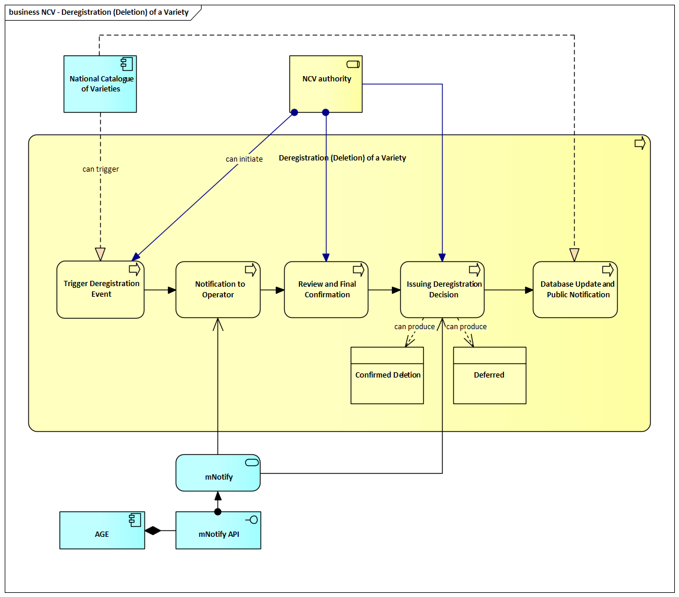
Steps in Deregistration (Deletion) of a Variety
1. Trigger Deregistration Event
- A deregistration process may be initiated due to:
  - Expired registration without submitted renewal
  - Voluntary removal request submitted by the operator
  - Discovery of non-compliance (e.g., revoked rights, invalid data)
  - Regulatory or legal audit outcomes
- The event may be triggered either by the NCV authority or automatically by the National Catalogue of Varieties system.

2. Notification to Operator
- Upon initiation, the operator is notified via the mNotify system and AGE infrastructure.
- The notification includes:
  - Reason for deregistration
  - Applicable deadlines and the right to object or appeal (if provided for)
  - Instructions for responding or submitting relevant documentation
3. Review and Final Confirmation
- The NCV authority reviews the case to determine whether deregistration is justified and must proceed.
- This step involves verifying compliance with legal and administrative rules.
- Advisory input may be requested where applicable.
4. Issuing Deregistration Decision
- Following review, the NCV authority issues a formal administrative decision:
  - Confirmed Deletion, if the variety is to be removed from the register
  - Deferred, if the decision is postponed (e.g., due to an appeal or request for more time)
- The decision is formalized, recorded in the system, and communicated to the operator via mNotify and AGE infrastructure.
5. Database Update and Public Notification
- The variety’s status is updated in the NCV database, and the public interface reflects the change (e.g., removal from active list).
- Changes are also synchronized with dependent systems if applicable.

Architecture of the System
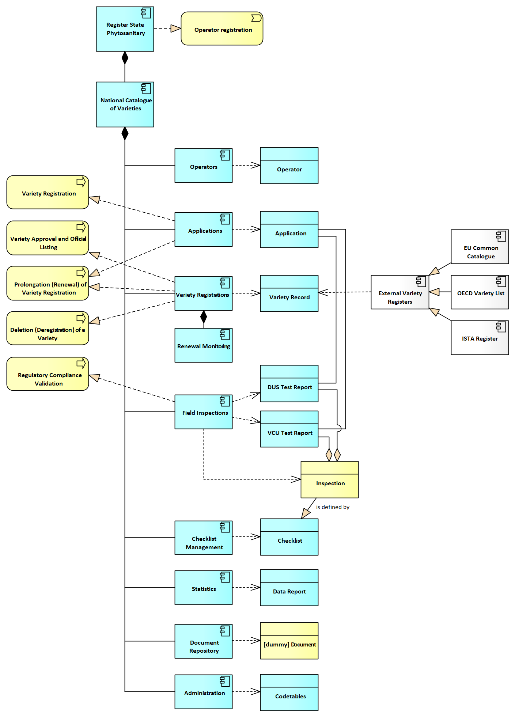

System Components and Related Data Objects
This section outlines the core system components and their related data objects, ensuring efficient record management, process tracking, and compliance validation within the NCV system.
Register State Phytosanitary
The core information system that integrates all modules, acting as the central repository for managing operators, applications, certifications, controls, and other related data in the seed management domain.
National Catalogue of Varieties (NCV)
The National Catalogue of Varieties (NCV) is a core module responsible for managing the registration, approval, renewal, and deregistration of plant varieties. It ensures that only approved and compliant varieties are legally cultivated, certified, and commercialized. The system aligns with national regulations and international standards such as the EU Common Catalogue, OECD Variety List, and ISTA Register, supporting regulatory oversight and market access.
Operators
A component dedicated to managing information on registered breeders, seed producers, and relevant stakeholders involved in a variety of registration and regulatory compliance.
Data entities:
- Operator - Represents a registered breeder, seed producer, or other relevant entity authorized to submit applications for variety registration.
Applications
Handles all variety registration applications submitted by breeders and seed operators. It tracks the progress of applications, approvals, and regulatory validation.
Data entities:
- Application - Records details about the submitted variety, applicant information, and supporting documentation.
Variety Registration
The core system module responsible for maintaining variety records, tracking approval status, renewal eligibility, and deregistrations.
Data entities:
- Variety Record - Stores variety-specific details, including name, breeder, registration date, expiration, and approval status.
Renewal Monitoring
Tracks variety registration expiry dates and manages renewal requests to ensure continuous regulatory compliance.
Data entities:
- Renewal Record - Contains information about renewal requests, updated performance data, and regulatory decisions.
Field Inspections
Supports the assessment of plant varieties through DUS (Distinctness, Uniformity, Stability) and VCU (Value for Cultivation and Use) testing, ensuring compliance before registration.
Data entities:
- DUS Test Report - Documents distinctness, uniformity, and stability test results.
- VCU Test Report - Stores performance-based agronomic and economic evaluation data.
Regulatory Compliance Validation
Ensures that registered varieties comply with national and international variety listing standards by cross-referencing external variety registers.
Data entities:
- Compliance Record - Tracks validation checks against the EU Common Catalogue, OECD Variety List, and ISTA Register.
Statistics & Reporting
Provides analytical tools and reporting functionalities for tracking variety approvals, market impact, and compliance rates.
Data entities:
- Data Report - Aggregates a variety of registration statistics, renewal trends, and regulatory compliance reports.
Document Repository
Stores all official documents related to variety applications, approvals, and regulatory decisions.
Data entities:
- Regulatory Document - Includes official approval certificates, test reports, and deregistration records.

Administration
Manages user roles, system settings, and regulatory oversight functions to ensure secure and controlled access to the NCV system.
Data entities:
- User Role Record – Defines permissions and access rights for breeders, inspectors, and regulatory authorities.

Components specific functions
F01: SubmitVarietyApplication – Allows operators (breeders, seed producers) to submit a new application for variety registration, including relevant details such as breeder information, variety characteristics, and required supporting documents.
F02: SaveDraftApplication – Enables users to save partially completed applications for later modification and finalization before submission.
F03: ViewApplicationStatus – Provides real-time tracking of application progress, including stages such as Draft, Submitted, Under Review, Testing, Approved, or Rejected.
F04: UpdateApplication – Allows applicants to edit submitted application details and upload missing information prior to approval or formal closure.
F05: AttachApplicationDocuments – Supports uploading of required files (e.g., breeding origin, genetic description, DUS/VCU test requests, declarations) during the application process.
F06: ApproveOrRejectApplication – Enables regulatory authorities to assess and decide on applications. Rejections include justification and appeal options.
F07: AssignTestingAuthority – Allows NCV authorities to assign DUS and/or VCU testing tasks to designated institutions based on the crop type and test requirements.
F08: ManageTestResults – Allows testing authorities or NCV users to upload and manage DUS and VCU test results, including attaching final reports and validating completeness.
F09: PreIssuanceValidation – Performs a final completeness and compliance check prior to approval or renewal of a variety registration.
F10: CreateVarietyRecord – Automatically generates a variety record upon application approval, linking submitted data, test reports, and decision history.
F11: UpdateVarietyRecord – Allows regulatory users to update approved variety data such as validity period, ownership, or changes from renewal.

F12: DeleteVarietyRecord – Permanently deletes a variety record under controlled circumstances (e.g., system error or invalid creation), requiring high-level authorization and audit trail.
F13: MarkVarietyAsInvalid – Marks a variety as no longer valid for certification or trade (e.g., after deregistration or rejection), while retaining its record for regulatory traceability.
F14: ListVarieties – Displays submitted and approved varieties in a structured list, sortable by breeder, status, expiration date, and crop type.
F15: SearchVarieties – Allows full-text search across variety name, breeder, ID, crop type, and registration status.
F16: FilterVarieties – Applies filters to narrow search results by category (e.g., active, expired, under testing, horticultural vs. agricultural).
F17: ViewVarietyDetails – Provides detailed view of variety records including application data, test reports, approval metadata, and related decisions.
F18: TrackRenewalStatus – Continuously monitors expiration timelines and automatically notifies variety holders with reminders and renewal guidelines.
F19: SubmitRenewalRequest – Allows variety holders to request renewal of a registration and attach updated performance or ownership data.
F20: ProcessDeregistration – Supports the full deregistration workflow, from automated expiry detection and operator request handling to final confirmation and removal from the active catalogue.
F21: ValidateCompliance – Validates whether a variety complies with national laws and international frameworks (EU Common Catalogue, OECD, UPOV, ISTA), supporting both manual and linked cross-checks.
F22: ExportApplicationData – Enables users and regulators to export raw application data in standard formats (PDF, CSV, Excel) for audit or archiving.
F23: ExportVarietyData – Allows export of approved variety records for publication, regulatory reporting, or integration with seed certification and trade systems.

Data Drafts (Entity Relationship Model)
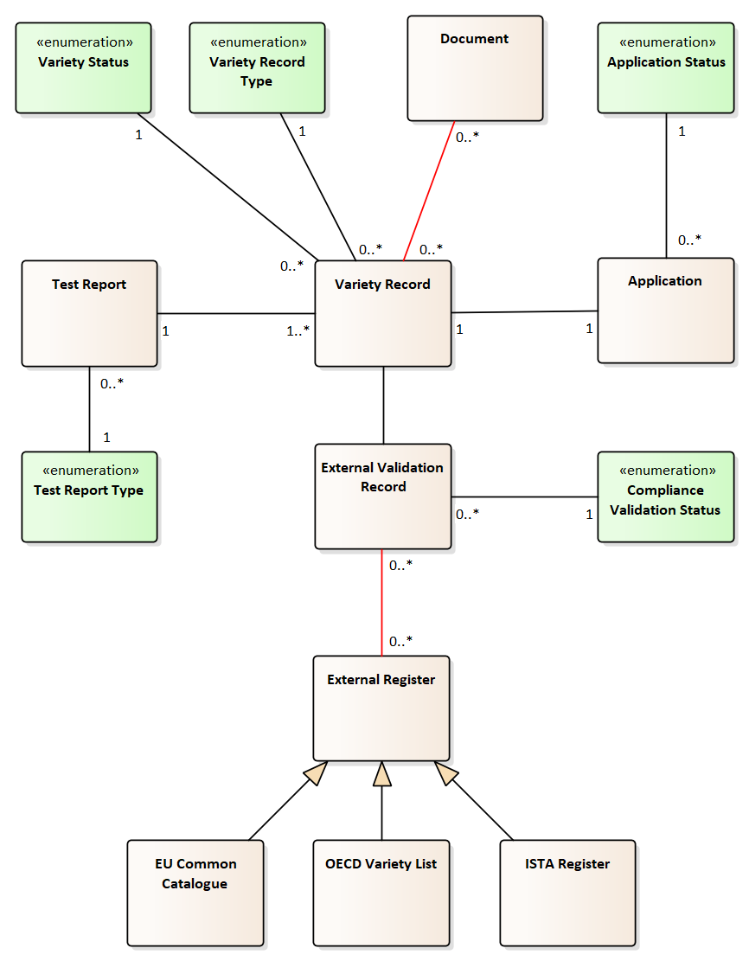

Functional Requirements
The National Catalogue of Varieties (NCV) module is designed to ensure the efficient management of plant variety registration, approval, renewal, and deregistration, while enabling regulatory compliance and traceability. The following functional requirements outline the system’s core capabilities.
FR-NCV-001: Operator Registration Process
The system must allow breeders and seed producers to register as authorized operators, enabling them to submit variety applications and renewal requests. The registration process should validate user credentials and ensure compliance with national and international regulatory frameworks.
FR-NCV-002: Role-Based Registration and Permissions
The system must assign role-based access to users such as breeders, regulatory authorities, and inspectors. Permissions must be aligned with variety application, review, and approval processes, ensuring secure data access and operational segmentation.
FR-NCV-003: Variety Application Submission and Management
Operators must be able to submit structured applications for variety registration, including required supporting documents, DUS/VCU test results, and breeder declarations. The system should track application status and approval workflow.
FR-NCV-004: Variety Approval and Official Listing
The system must support the review and approval process for variety applications, ensuring that only eligible varieties meeting DUS and VCU testing criteria are officially listed in the NCV database.
FR-NCV-005: Variety Renewal and Expiration Management
The system must track validity periods for variety registrations and automatically notify operators of upcoming expirations. Breeders must be able to request renewal, and authorities should be able to approve or reject renewal requests.
FR-NCV-006: Variety Deregistration Process
The system must allow regulatory authorities to deregister obsolete, non-compliant, or breeder-withdrawn varieties. Deregistered varieties must be archived for historical records but should not be eligible for seed certification.
FR-NCV-007: Regulatory Compliance Validation
The system must enable authorities to validate variety registrations against external registers (EU Common Catalogue, OECD Variety List, ISTA Register) to ensure market compliance and international trade eligibility.
FR-NCV-008: Manual Cross-Reference with External Variety Registers
The system must provide users, particularly regulatory authorities, with access to external links or embedded references to international plant variety registers such as the EU Common Catalogue, OECD Variety List, and ISTA database. This feature will support manual verification of variety compliance with international standards. Automation or API-based integration is not required at this stage.
FR-NCV-009: Test Report Management (DUS & VCU)
The system must store and manage DUS (Distinctness, Uniformity, Stability) and VCU (Value for Cultivation and Use) test reports, ensuring their association with the correct variety application or record.
FR-NCV-010: Data Accessibility and Reporting
The system must provide real-time access to variety registration data, allowing regulatory bodies to generate reports on approved, renewed, or deregistered varieties, ensuring transparency and decision-making support.
FR-NCV-011: Document Storage and Retrieval
The system must allow users to upload, store, and retrieve supporting documents, such as breeder declarations, certification approvals, and compliance reports, ensuring auditability and traceability.
FR-NCV-012: Notification and Alert System
The system must generate automated notifications for key actions, such as application approval, renewal deadlines, deregistration notices, and regulatory compliance alerts, ensuring timely decision-making for users.
FR-NCV-013: Configurable Checklists for Variety Field Testing (DUS/VCU)
The system shall support configurable digital checklists for field inspections related to DUS (Distinctness, Uniformity, Stability) and VCU (Value for Cultivation and Use) testing. These checklists must be defined by administrators and used by inspectors to record structured observations during field trials. The checklist functionality shall support dynamic form fields as described in chapter 5.3.
FR-NCV-014: Direct Registration of Approved Varieties
The system shall allow authorized ANSA users to bypass standard registration workflows and directly register already-approved variety entries into the National Catalogue. This feature shall be configurable and restricted to designated roles. All such records shall be captured in the audit log to ensure full traceability and data accountability.
FR-NCV-015: Public Access to Approved Varieties
The system must provide a public-facing interface that allows external users (e.g., farmers, importers, exporters) to search and view the list of officially registered plant varieties. The interface should support filters such as crop type, variety name, registration status, and approval date, and display relevant information such as validity, status, and issuing authority.
FR-NCV-016: Audit Log for Variety Lifecycle Actions
The system must maintain an audit log that captures all key actions taken on variety records throughout their lifecycle, including submission, modification, approval, renewal, deregistration, and direct entry. Each log entry must include the action type, timestamp, user ID, and affected data fields.
FR-NCV-017: Variety Metadata Management
The system must allow authorized users to configure and manage variety metadata such as crop groups, species, taxonomic categories, regulatory codes, and variety types. These values must be used consistently in registration forms, reports, and public interfaces. The metadata lists must be editable by administrators and version-controlled.

Non-Functional Requirements
NFR-NCV-001: Availability
The system must ensure that the NCV module is operational and accessible at least 99.5% of the time during official working hours (Monday to Friday, 08:00–18:00, Moldova time), excluding scheduled maintenance periods.
NFR-NCV-002: Performance – Application Processing
The NCV module must respond to user interactions (e.g., loading the variety registration form, saving an application, searching for a registered variety) within 2 seconds under normal load (up to 30 concurrent users).
NFR-NCV-003: Data Accuracy and Validation
The system must enforce data validation rules to ensure that all submitted variety applications contain complete, accurate, and logically consistent data (e.g., mandatory DUS/VCU references, correct dates, taxonomy links).
NFR-NCV-004: Auditability and Traceability
All user actions that affect the status or data of a variety record (e.g., submission, approval, renewal, deregistration) must be logged in an immutable audit trail including the action, user ID, timestamp, and affected fields.
NFR-NCV-005: Data Integrity
The system must prevent partial submissions and must ensure that variety records remain in a consistent state even in the event of application errors, power loss, or network disruptions.
NFR-NCV-006: Role-Based Access Security
Access to NCV data must be secured using role-based permissions (as defined in FR-NCV-002). Only authorized personnel shall perform approval, renewal, or deregistration tasks.
NFR-NCV-007: Backup and Recovery
The NCV data must be backed up at least once every 24 hours, and a recovery plan must exist that allows full restoration of the NCV database within 4 business hours in case of system failure.
NFR-NCV-008: Multilingual Public Interface
The public-facing interface for viewing registered varieties (FR-NCV-015) must support Romanian (default) and English for search and result display, ensuring accessibility for national and international stakeholders.

Plant Reproductive Material Management System
The Plant Reproductive Material Management System (PRMMS) is a critical module that facilitates the regulation, certification, and monitoring of all types of plant reproductive material (PRM) - including seeds, planting material, grafts, and other reproductive material - throughout their lifecycle. It ensures full compliance with national and international standards and supports authorities, producers, traders, and inspectors by digitizing key processes, improving traceability, and enhancing operational efficiency.
Core Functionalities
- PRM Certification Management
  - Digitizes the application, review, and issuance of certifications for plant reproductive material, ensuring compliance with legal and regulatory requirements.
  - Supports both local and export certification processes, including integration with international frameworks such as the International Seed Testing Association (ISTA), OECD seed schemes, and applicable EU legislation for vegetative propagation materials.
  - Tracks certification data at the seed lot ensuring traceability from production to commercialization, and enabling quick issue resolution.
- Inspection and Monitoring
  - Provides inspectors with tools for scheduling inspections, collecting field crop and nursery data, and submitting digital reports directly through the system.
  - Ensures consistent compliance with EU and Moldovan legislation through risk-based inspection protocols and periodic audits, differentiated by crop type and material category.
- Traceability
  - Maintains a comprehensive record of PRM seed lots linking them to certification details, operator roles (e.g., producer, processor, seller), and distribution pathways.
  - Facilitates efficient tracking of PRM in both domestic and international markets, improving accountability and regulatory oversight, and enabling post-market controls and recalls when necessary.
- Integration with Systems
  - Seamlessly connects with the e-ANSA platform and cross-border platforms such as CEFTA TRACES NT and ePHYTO.
  - Supports interoperability with Moldova's national e-governance services, including secure authentication (mPass), electronic signatures (mSign), government payments (mPay), notifications (mNotify), and personal workspaces (mCabinet).
- Compliance and Reporting
  - Monitors adherence to EU, OECD, ISTA, and international phytosanitary regulations through structured reporting, visual dashboards, and real-time data analytics.
  - Enables rapid identification and resolution of quality or regulatory non-conformities, strengthening market compliance and public confidence.

Benefits
- Producers and Traders (Operators)
  - Simplifies certification and registration processes for all categories of PRM.
  - Improves access to regulatory information and guidance.
  - Ensures transparency in quality management, enabling safe trade and improved competitiveness.
- Inspectors
  - Provides mobile-enabled tools for real-time data entry, inspection checklists, and history tracking.
  - Enhances efficiency in field crop, nursery, and warehouse inspections through guided workflows and decision-support mechanisms.
- Regulatory Authorities
  - Enables end-to-end monitoring, enforcement, and strategic reporting for PRM-related activities.
  - Supports Moldova’s alignment with EU accession requirements and international trade protocols through data-driven oversight and digital harmonization.
By modernizing PRM management processes, the PRMMS improves transparency, efficiency, and data accuracy. It strengthens Moldova’s compliance with phytosanitary and varietal certification standards while promoting market access and global competitiveness through seamless integration with both local and international frameworks.

Relevant Business Processes

Plant Reproductive Material (PRM) Crop Certification process
The Plant Reproductive Material (PRM) Crop Certification process is a critical component in ensuring the biological value, varietal identity, and phytosanitary quality of materials intended for propagation. It involves the systematic evaluation and control of seeds, planting material, rootstocks, grafts, and other reproductive materials. This process ensures compliance with established technical and legal standards, facilitating traceability and quality assurance throughout the production chain. Certification is required for both sexually and vegetatively propagated material, including horticultural, viticultural, and Field crops, in alignment with Moldova’s regulatory framework and international best practices (EU, ISTA, OECD).
Pre-Conditions
- The operator must be registered in the system and authorized to produce, process, or market plant reproductive material, in accordance with national legislation.
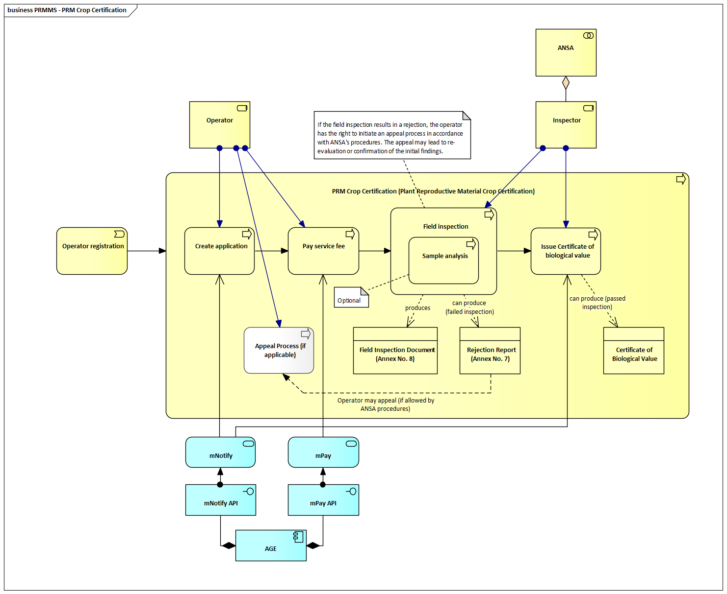
Steps in the PRM Certification Process
1. Create Application
- The certification process is initiated when the operator submits an application or multiplication declaration for Plant Reproductive Material (PRM).
- The application includes:
  - Species and variety
  - PRM category (e.g., pre-basic, basic, certified)
  - Production method
  - Intended use
- Upon submission, the ANSA inspector and internal systems are automatically notified via mNotify and AGE infrastructure.
2. Pay Service Fee
- The operator pays the applicable certification service fee.
- Payment is processed through the integrated mPay system, and recorded via mPay API, with traceability linking it to the application.
3. Field Inspection (Nursery/Greenhouse)
- ANSA inspectors conduct an on-site inspection to assess compliance with certification requirements.
- The inspection includes verification of:
  - Crop identity and classification
  - Isolation distances and source material
  - Presence of pests or disease
- Results in:
  - A Field Inspection Document (Annex No. 8)
  - If non-compliant, a Rejection Report (Annex No. 7) is issued and the process ends.
4. Sample Analysis (If Applicable)
- Performed only if required by PRM category, crop type, or suspicion of non-conformity.
- Samples are tested in accredited laboratories (LIMS) for parameters such as:
  - Germination, purity, seed health, identity, and moisture content
- Test results support the final certification decision.
5. Decision on Certification
- Based on field inspection and (if applicable) lab results, the inspector decides:
  - Rejection: Rejection Report issued with reasons (e.g., impurity, disease)
  - Approval: Application proceeds to certificate issuance
- Operator has the right to appeal per ANSA’s procedures. The appeal may result in re-evaluation or confirmation of findings.
6. Issuance of Certificate
- If the PRM meets all certification criteria, the appropriate certificate is issued (e.g., Certificate of Biological Value).
- The certificate confirms legal and technical conformity and enables marketing or export.
- The operator is notified of the issued certificate via mNotify and AGE, and it becomes available in their user portal.

Plant Reproductive Material (PRM) Certification process for the local market
The Plant Reproductive Material (PRM) Certification process for the local market ensures that seeds and other propagating materials meet national and EU quality standards, enabling their commercialization within Moldova. This certification process is governed by technical regulations and involves coordinated activities between operators, inspectors, and accredited laboratories to verify the biological, varietal, and phytosanitary integrity of the material. It is supported by integrated digital workflows to ensure transparency, traceability, and compliance across the certification lifecycle.
As a pre-condition, the operator must be registered in the system. Additionally, the plant reproductive material must meet at least one of the following eligibility criteria:
- Be listed in the National or EU Catalogue of Varieties,
- Be covered by a valid Certificate of Biological Value,
- Be subject to re-certification under a previously issued Seed/PRM Quality Certificate.
These conditions ensure that only verified and eligible PRM lots proceed to certification, maintaining compliance with national and EU quality standards.
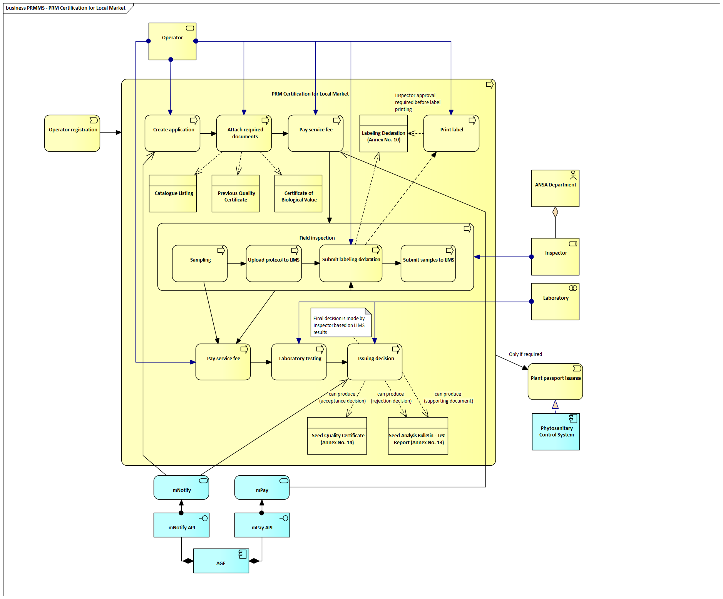
Steps in the PRM Certification for Local Market Process
1. Create Application
- The operator submits an application via the system to initiate PRM certification.
- The application includes:
  - Species and variety
  - PRM category (e.g., pre-basic, basic, certified)
  - Production lot size and intended use (e.g., commercialization, repackaging)
- This forms the basis for all subsequent verification, labeling, sampling, and testing steps.
- The system notifies relevant ANSA inspectors via mNotify and AGE infrastructure upon submission.
2. Attach Required Documents
- The operator attaches mandatory supporting documents, including:
  - Catalogue listing status
  - Valid previous quality certificate (if applicable)
  - Certificate of Biological Value (if already issued)
3. Pay Service Fee
- The operator pays the applicable certification fee using mPay, linked through mPay API.
- Payment status is automatically connected to the submitted application for traceability.
4. Submit Labeling Declaration and Print Label
- The operator submits the Labeling Declaration (Annex No. 10) with information on:
  - Label type, range, and traceability code
- After approval by an ANSA inspector, the system enables label printing based on predefined templates.
5. Field Inspection and Sampling
- A designated inspector performs a physical inspection (field, nursery, or warehouse) appropriate to the PRM type.
- This includes three key steps:
  - Sampling – Seeds and some vegetative material are sampled for lab testing
  - Upload protocol to LIMS – Inspector uploads the inspection protocol directly
  - Submit samples to LIMS – Collected samples are sent to the designated lab
6. Laboratory Testing
- The laboratory performs testing based on PRM type:
  - For seeds: germination, purity, moisture, seed health
  - For vegetative PRM: varietal identity, visual quality, phytosanitary indicators
- Results are recorded in the LIMS and are used to support decision-making.
- A second service fee may be collected for lab testing, if applicable.
7. Issuing Decision
- The final decision is made by ANSA inspectors, based on LIMS lab results and field findings.
- Outcomes include:
  - Acceptance Decision → A Seed Quality Certificate (Annex No. 14) is issued
  - Rejection Decision → A Seed Analysis Bulletin – Test Report (Annex No. 13) is issued for non-compliant batches
- The system notifies the operator of the result via mNotify and AGE.
8. Database Update and Certificate Delivery
- Issued certificates and test reports are made available in the operator's portal (e.g., mCabinet or user dashboard).
- All status updates are reflected in the PRMMS system and linked to traceability records.
9. Plant Passport Issuance (If Required)
- If required based on PRM type or export intent, the system may trigger plant passport issuance.
- This is handled via integration with the Phytosanitary Control System, and if needed, the plant passport can be embedded into the printed label in line with EU Regulation 2016/2031 and Implementing Regulation 2017/2313.

Plant Reproductive Material (PRM) Certification process for the export
The PRM Certification process for export ensures that plant reproductive material destined for international markets meets the relevant quality standards and complies with the specific phytosanitary and technical requirements of importing countries. The process is conducted under the oversight of ANSA and involves cooperation among operators, inspectors, and accredited laboratories. The system supports the issuance of internationally recognized certificates - such as ISTA and OECD documents - facilitating efficient and compliant export operations.
As preconditions, the operator must be registered in the national system and authorized for export activities. The certified PRM may or may not be listed in the National or EU Catalogue of Varieties, depending on the requirements of the importing country. Additionally, one or more of the following documents must be used to demonstrate eligibility:
- A valid Certificate of Biological Value,
- A previous PRM Quality Certificate, or
- An export contract or importing country-specific requirement.
These flexible conditions ensure that both catalogued and non-catalogued PRM can undergo export certification, as long as the material meets the specific legal and technical demands of the destination country.
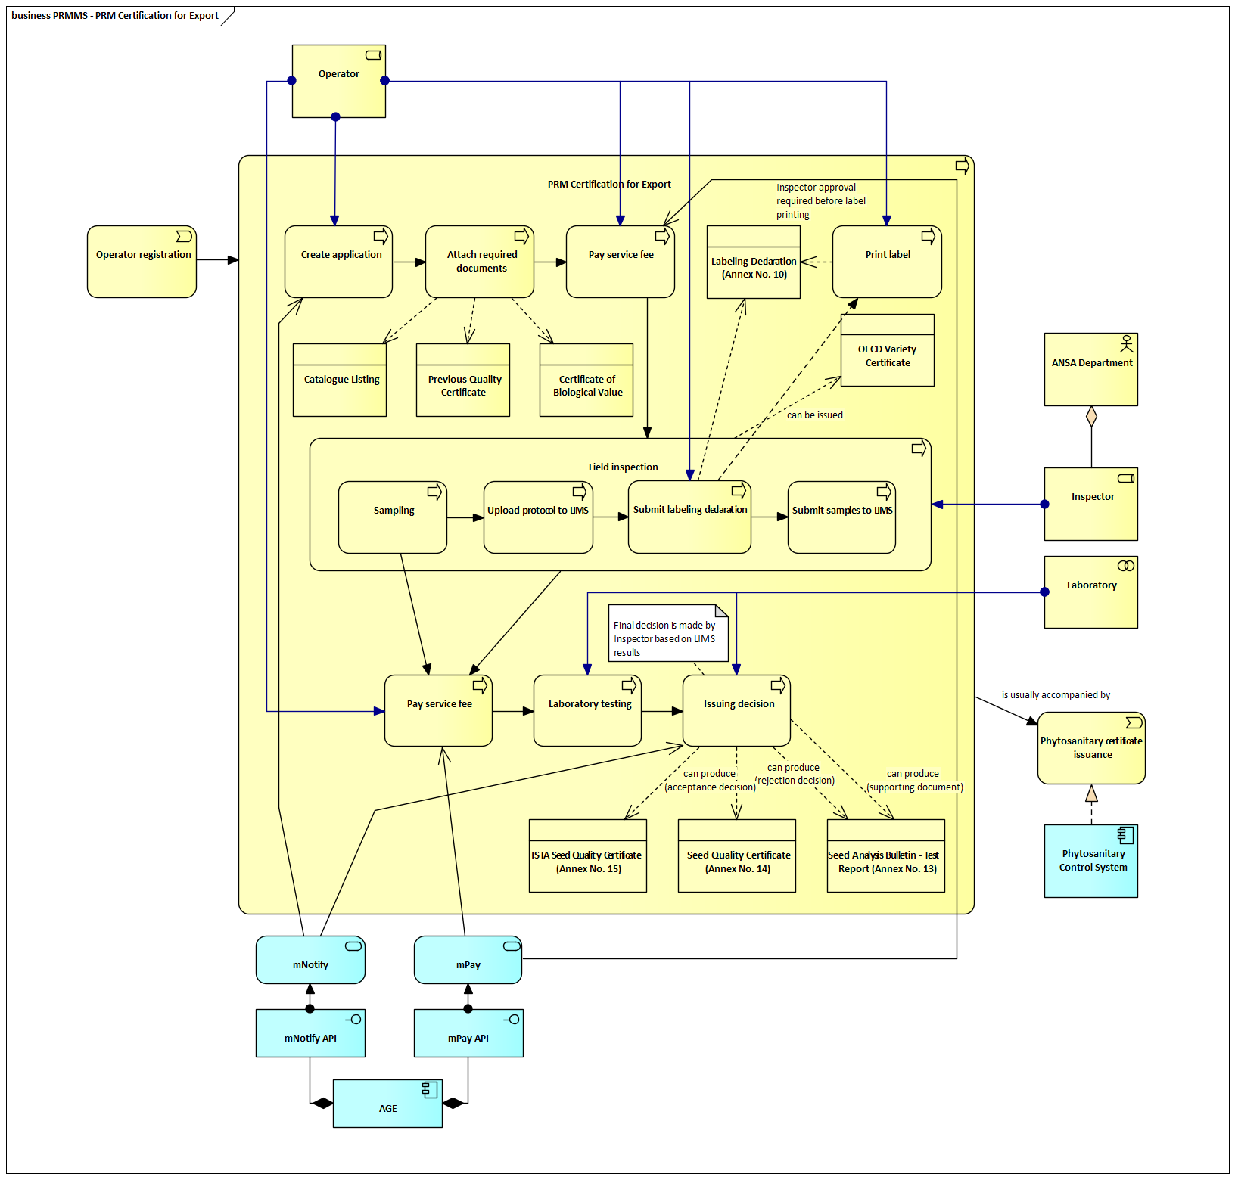
Steps in the PRM Certification Process for Export
1. Create Application
- The operator submits an application for the certification of PRM intended for export.
- The application includes:
  - Species and variety
  - PRM category (e.g., pre-basic, certified)
  - Destination country
  - Type of certification requested (ISTA, OECD, national)
- Upon submission, the system automatically notifies the relevant inspector via mNotify and AGE.
2. Attach Required Documents
- The operator uploads mandatory supporting documentation, including:
  - Certificate of Biological Value
  - Previous Quality Certificate (if applicable)
  - Catalogue listing or other legal references (depending on export destination)
3. Pay Service Fee
- The operator pays the certification service fee via mPay, integrated using mPay API.
- The payment is linked to the submitted application for traceability and audit purposes.
4. Submit Labeling Declaration and Print Label
- The operator submits a Labeling Declaration (Annex No. 10) including label series, packaging details, and traceability codes.
- After inspector validation, label printing is enabled using approved formats (aligned with OECD/ISTA/national schemes).
5. Field Inspection and Sampling
- ANSA inspectors perform on-site field/warehouse inspections including:
  - Sampling – Collection of PRM samples
  - Upload protocol to LIMS – Inspector submits inspection data
  - Submit samples to LIMS – Samples sent to accredited labs
6. Laboratory Testing
- Testing is performed according to PRM type and certification requirements:
  - For seeds: germination, purity, moisture, seed health
  - For vegetative PRM: varietal identity, disease status, visual compliance
- Results are returned via LIMS and used to inform final certification decisions.
7. Issuing Decision
- The inspector, using field and lab data, makes a final decision:
  - Acceptance Decision – Can result in one or more of:
    - ISTA Seed Quality Certificate (Annex No. 15) – for ISTA-compliant international trade
    - OECD Variety Certificate – issued by ANSA for varietal conformity
    - Seed Quality Certificate (Annex No. 14) – for national-level quality confirmation
  - Rejection Decision – A Seed Analysis Bulletin – Test Report (Annex No. 13) is issued for non-compliant batches
- The operator is notified of the decision via mNotify, and documents are uploaded to their portal (e.g., mCabinet).
8. Phytosanitary Certificate Issuance (If Required)
- If required by the destination country, the certification is followed by Phytosanitary Certificate issuance, handled via the Phytosanitary Control System (PCS).
- This certificate confirms PRM compliance with international plant health regulations.

Imported PRM Notification
The Imported PRM Notification process enables the regulated import of plant reproductive material (PRM) that is not listed in the National or EU Catalogue of Varieties. The process is overseen by ANSA’s Head of the Seed Control Directorate and involves collaboration between registered operators and the competent authority. It ensures that all non-catalogued PRM imports meet Moldova’s legal, quality, and varietal purity requirements before market entry.
As a prerequisite, the operator must be registered in the system, and the PRM must not appear in the National or EU variety catalogues. In such cases, the submission must include a Letter of Acceptance from the competent authority, confirming authorization for import outside the standard catalog listing.
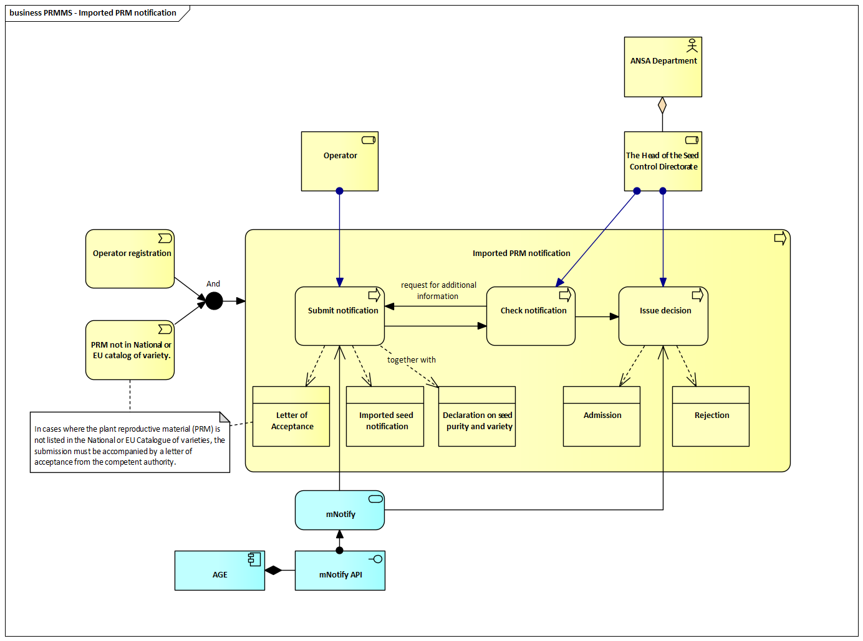
Steps in the Imported PRM Notification Process
1. Submit Notification
- The operator initiates the process by submitting an Imported PRM Notification through the system.
- The submission includes the following mandatory documents:
  - Letter of Acceptance – confirming authorization for PRM not listed in National or EU catalogues
  - Imported Seed Notification – specifying variety, quantity, purpose, and origin
  - Declaration on Seed Purity and Variety – verifying compliance with quality standards
- These documents form the basis for administrative review by ANSA.
- Upon submission, the system notifies the competent authority via mNotify and AGE infrastructure.

2. Check Notification
- The Head of the Seed Control Directorate at ANSA reviews the submitted documentation for completeness and legal conformity.
- If required, ANSA may issue a request for additional information or corrections.
- The review confirms that:
  - The PRM variety is not catalogued
  - The submitted documents are authentic and complete
  - The operator is eligible to import the declared material
3. Issue Decision
- Based on the outcome of the review, ANSA issues one of the following decisions:
  - Admission – If the PRM meets all regulatory and quality requirements, approval is granted. The operator is notified via mNotify, and the PRM may proceed through import and inspection.
  - Rejection – If the submission is incomplete or the PRM fails to meet legal or quality criteria, the application is rejected. A rejection notice is issued via mNotify, detailing the reason(s) for non-compliance.

Imported Plant Reproductive Material (PRM) Certification process
The Imported Plant Reproductive Material (PRM) Certification process ensures that imported planting material, grafts, rootstocks, and other vegetatively propagating material comply with national and international standards for quality, traceability, and phytosanitary safety. The process includes verification of supporting documentation, evaluation of eligibility, and formal certification by ANSA-designated inspectors. The resulting certification enables the lawful use, commercialization, or multiplication of imported PRM within Moldova under full regulatory oversight.
As preconditions, the operator must be registered in the Register State Phytosanitary (RSF) system and authorized for PRM-related activities. The imported PRM must not be listed in the National or EU Catalogue of Varieties. These criteria ensure that the certification process applies only to non-catalogued plant reproductive materials requiring targeted regulatory validation before use on the Moldovan market.
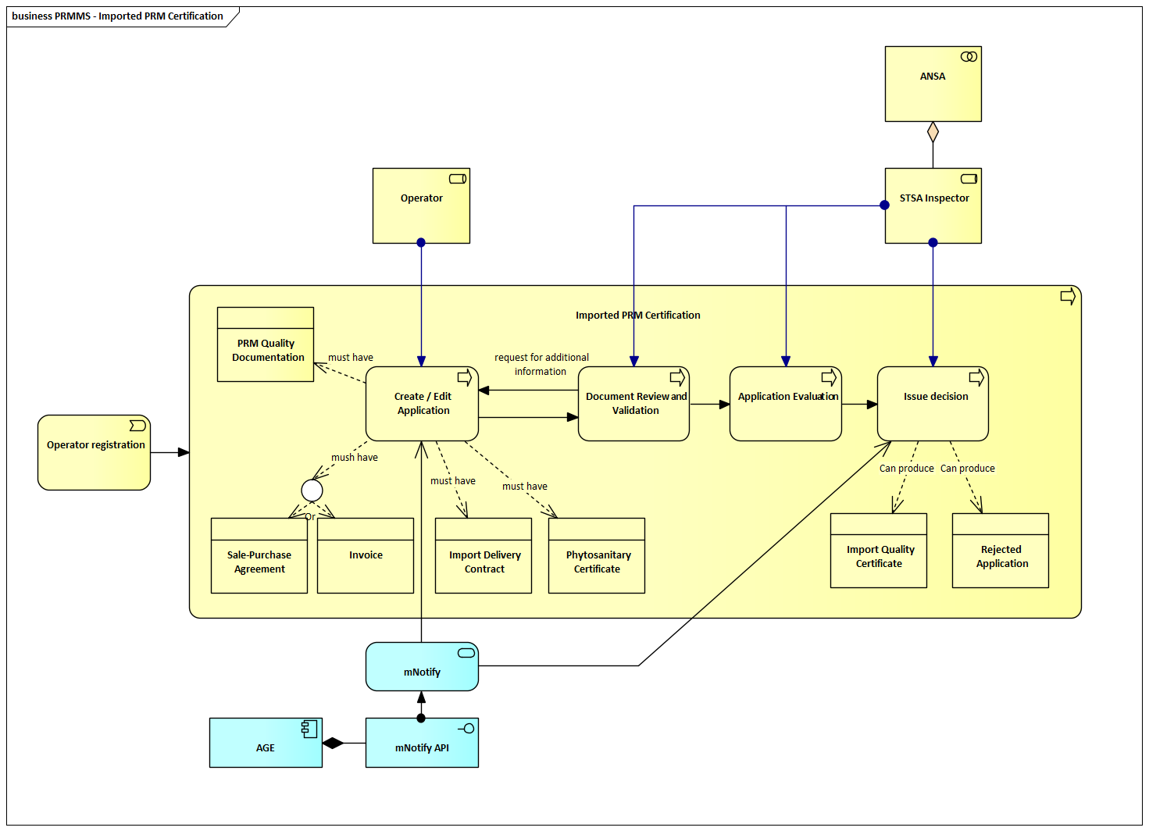
Steps in the Imported Plant Reproductive Material (PRM) Certification Process
1. Create/Edit Application
- The certification process starts with the operator creating or editing an application for imported PRM certification.
- Before submission, the operator must attach the following mandatory documentation:
  - PRM Quality Documentation – proving the material’s technical attributes
  - Import Delivery Contract – defining shipment terms and source
  - Phytosanitary Certificate – confirming plant health compliance from the country of origin
  - Sale-Purchase Agreement – if applicable
  - Invoice – stating the shipment’s financial and logistical reference
- The system checks that all required documents are attached before proceeding.
- Once submitted, the system notifies the ANSA inspector via mNotify and AGE.
2. Document Review and Validation
- The ANSA authority conducts an administrative review to confirm:
  - Completeness of the documentation
  - Internal consistency (e.g., variety ID matches across all forms)
  - Compliance with legal and procedural standards
- If any required data is missing or incorrect, the system triggers a request for additional information, which the operator must resolve before advancing.
3. Application Evaluation
- Once validated, the application is evaluated by a STSA Inspector.
- The inspector reviews all submitted materials to confirm:
  - Import documentation legitimacy
  - Traceability and varietal conformity
  - PRM labeling and destination compliance
- This step focuses on use authorization in Moldova, not phytosanitary border checks.
Note: This certification process is separate from border phytosanitary inspections and does not duplicate health certificate verification. It certifies the quality and usability of vegetative PRM within Moldova.
4. Issuing Decision
- Based on the evaluation, the inspector issues one of the following outcomes:
  - Import Quality Certificate – issued if all conditions are met, allowing PRM use or commercialization in Moldova
  - Rejected Application – issued if the application fails, with documented reasons (e.g., invalid paperwork, variety issues)
- The system notifies the operator of the outcome via mNotify, and the result is logged and linked to the original submission.

Architecture of the System
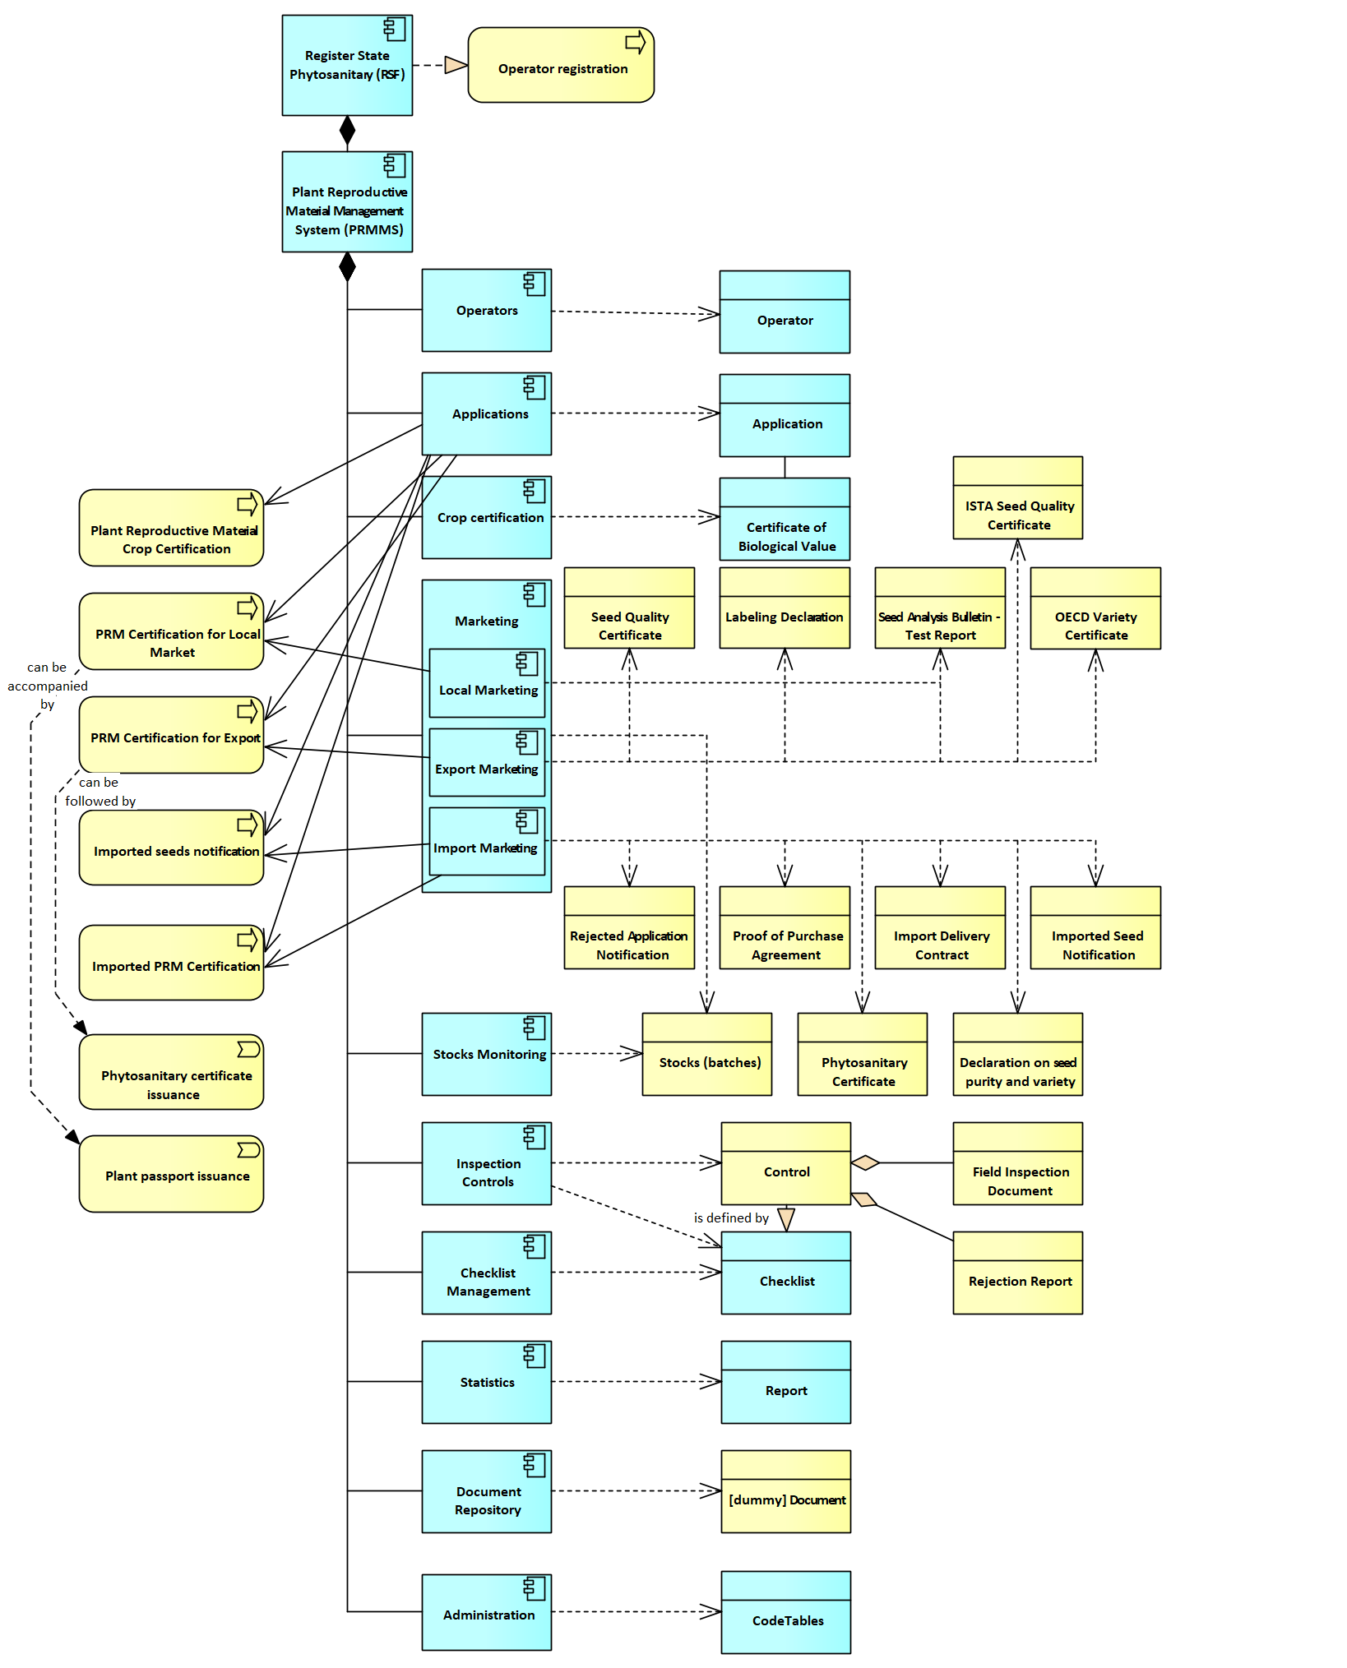

System Components and Related Data Objects
The system comprises several interconnected components and data objects that collectively manage seed certification, inspection, marketing, and compliance processes. Below is a detailed overview of these components, their functions, and related data entities.
Register State Phytosanitary
The core information system that integrates all modules, acting as the central repository for managing operators, applications, certifications, controls, and other related data in the seed management domain.
Plant Reproductive Material Management System (PRMMS)
A core module responsible for overseeing seed certification, inspection, and traceability. It ensures compliance with national and international standards, providing seamless integration with laboratory systems and regulatory platforms.
Operators
A component dedicated to managing information on all registered operators involved in seed production, certification, and trade activities.
Data entities:
- Operator: Represents a registered seed producer, distributor, or other relevant entity.
Applications
Handles all applications submitted by operators for certification or other related processes. It tracks the progress and outcomes of applications across various workflows.
Data entities:
- Application: Records details about the crop, certification requirements, and application status.
Crop Certification
This component manages the certification process to ensure seed crops meet biological and regulatory standards.
Data entities:
- Certificate of Biological Value: Issued upon successful compliance with certification requirements.
- Decision on Rejection of the Breeding Stand: Documented decision when certification standards are not met.
Marketing (Local, Export, Import)
Dedicated to managing the marketing of certified seeds at both local and international levels. It oversees compliance with relevant standards for seed movement within domestic markets and across borders.
- Local Marketing: Manages the distribution and certification of seeds within Moldova’s domestic market.
  - Data entities:
    - Seed Quality Certificate: Verifies that seeds meet domestic quality standards.
    - Labeling Declaration: Provides essential traceability information on certified seeds.
- Export Marketing: Ensures compliance with OECD, ISTA, and other international certification standards for export.
  - Data entities:
    - Seed Quality Certificate: Certifies general seed quality for export.
    - Labeling Declaration: Required for seed traceability during export.
    - Seed Analysis Bulletin - Test Report: Summarizes laboratory analysis results for exported seeds.
    - OECD Variety Certificate: Certifies varietal purity and compliance with OECD standards.
    - ISTA Seed Quality Certificate: Issued according to ISTA testing standards.
- Import Marketing: Tracks and verifies imported seed materials to ensure they meet domestic regulatory requirements.
  - Data entities:
    - Rejected Application Notification: Document issued when imported materials fail compliance checks.
    - Imported Seed Notification: Provides detailed information on imported seed material.
    - Declaration on Seed Purity and Variety: Confirms compliance with purity and varietal standards.
    - Phytosanitary Certificate: Certifies compliance with plant health regulations.
    - Proof of Purchase Agreement: Confirms the transaction for imported seeds.
    - Import Delivery Contract: Governs the terms of seed material import.
Stocks Monitoring
Tracks seed inventories and their compliance status across storage and distribution points, ensuring traceability and regulatory adherence.
Data entities:
- Stocks: Contains information on current seed inventories.
Controls
Manages inspections, audits, and compliance checks related to seed production, marketing, and certification.
Data entities:
- Control: Records inspections or audits conducted to ensure regulatory compliance.
Statistics
Generates reports and statistical analyses based on seed management data, supporting operational oversight and regulatory audits.
Data entities:
- Report: Represents a statistical or operational report generated by the system.
Administration
Handles system configuration, including the maintenance of code tables, checklists, and dependencies used across various processes.
Data entities:
- CodeTables: Stores standardized codes for consistent data handling.
- Checklists: Contains predefined inspection or operational checklists.
- Dependencies: Defines relationships between various system entities.

Documents
Stores and manages documentation related to seed certification, inspections, and compliance processes.
Data entities:
- Document: Represents uploaded or system-generated documents necessary for certification and control processes.

Components specific functions
F01: ListRecords – Displays all data objects stored within the component in a structured list format, allowing users to browse, sort, and review them with relevant details.
F02: SearchRecords – Performs a full-text search across all relevant fields and columns to quickly locate specific entries or records.
F03: FilterRecords – Applies advanced filters to specific columns, enabling users to narrow down displayed records based on defined criteria such as status, type, date range, or operator.
F04: ViewRecordDetails – Allows users to view detailed information about a specific record, including inspection reports, certificates, applications, and related documentation.
F05: CreateRecord – Facilitates the creation of new entries or records for certification, inspections, import notifications, or application submissions.
F06: SaveDraft – Allows users to save partially completed entries or applications as drafts for later modification and submission.
F07: DuplicateRecord – Creates a duplicate of an existing record in an editable state to expedite new entries by reusing common attributes.
F08: UpdateRecord – Allows authorized users to modify existing record details, such as inspection findings, documentation, or status updates.
F09: DeleteRecord – Permanently removes a record from the system, subject to access control and audit logging for traceability.
F10: PreIssuanceUpdate – Enables users to finalize updates or validations before the issuance of a certificate or decision, ensuring data completeness.
F11: AddAttachment – Allows uploading of relevant supporting documents (e.g., certificates, test results, contracts, declarations) to a record at key process stages.
F12: MarkAsInvalid – Flags a record as invalid, excluding it from active processes while preserving it for audit purposes.
F13: ExportData – Enables export of records or filtered datasets into formats like CSV, PDF, or Excel for external analysis or regulatory reporting.
F14: NotifyOperator – Sends automated system notifications to operators regarding status changes, required actions, inspection scheduling, or decision outcomes.
F15: SubmitApplication – Supports submission of applications for certification, import, or labeling declaration, triggering downstream validation and inspection tasks.
F16: AssignInspector – Assigns a designated inspector or control officer to a task such as field inspection or application evaluation, based on PRM type and location.
F17: ApproveApplication – Allows authorized inspectors or reviewers to approve applications following successful inspection or document review, enabling certificate issuance.
F18: GenerateInspectionReport – Automatically generates a digital inspection report or protocol based on field data, including findings, conclusions, and geolocation tags.
F19: MonitorStocks – Monitors PRM inventory, tracking seed volumes and stock status linked to certification or labeling declarations.
F20: ValidateDocuments – Performs automated and manual validation of uploaded documents (e.g., labeling declarations, import contracts) for accuracy and regulatory compliance.
F21: ArchiveRecord – Archives records that are no longer active, maintaining them in read-only mode for historical or audit purposes.
F22: ManageLabelDeclarations – Supports the submission and management of labeling declarations (Annex 10), including label range input, packaging info, and traceability codes.
F23: GenerateLabels – Enables the generation and printing of standardized labels following approval, embedding traceability and optional plant passport elements.
F24: ManageImportedSeedNotifications – Allows operators to submit seed import notifications and declarations, and enables regulators to review, approve, or reject them.
F25: CertifyImportedPRM – Supports the certification of imported vegetative PRM based on verified documentation and inspector evaluation, resulting in issuance or rejection of Import Quality Certificates.
F26: IssueCertificate – Issues final certificates (e.g., Certificate of Biological Value, Seed Quality Certificate, ISTA/OECD documents) based on decision outcomes.
F27: IssueRejectionNotice – Issues a formal rejection report or test bulletin if certification requirements are not met, with reference to applicable annex templates.
F28: LinkToPhytosanitarySystem – Triggers integration with the Phytosanitary Control System for plant passport issuance or validation, based on PRM type and export destination.

Data Drafts (Entity Relationship Model)
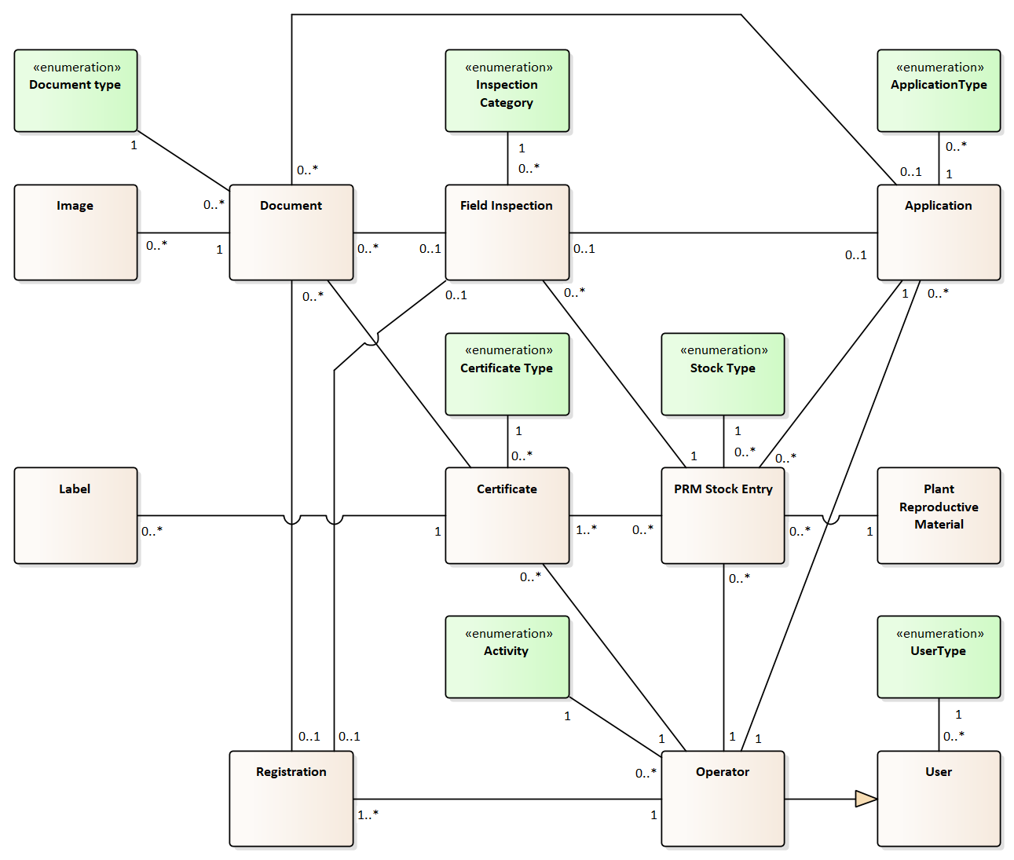

Functional Requirements
The Plant Reproductive Material Management System (PRMMS) is designed to ensure effective management of seed registration, certification, and inspection processes while enabling traceability and compliance with international standards. The following functional requirements detail the system’s core capabilities.
FR-PRMMS-001: Role-Based Registration and Permissions
The system must assign roles to operators and users (e.g., inspectors, administrators) based on their activities. Permissions must be tailored to role-specific tasks, ensuring secure data access and workflow segmentation. Operators must provide supporting documentation, such as trade licenses or facility details, during registration.
FR-PRMMS-002: Application Submission and Management
Operators must be able to submit structured applications for certification and inspections. Applications should support validation checks, attachments (e.g., contracts, declarations), and automated linking to operator profiles.
FR-PRMMS-003: Fee Payment Integration
The system must integrate with M-Pay to handle electronic payments for services (e.g., certifications, inspections). Payments should be linked to specific applications with automatic confirmation and payment status updates.
FR-PRMMS-004: Inspection Scheduling
The system must allow inspectors to schedule inspections based on predefined criteria, including application deadlines, compliance risk factors, and inspector availability. The system should generate reminders and notifications for scheduled inspections.
FR-PRMMS-005: Field Data Collection and Reporting
Inspectors must be able to record inspection data in real-time, including photographs, test results, and recommendations. Field data should sync with the central system when online and contribute to digital inspection reports.
FR-PRMMS-006: Certification Issuance
Based on inspection and laboratory results, the system must allow authorized personnel to issue certificates, such as the Seed Quality Certificate and ISTA Certificate. It must generate and store both certification and rejection documents.
FR-PRMMS-007: Certification Validity Management
The system must track the validity period of certifications and automatically notify operators of upcoming expirations. Operators must be able to request renewal or recertification within the system.
FR-PRMMS-008: Labeling and Packaging Management
The system must allow operators to submit labeling declarations and print labels for certified seed batches. Labels should comply with approved formats and contain traceability information, such as batch numbers and certification status.
FR-PRMMS-009: Batch-Level Certification and Traceability
Seed certification must be managed at the batch level, with each batch assigned a unique identifier. The system must link certification data to production, inspection, and distribution records, ensuring full traceability throughout the seed lifecycle.
FR-PRMMS-010: Non-Compliance and Suspension Management
The system must manage non-compliant batches, enabling inspectors to issue rejection reports and corrective action recommendations. Applications and batches under suspension must be clearly marked and tracked within the system.
FR-PRMMS-011: Centralized Seed Data Management
The system must maintain a centralized database of all seed-related data, including operator details, certifications, inspections, and compliance history. The database must support data retrieval through search, filtering, and reporting.
FR-PRMMS-012: Notification and Alert System
The system must notify users of key events, including application updates, inspection schedules, and certification decisions. Notifications should be sent via mNotify and support both email and SMS delivery.
FR-PRMMS-013: Reporting and Analytics
The system must generate statistical and operational reports, including metrics on registered operators, inspections, certifications, and compliance incidents. Reports must be exportable in formats such as PDF and Excel.
FR-PRMMS-014: Role-Based Access and Security
The system must implement secure, role-based access using mPass. Roles and permissions must control access to sensitive data and functions, ensuring compliance with security and privacy regulations.
FR-PRMMS-015: External System Integration
The system must integrate with external platforms, including e-ANSA, TRACES NT, and ePHYTO. It must support secure data exchange for applications, inspections, and certifications to ensure compliance with cross-border regulations.
FR-PRMMS-016: Multi-Language Support
The system must support Romanian as the primary interface language, with optional English and Russian interfaces for international stakeholders.
FR-PRMMS-017: Mobile and Offline Access
Field inspectors and operators must have access to a mobile-friendly interface with offline functionality. Data collected offline must sync with the central system upon reconnection.
FR-PRMMS-018: Audit Logs and Traceability
The system must maintain a complete audit log of all actions, including data changes, application submissions, and certification issuance. Logs must be accessible to authorized personnel for compliance monitoring and audits.
FR-PRMMS-019: Configurable Checklists for Field Inspections
The system shall allow administrators to define and manage configurable inspection checklists for plant reproductive material-related field inspections. Inspectors shall complete these checklists during on-site visits, with each filled checklist stored as part of the inspection record, as described in chapter 5.3. Checklist templates must support dynamic field types and version control.
FR-PRMMS-020: Laboratory Result Integration
The system must allow authorized laboratory personnel or inspectors to upload and manage laboratory analysis results (e.g., germination rate, purity, moisture content) associated with seed batches. These results must be linked to certification decisions and stored as part of the batch’s official record. The system shall ensure secure storage, traceability, and easy retrieval of uploaded results.
FR-PRMMS-021: Inspector Assignment and Load Balancing
The system must support administrator-driven or rule-based assignment of inspectors to certification and inspection applications. Assignment criteria should include workload balancing, geographic location, application deadlines, and inspector qualifications. The system should allow reassignment and generate alerts for potential bottlenecks or overdue inspections.

Non-Functional Requirements
The non-functional requirements for the Plant Reproductive Material Management System (PRMMS) define the system’s operational characteristics, ensuring efficiency, reliability, scalability, and compliance with regulatory standards.
NFR-PRMMS-001: Role-Based Access Control
The system must enforce fine-grained role-based access to PRMMS data and actions. Only authorized users (e.g., inspectors, administrators, lab personnel) may perform inspection, certification, or result entry actions. Permissions must be fully configurable by system administrators.
NFR-PRMMS-002: Mobile and Offline Support
The system must support mobile-friendly access for inspectors and allow offline data entry for inspections. Offline-collected data must synchronize automatically with the central server once connectivity is restored, without data loss or duplication.
NFR-PRMMS-003: Certification Accuracy and Validation
The system must validate all input data related to seed batch certification (e.g., test results, labeling data) before issuance. Certificates with missing or invalid data must be blocked from generation.
NFR-PRMMS-004: Real-Time Inspection Scheduling Feedback
Inspection scheduling actions must trigger immediate system feedback on potential conflicts (e.g., inspector unavailability, duplicate visits), and prevent assignment collisions.
NFR-PRMMS-005: Performance – Certificate Generation
The system must generate a certification document (e.g., Seed Quality Certificate, ISTA Certificate) within 3 seconds from the time of user submission, under normal usage conditions (up to 20 concurrent certification tasks).
NFR-PRMMS-006: Inspection and Lab Data Integrity
Data entered during inspections or lab result submission must be transactionally safe—no partial or broken records must be saved in the event of a failure during upload or form submission.
NFR-PRMMS-007: Batch-Level Traceability
The system must ensure that each certified seed batch is traceable across its lifecycle—from operator application, to inspection, to laboratory analysis and final certification—via a single, immutable batch identifier.
NFR-PRMMS-008: Notification Reliability
All critical notifications (e.g., inspection schedule, certification outcome, renewal reminders) must be logged and time-stamped, and the system must support retries for failed SMS/email dispatch through mNotify.
NFR-PRMMS-009: Language Support for Field Work
The mobile and web user interface for PRMMS modules must support Romanian (default) with optional toggling to Russian and English, especially for inspectors and operator-facing features (e.g., applications, reports).
NFR-PRMMS-010: Certification History Retention
All versions of issued certificates, including voided or revised ones, must be stored and retrievable for a minimum of 10 years to support compliance, dispute resolution, and audit purposes.

Phytosanitary Control System
The Phytosanitary Control System (PCS) is a critical module designed to manage the issuance and monitoring of phytosanitary certificates and plant passports, ensuring compliance with national and international regulations. It supports regulatory authorities, operators, and inspectors by digitizing key processes, enhancing traceability, and improving operational efficiency.
Core Functionalities
- Phytosanitary Certificate and Plant Passport Management:
  - Digitizes the application, review, and issuance of phytosanitary certificates and plant passports, ensuring compliance with legal and regulatory standards.
  - Tracks the status of issued certificates and passports, enabling traceability across the supply chain.
- Inspection and Monitoring:
  - Provides inspectors with tools to schedule and perform field inspections, record findings, and submit reports directly through the system.
  - Links inspection results to the certificate and plant passport issuance process, ensuring seamless integration of data.
- Traceability:
  - Maintains comprehensive records of issued phytosanitary certificates and plant passports, linking them to specific operators and applications.
  - Facilitates tracking of plant material movement, ensuring accountability and regulatory oversight across national and international borders.
- Integration with Systems:
  - Integrates with e-ANSA and cross-border platforms like TRACES and ePHYTO to ensure smooth data exchange and alignment with international trade standards.
  - Incorporates GIS tools for geospatial validation of operator facilities and inspection areas, improving accuracy and decision-making.
- Compliance and Reporting:
  - Monitors compliance with EU Plant Health Regulation 2016/2031, EU Official Control Regulation 2017/625 and their secondary legal acts and other international phytosanitary standards, generating detailed reports for stakeholders.
  - Enables quick identification of non-compliance issues, ensuring timely corrective actions including phytosanitary measures against introduction and spreading regulated pests.
Benefits
- Operators: Simplifies the process of applying for issuance of phytosanitary/pre-export certificates or plant passports or carrying out phytosanitary import controls and authorization to issue plant passports while providing real-time updates on the status of applications.
- Inspectors: Offers tools for efficient inspection scheduling, data collection, and integration with certification workflows.
- Regulatory Authorities: Enhances monitoring, reporting, and enforcement capabilities, supporting Moldova’s alignment with EU and international phytosanitary standards.

Relevant Business Processes

Phytosanitary certificate issuance
The Phytosanitary Certificate Issuance process ensures that plant materials - including seeds, planting material, and other regulated commodities - comply with international phytosanitary standards, particularly those required by importing countries and defined under EU legislation (e.g., Regulation (EU) 2016/2031).
This process includes multiple sequential steps such as application submission, risk-based inspection, laboratory testing (if required), verification of supporting documents, and issuance of the final phytosanitary certificate. In the case of re-export, additional validation of the original certificate and documentation from the previous export country is required.
The process is conducted under the supervision of ANSA and includes collaboration between operators, inspectors, and accredited laboratories. The entire workflow is digitally managed within the system to ensure traceability, interoperability (e.g. with TRACES NT), and compliance with both national and international phytosanitary regulations.
Pre-Conditions
- The operator must be registered in the system in order to export or re-export plant material for which a phytosanitary certificate is required.
- The operator must be registered in the system in order to export or re-export plant material for which a phytosanitary certificate is required.
- The consignment must meet all applicable phytosanitary requirements set by the destination country, including product-specific conditions (e.g., pest freedom, treatment, origin) as well as documentation compliance (e.g., import permit, pre-export certificate, or TRACES CHED-PP record).
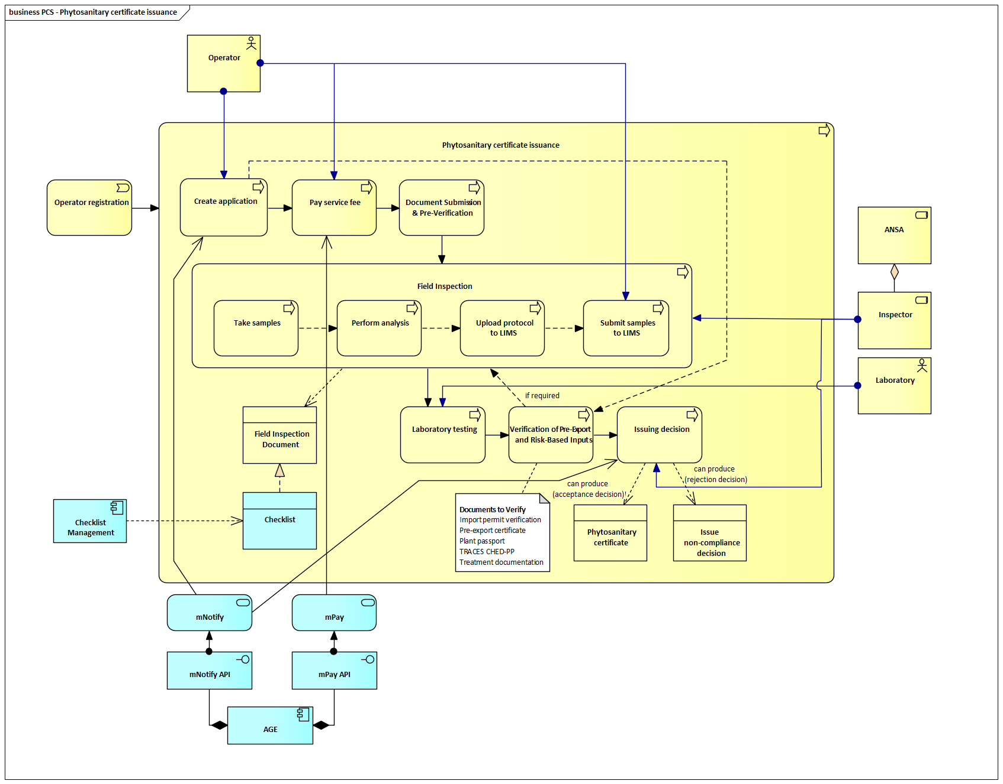
Steps in the Phytosanitary Certificate Issuance Process
1. Create Application
- The operator submits a digital application through the system for the issuance of a phytosanitary certificate.
- The application must specify whether it concerns an export or re-export and provide consignment details including product type, quantity, and destination.
- Upon submission, the system notifies the relevant ANSA inspector via mNotify and AGE.
2. Pay Service Fee
- The operator pays the required service fee using mPay, integrated via mPay API.
- The payment is linked to the application for traceability.
3. Document Submission & Pre-Verification
- The operator uploads all mandatory supporting documents, such as:
  - Import permit (if applicable)
  - Pre-export certificate (for re-export cases)
  - Plant passport (if required)
  - Original phytosanitary certificate (re-export)
  - Transport/treatment documentation
  - ISTA/OECD documentation (if required)
- Documents are verified for completeness by the system or inspector.
4. Field Inspection (if required)
- Triggered based on risk profile, product classification, or destination country.
- The inspection includes:
  - Sampling (if needed)
  - Use of a configurable checklist for inspection procedures (see section 5.5)
  - Completion of a Field Inspection Document
  - Protocol is uploaded to LIMS
5. Laboratory Testing (if required)
- Samples collected during inspection are submitted to an accredited lab.
- The lab performs diagnostic testing (based on risk/commodity type).
- Results are returned electronically through LIMS.
6. Verification of Pre-Export and Risk-Based Inputs
- Before final decision, the inspector/system verifies:
  - Validity of import permits
  - Pre-export certificates
  - Plant passport traceability
  - TRACES NT CHED-PP documentation (if applicable)
  - Treatment records and risk-based compliance
7. Issuing Decision
- Based on inspection findings, lab results, and document verification, the inspector issues:
  - Phytosanitary Certificate – if compliant (digitally signed and stored)
  - Non-Compliance Decision – if not compliant, including justification
- The decision triggers automatic notification to the operator via mNotify and is made available in the operator’s portal.

Phytosanitary Certificate Import Verification
The Phytosanitary Certificate Import Verification process ensures that regulated plant products imported into Moldova—such as seeds, planting material, fruits, vegetables, and other commodities—comply with national and international phytosanitary requirements. This process is especially important in light of Moldova's alignment with Regulation (EU) 2016/2031 and the national legal framework, including Law No. 422/2023 on Measures for the Protection against Harmful Organisms to Plants.
The process verifies the authenticity and validity of phytosanitary certificates issued by third countries, performs risk-based visual inspections and laboratory testing, and ensures that consignments are not contaminated with regulated pests. Based on inspection outcomes, ANSA inspectors make an official clearance or detention decision, and all steps are digitally recorded in the Phytosanitary Control System (PCS) for traceability.
Pre-Conditions
- Operator Registration:
The importer (operator) must be registered in RSF in order to import regulated plant products for which a phytosanitary certificate is required.
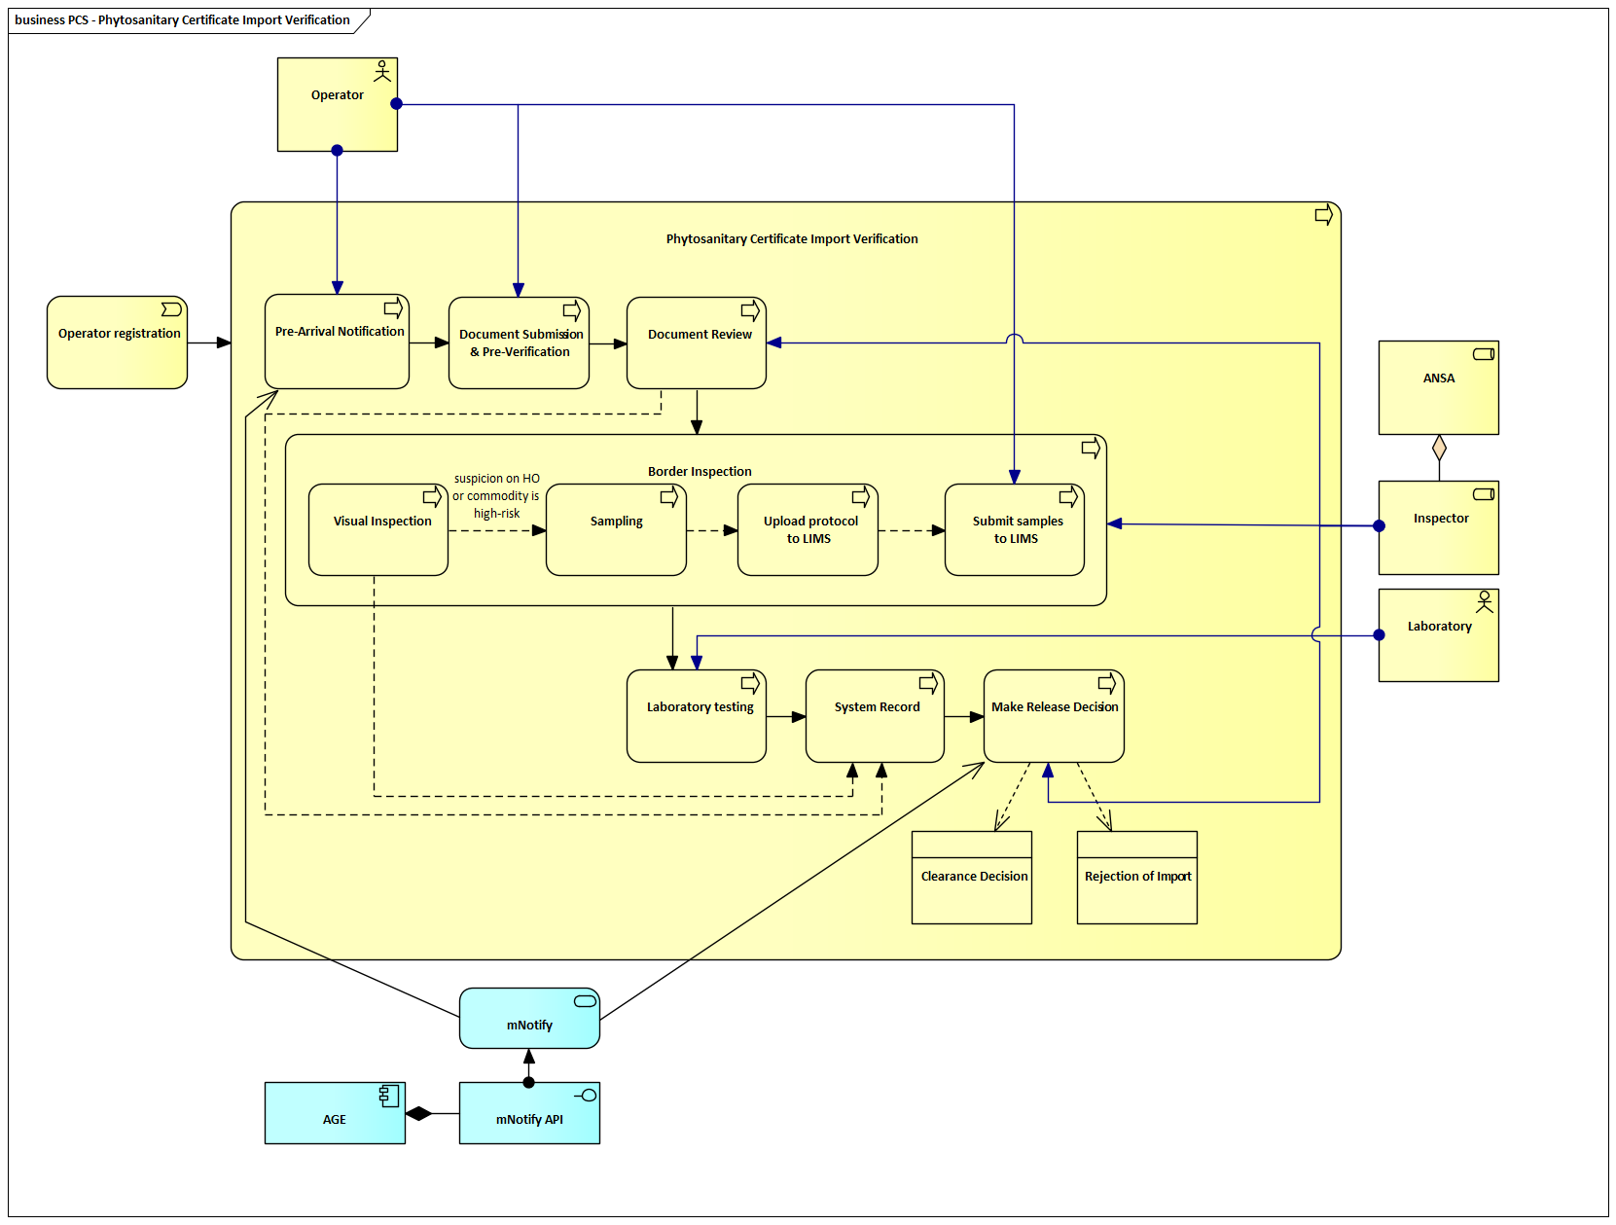
Steps in the Phytosanitary Certificate Import Verification
1. Pre-Arrival Notification
- The operator submits a pre-arrival notification for the incoming consignment using PCS or the e-ANSA platform.
- This includes declaration of goods, transport data, and operator identification (must be registered in the system).
2. Document Submission and Pre-Verification
- The operator attaches all required documentation:
  - Phytosanitary certificate from the country of origin
  - Invoice, packing list, and import permit (if applicable)
- The system verifies completeness and format.
3. Document Review
- An ANSA inspector reviews the documentation to check:
  - Authenticity of the certificate
  - Compliance with import conditions (e.g., pest-free declaration)
  - Presence of any risk indicators based on origin, commodity, or alerts
4. Visual Inspection at Border
- Border inspections are carried out based on legal requirements for specified commodity groups, as well as on a risk-based or random sampling basis.
  - Mandatory inspections apply to commodities designated by legislation.
  - Additional inspections may be triggered based on risk indicators (e.g., country of origin, pest alerts, or incomplete documentation).
- The inspector performs an on-site visual inspection of the goods.
- The inspection checks physical integrity, labeling, packaging, and visible signs of contamination or infestation.
5. Sampling (Conditional)
- If suspicion on harmful organisms exists, or the product is high-risk, samples are taken from the consignment.
- Sampling follows national and EU procedures for inspection and control.
6. Upload Protocol to LIMS
- The sampling protocol is uploaded into the Laboratory Information Management System (LIMS) through PCS.
- The protocol includes consignment ID, sample type, and test type required.
7. Submit Samples to Laboratory
- Physical samples are submitted to the Central Phytosanitary Laboratory.
8. Laboratory Testing
- The laboratory performs diagnostic tests on samples for specified pests or diseases.
- Results are recorded in LIMS and manually uploaded to the PCS system.
9. System Record
- The system logs all results, inspection outcomes, and actions taken.
- The operator profile, consignment ID, inspection report, and lab results are archived.
10. Make a Release Decision
- Based on documentation, inspection, and lab results, the inspector makes a decision:
  - Clearance Decision: if goods meet all phytosanitary requirements
  - Detention Decision: if non-compliance or contamination is detected

Authorisation to issue plant passports
Authorisation to Issue Plant Passports process grants operators the authority to independently issue plant passports for specific families, genera, or species of plants, plant products, and other regulated commodities, as defined in Regulation (EU) 2019/2072. Authorisation is granted only after the operator meets regulatory requirements for professional competence and inspection compliance. This process is crucial for ensuring that operators adhere to plant health standards and maintain traceability and compliance in the movement and trade of regulated items.
Pre-Conditions:
- The operator must be registered in the system.
- The operator must demonstrate the necessary competence and meet inspection standards for their facilities.
  - The professional knowledge and competence of the operator must be verified by the competent authority or an authorised body, using an appropriate method such as an examination, an interview, or other accepted forms of verification.
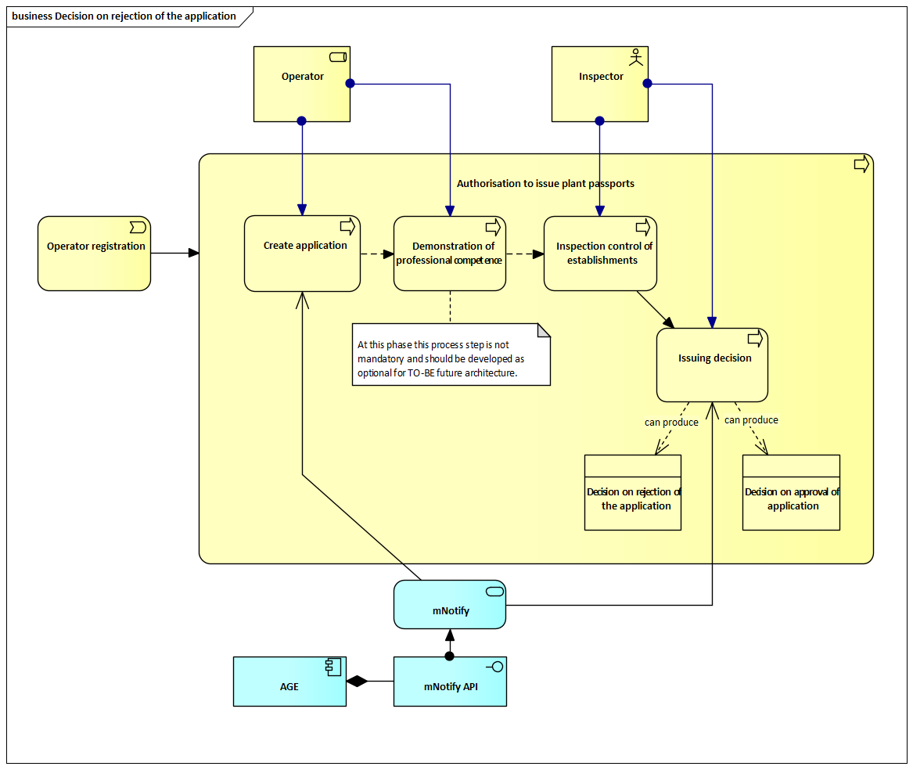
Steps in the Authorisation to Issue Plant Passports Process
1. Create Application
- The operator submits an application requesting authorisation to issue plant passports.
- The application includes details about the operator, facilities, and the intended scope of passport issuance.
2. Demonstration of Professional Competence (optional in current phase)
- The operator must provide evidence of professional competence. This competence must be verified by the competent authority or an authorised body using an appropriate method, such as an examination, interview, or other accepted form of verification.
- The system validates the submitted evidence of professional competence and documentation, and may initiate further inspections if required.
Note: At this phase, this process step is not mandatory and should be developed as optional for TO-BE future architecture.
3. Inspection Control of Establishments
- Inspectors conduct on-site inspections to verify the operator’s compliance with facility requirements, including infrastructure, processes, and staff competence.
- Inspection findings are documented and uploaded into the system, contributing to the decision-making process.
4. Issuing Decision
- Based on the inspection and evaluation results, the system allows authorised personnel to issue one of the following decisions:
  - Approval of Application – The operator is granted authorisation to issue plant passports.
  - Rejection of Application – The operator’s request is denied, and a rejection notice is generated outlining the reasons and corrective actions needed.
- The operator is notified of the outcome via mNotify and AGE infrastructure.

Authorisation and Supervision of Registered Operators Applying the Mark of Wood Packaging Material (WPM)
This section outlines the envisioned process and system readiness for managing authorisation and supervision of operators applying the mark for wood packaging material (WPM) in accordance with ISPM 15 and potential future requirements stemming from Moldova’s alignment with EU phytosanitary regulations.
This process is already implemented in the Republic of Moldova. ANSA maintains a register of operators authorised to apply the ISPM 15 mark on wood packaging materials and follows a specific procedure along with an informational guide regarding heat treatment chambers. Economic operators are also registered in the current State Phytosanitary Register (RSF) under the activity type defined in point 3.2.4. At present, there is no system-generated model of the authorisation issued through the information system.
Purpose and Scope
The process of authorising WPM operators ensures that only registered and competent entities are allowed to treat wood material and apply the internationally recognised ISPM 15 mark. This process is essential to prevent the spread of harmful organisms via wood packaging materials used in international trade, and to comply with EU and IPPC obligations.
This chapter anticipates the future inclusion of such a module in the Register State Phytosanitary (RSF) system, should Moldova proceed toward EU accession and legal harmonisation in this area.
Key Process Features (Modeled after Plant Passport Authorisation)
The authorisation process for WPM operators would follow a structure similar to the existing authorisation to issue plant passports, as described in section 4.3.1.3. The steps include:
- Operator Registration: The entity must be registered in the RSF as a treatment provider.
- Application for Authorisation: A formal request is submitted, including evidence of technical capacity, knowledge of ISPM 15 requirements, and proof of treatment infrastructure.
- Professional Competence Verification: Competence is verified by ANSA or a designated body through inspection, interview, or technical documentation review.
- Inspection of Facilities: An inspection confirms the availability and operational use of compliant treatment equipment (e.g. heat treatment chambers).
- Decision: ANSA issues a decision either granting or denying the authorisation. In the case of approval, the operator is added to the WPM register.
- Supervision: The system enables scheduling and documentation of regular supervisory inspections, non-compliance tracking, and potential suspension of authorisation.
System Requirements
The RSF system should be technically prepared to support the WPM authorisation and supervision process, even if it is not implemented in the current phase. This includes:
- Defining WPM as a distinct operator role within the operator registration entity.
- Utilizing the existing ISPM 15-specific checklist maintained by ANSA for WPM authorisation workflows.
- Enabling tagging of operators with “WPM Authorised” status and supporting traceability.
- Logging inspection history, corrective actions, and renewal decisions for supervisory oversight.
Future Considerations
The inclusion of this module is mandatory, as its provisions have been implemented following the harmonisation of Regulation (EU) 2016/2031 into Moldova’s national legislation.

Plant Passport Issuance by Operator
The Issuance of Plant Passports by Operators process defines the workflow through which authorized operators independently issue plant passports after successful examination, ensuring regulatory compliance, traceability, and alignment with national and EU standards. Only operators who are properly registered and have received formal authorisation may issue plant passports for specified families, genera, species of plants, and designated types of plant products and other regulated objects, as defined by relevant legislation.
Pre-Conditions:
- The operator must be registered in the system.
- The operator must have been granted authorisation to issue plant passports for specified families, genera, species of plants, or designated types of plant products and other regulated commodities, as defined in the applicable legislation.
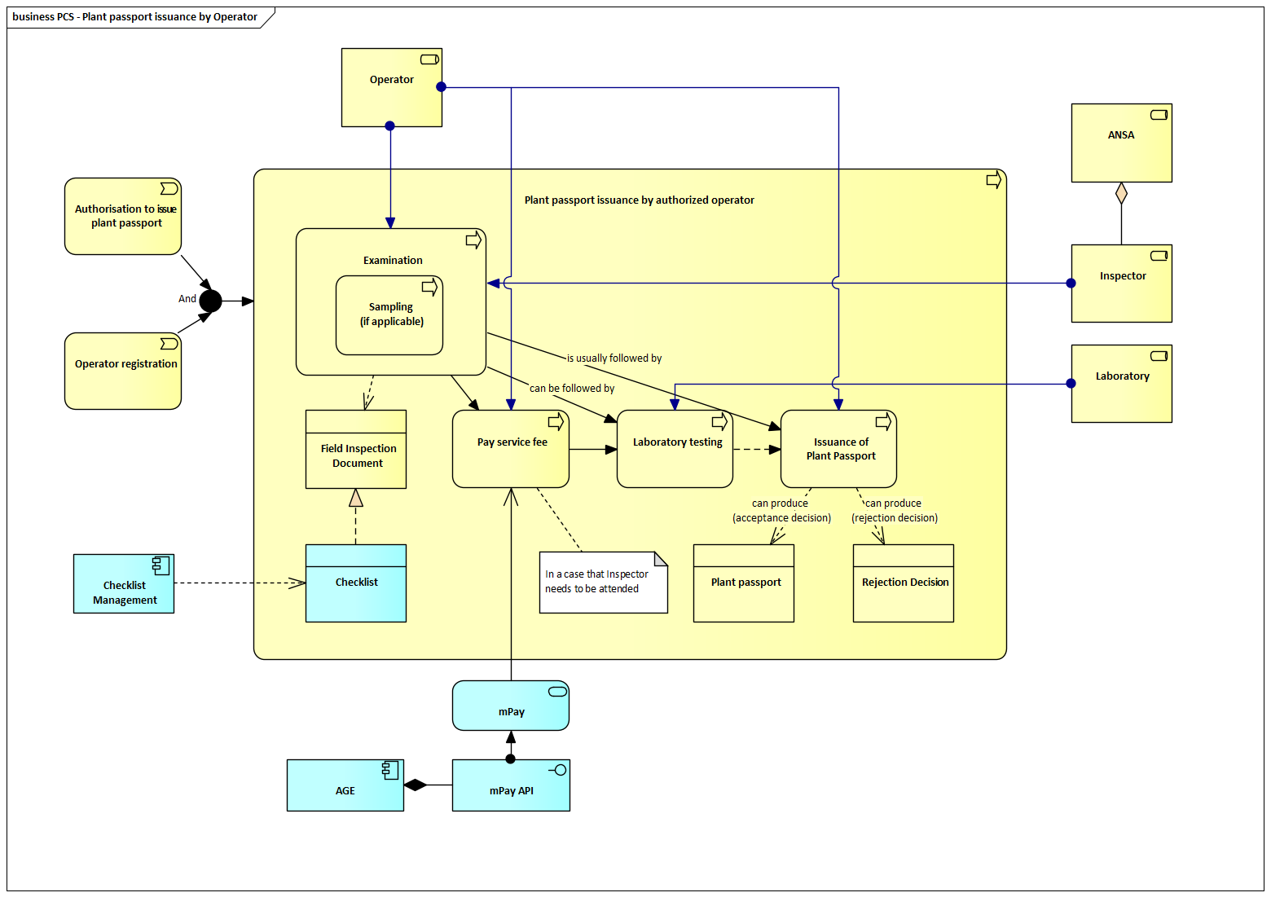
Steps in the Plant Passport Issuance by Authorized Operator
1. Conduct Examination (Field Inspection):
- The authorized operator must perform an examination (field inspection) of the plant, plant product or other object to verify compliance with phytosanitary requirements.
- The results of the examination are recorded in the system using a standardised examination document (Annex No. 8).
- Examination is a mandatory step for all plant passport issuance. In some cases (mandated by legislation), the examination shall be carried out by the competent authority (ANSA).
2. Sampling (if applicable):
- Sampling is conducted only if:
  - It is mandated by legislation for a specific plant–pest combination, or
  - There is a suspicion of a harmful organism detected during the visual examination (field inspection).
- Sampling is performed by the competent authority (e.g., ANSA inspector), and collected samples are sent for laboratory testing. If no sampling is required, the process proceeds directly to evaluation based on the visual examination (field inspection) outcome.
3. Pay Service Fee (if applicable):
- If the process requires the intervention of an ANSA inspector (e.g., for sampling or inspection), the operator must pay a service fee.
- The payment is handled via the national eGovernment system (mPay) and is automatically linked to the request.
4. Laboratory Testing (if applicable):
- If sampling is performed, the collected samples are sent to the laboratory for analysis.
- Laboratory testing verifies the presence or absence of harmful organisms.
- The results are recorded in the system and are used in the decision-making process. If no sampling is conducted, this step is skipped.
5. Issuance of Plant Passport
- Based on the visual examination (field inspection) and laboratory test results (if applicable), the system allows for two possible outcomes:
  - Issuance of Plant Passport – If the plant, plant product or other object meets the phytosanitary requirements, the authorized operator issues the plant passport and affixes it to the consignment, ensuring traceability.
  - Rejection Decision – If the crop does not meet the requirements, a Rejection Report (Annex No. 7) and a Rejection Decision are issued, stating the reasons for refusal.

Plant Passport Issuance by ANSA
In this process, the examination of the plant, plant product or other object is carried out exclusively by ANSA inspectors. ANSA also exclusively manages the final decision on the issuance or rejection of the plant passport.
The Plant Passport Issuance by ANSA process ensures that plant material complies with phytosanitary and regulatory standards before a plant passport is issued. The process includes the submission of an application by the operator, payment of a service fee, a mandatory visual examination (field inspection), optional sampling and laboratory testing if required, and the final decision leading to the issuance of a plant passport or a rejection.
Pre-Conditions:
- The operator must be registered in the State Phytosanitary Register.
- The operator must submit an official application to ANSA requesting the issuance of a plant passport.
- The operator must pay the applicable service fee as prescribed by the current tariff regulations.
- The plant material must undergo visual examination (field inspection), and if necessary, laboratory testing to confirm compliance with phytosanitary requirements.
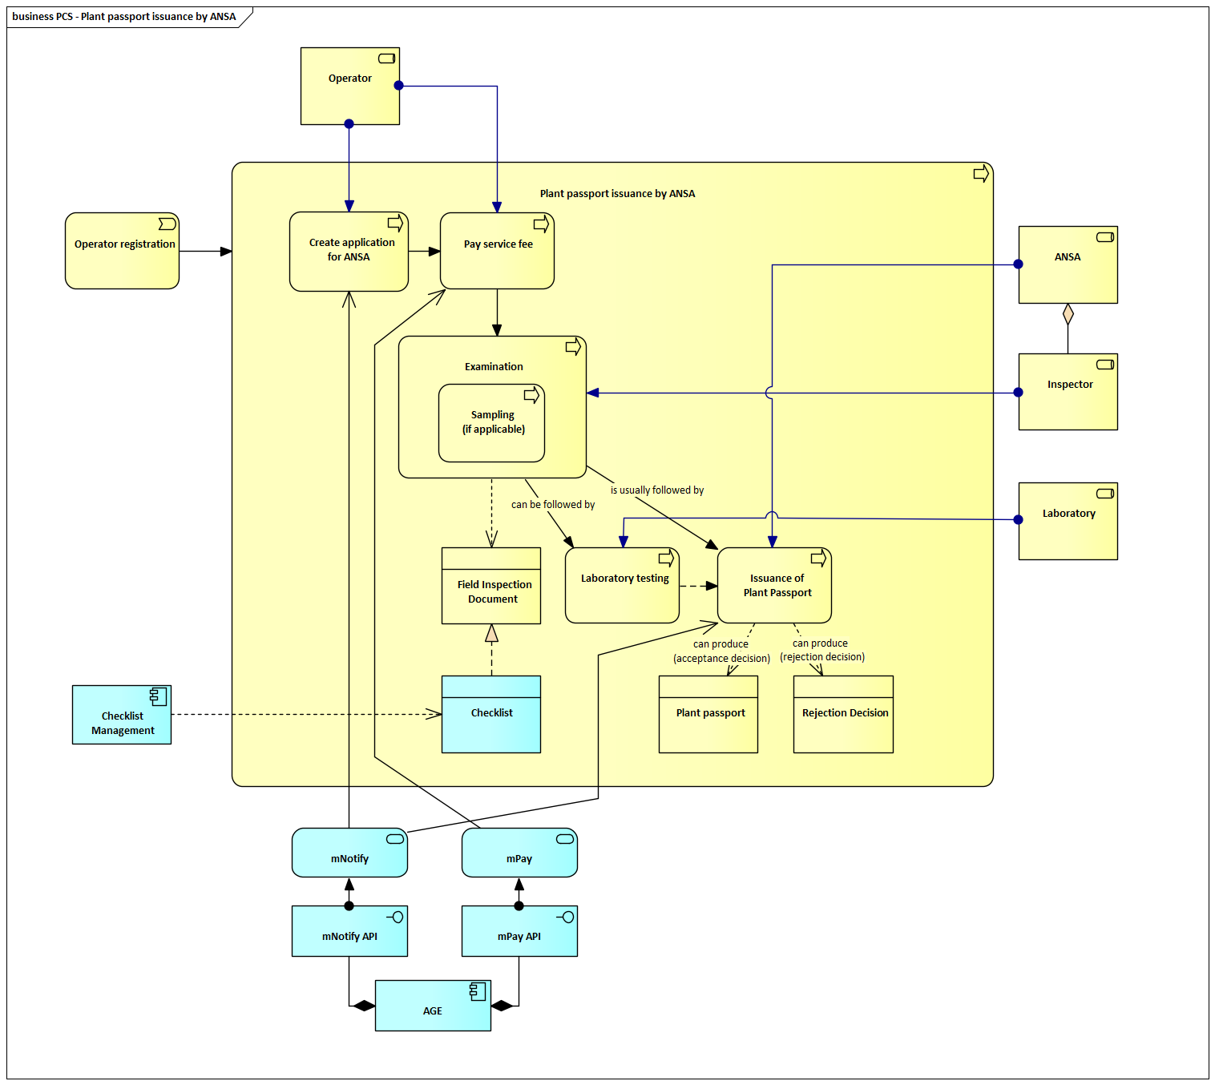
Steps in the Plant Passport Issuance by ANSA
1. Create Application
- The operator must submit an application to ANSA requesting the issuance of a plant passport for the relevant plants, plant products, or other objects. Submission of the application is a mandatory prerequisite for initiating the process.
2. Pay Service Fee
- Following the application submission, the operator must pay the applicable service fee according to the tariff structure defined by the competent authority. The inspection process cannot proceed until the payment is confirmed.
3. Conduct Examination (Field Inspection)
- ANSA inspectors perform an examination (field inspection) of the plant, plant product or other object to verify compliance with phytosanitary requirements.
- The findings are recorded in the system using the standardised Examination Document (Annex No. 8).
- Examination is mandatory for all plant passport issuance.
4. Sampling (if applicable)
- Sampling is conducted only if:
  - It is mandated by legislation for a specific plant–pest combination, or
  - There is a suspicion of a harmful organism detected during the visual examination (field inspection).
- Sampling is performed by ANSA inspectors, and collected samples are submitted to the laboratory for analysis. If no sampling is prescribed or needed, the process proceeds based on the visual examination (field inspection) outcome.
5. Laboratory Testing (if applicable)
- If sampling was performed, laboratory testing is conducted to determine the presence or absence of harmful organisms.
- Test results are recorded in the system and considered during the final decision process.
- If no sampling occurs, this step is skipped.
6. Issuance of Plant Passport or Rejection Decision
- Based on the field inspection and laboratory test results (if applicable), ANSA makes the final decision:
  - Issuance of Plant Passport – If compliant, a plant passport is issued.
  - Rejection Decision – If non-compliance is detected, a Rejection Report (Annex No. 7) and a formal Rejection Decision are issued, stating the reasons for refusal.
- The decision is recorded in the system and the operator is automatically notified via mNotify.

Architecture of the System
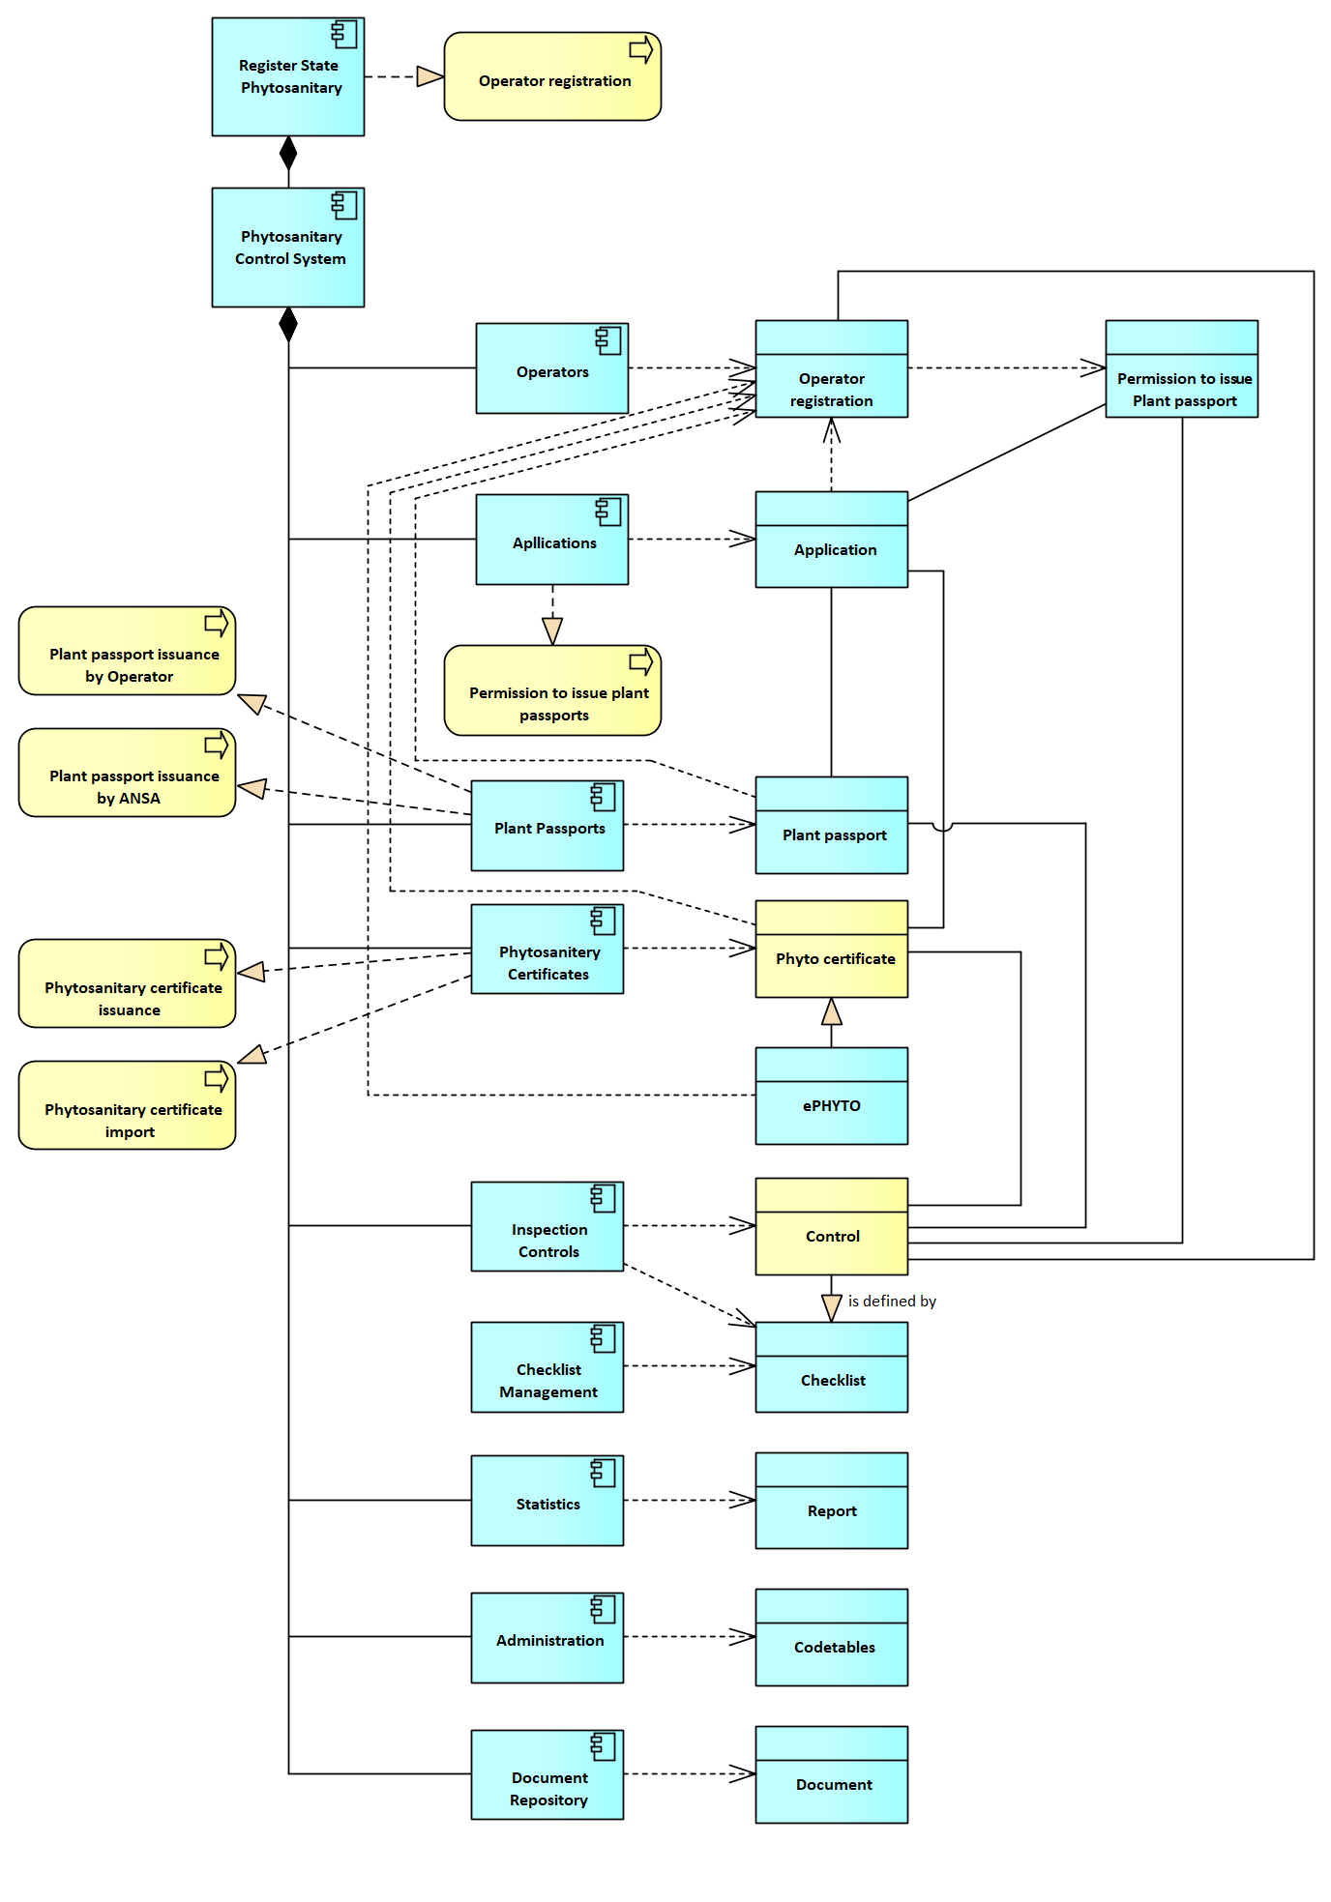

System Components and Related Data Objects
Register State Phytosanitary
The main information system that integrates modules such as operator management, applications, plant passport issuance, and phytosanitary certificates. It ensures comprehensive data management and compliance with national and international phytosanitary standards.
Phytosanitary Control System (PCS)
A module dedicated to managing processes like the issuance of plant passports, phytosanitary certificates, and the monitoring of controls.
Operators
Component for maintaining information about all registered operators engaged in phytosanitary activities.
Data Entities:
- Operator: Represents a registered entity such as exporters, importers, producers, traders and treatment service providers.
- Authorisation to Issue Plant Passport: Indicates whether an operator has been authorized by ANSA to issue plant passports.
Applications
Manages applications related to plant passports and phytosanitary certificates, supporting operators' formal requests for these services.
Data Entities:
- Application: Stores data on each application submitted by operators for phytosanitary certification or passport issuance.
Plant Passports
Component for recording all plant passports issued by either operator or ANSA.
Data Entities:
- Plant Passport: A document that ensures compliance with regulations and traceability within the domestic market.
- Phytosanitary Certificates
Stores information on certificates issued for the export of plant material and products.
Data Entities:
- Phytosanitary Certificate: Official documentation verifying compliance with export phytosanitary standards.
- ePHYTO: An electronic version of the phytosanitary certificate for integration with global trade platforms.
Controls
Handles all official controls made by ANSA on checks on compliance with the requirements laid down in legislation or regulations for the control of pests.
Data Entities:
- Control: Represents recorded inspections and audits, ensuring compliance with legislation, orders and regulatory standards.
Statistics
Provides analytical tools to generate reports on core data objects, aiding in operational and regulatory oversight.
Data Entities:
- Report: A structured output of summarized data for internal and external stakeholders.
Administration
Component responsible for system configuration, including managing code tables and documents.
Data Entities:
- CodeTables: Stores values for standardized classifications across system modules.
- Document: Digital files associated with processes, including supporting documentation for applications or inspections.

Components specific functions
F01: ListRecords – Displays all data records (e.g., operators, certificates, applications, plant passports, inspections) in a structured, sortable format.
F02: SearchRecords – Performs full-text search across all indexed fields to quickly retrieve relevant records, including consignment or certificate IDs.
F03: FilterRecords – Enables users to apply filters such as status, record type, date range, or operator to narrow the displayed dataset.
F04: ViewRecordDetails – Allows access to full details of a selected record, including linked documents, inspection results, certificate metadata, and related consignment info.
F05: CreateRecord – Enables users to initiate new entries such as applications for plant passports, phytosanitary certificates, or operator authorisation requests.
F06: SaveDraft – Allows in-progress applications or forms to be saved for later completion and submission.
F07: DuplicateRecord – Creates an editable copy of an existing record to simplify the creation of similar entries.
F08: UpdateRecord – Updates an existing record’s content (e.g., inspection notes, certificate data, status) while maintaining version tracking and audit history.
F09: PreIssuanceUpdate – Allows final review and data validation of an application or record before certificate or passport issuance.
F10: AddAttachment – Supports attaching documents such as inspection protocols, laboratory results, import permits, original phytosanitary certificates, and rejection reports.
F11: SubmitApplication – Submits applications for plant passport issuance, phytosanitary certification, or operator authorisation, initiating the corresponding administrative review process.
F12: AssignInspector – Assigns specific inspectors to applications or inspections based on product type, location, or workload balancing.
F13: GenerateInspectionReport – Automatically generates structured inspection reports (e.g., Annex No. 8) after field examination, including sampling notes and risk findings.
F14: ValidateDocuments – Performs validation of submitted documents, including authenticity checks for import permits, original phytosanitary certificates, and CHED-PP records.
F15: ApproveApplication – Grants regulatory approval for submitted applications once all preconditions and inspection requirements are met.
F16: IssuePhytosanitaryCertificate – Generates and issues export or re-export phytosanitary certificates upon completion of inspections and lab tests, and document validation.
F17: RevokePhytosanitaryCertificate – Revokes an issued certificate if non-compliance is later detected or original documentation is found invalid.
F18: IssuePlantPassport – Issues a plant passport either through ANSA or by an authorised operator, based on inspection and lab testing results.
F19: RevokePlantPassport – Revokes a previously issued plant passport if non-compliance is found or traceability is broken.
F20: NotifyOperator – Sends system notifications to operators regarding application status, inspection results, issuance decisions, or rejections.
F21: ExportData – Exports certificate, inspection, or passport data into standard formats (CSV, PDF, Excel) for reporting, archiving, or interoperability.

F22: DeleteRecord – Permanently removes a record from the system, subject to appropriate permissions and logging.
F23: MarkAsInvalid – Flags a record as invalid without deleting it, restricting further actions while retaining the data for auditing.
F24: ManageCertificateTemplates – Allows administrators to manage and edit certificate and passport templates (e.g., layout, fields, digital signature rules).
F25: MakeReleaseDecision – Enables inspectors to record a final clearance or detention decision following import verification, based on document, inspection, and lab results.
F26: CertifyOperatorPassportAuthorization – Supports the full operator authorisation process for issuing plant passports, including competence validation and facility inspection review.
F27: ConductOperatorInspection – Enables the scheduling, execution, and documentation of on-site inspections of operator facilities during authorisation assessment.
F28: RecordTestResults – Records or retrieves laboratory diagnostic results linked to sampling (e.g., pests, diseases), automatically returned from LIMS.
F29: IssueRejectionNotice – Issues structured rejection decisions (e.g., Rejection Report Annex No. 7) when a certificate or passport cannot be issued due to non-compliance.

Data Drafts (Entity Relationship Model)
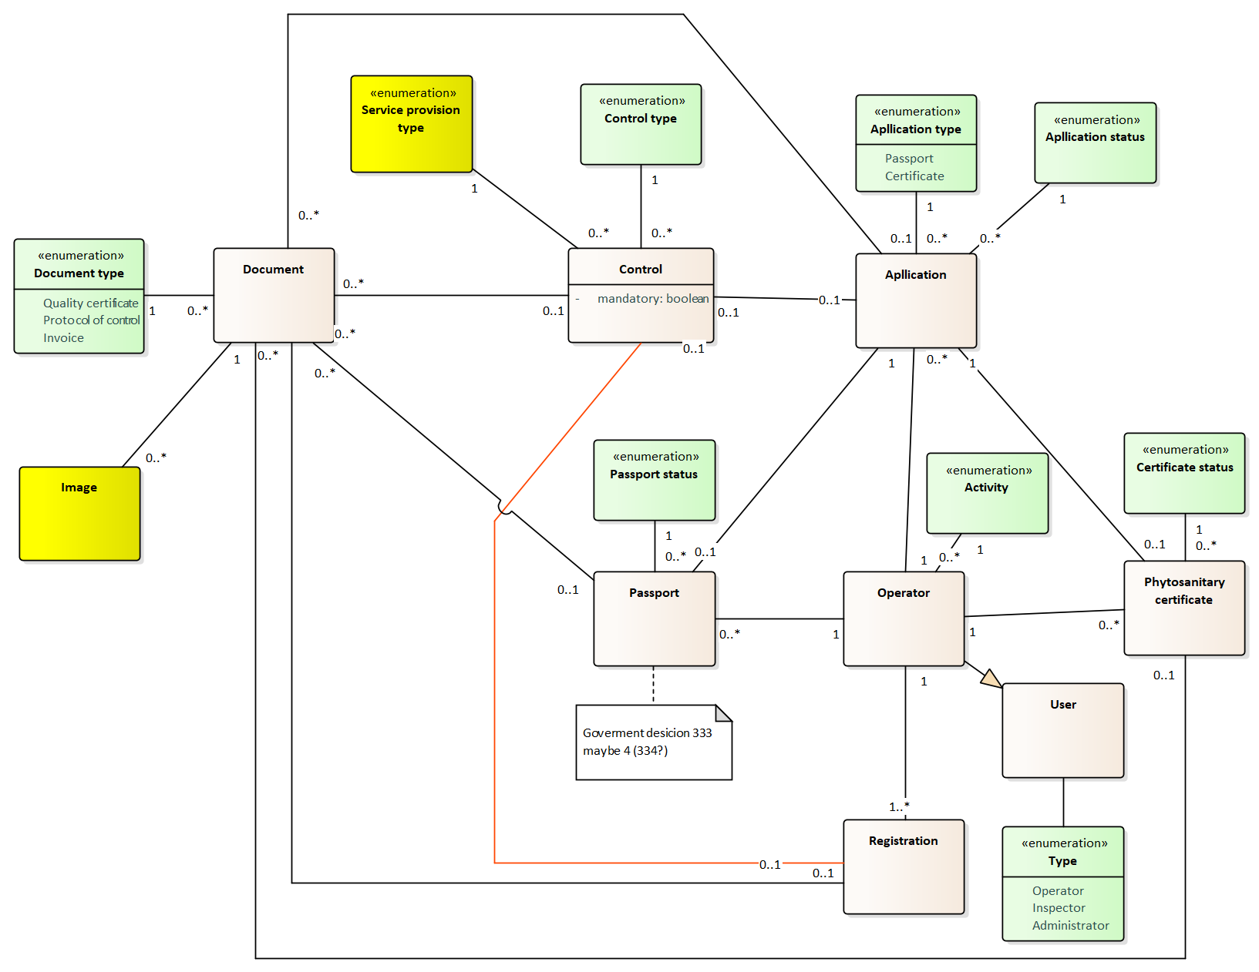

Functional Requirements
The Phytosanitary Control System (PCS) will facilitate critical processes for managing operator registrations, phytosanitary certificates, plant passports, inspections, and data reporting. The following detailed functional requirements outline the system's core capabilities.
FR-PCS-001: Operator Registration Process
The system must allow operators, including producers, exporters, importers, traders and service providers, to register through both online and offline channels. The registration process should collect data such as contact details, facility locations, and operational scope, validating the completeness of information before approval​.
FR-PCS-002: Role-Based Registration and Permissions
Operators must be categorized by roles, such as importers, exporters, producers, traders, and inspectors. The system must offer customized input fields, validation rules, and submission workflows tailored to each role. Permissions must restrict access to role-specific functionalities.
FR-PCS-003: Operator Validation and Inspection
Inspectors must validate operator details by conducting facility inspections. The system should provide tools to schedule inspections, capture findings digitally, and validate data, including location verification with GIS integration.
FR-PCS-004: Operator Data Updates
Operators must be able to update registration details such as addresses, operational scope, and roles. Critical changes should trigger re-validation workflows. The system must maintain an audit trail for compliance tracking.
FR-PCS-005: Certificate Issuance Workflow
The system must automate the issuance of phytosanitary certificates. Certificates must include a unique identifier, QR code, and batch details, linking directly to inspection results and laboratory data​.
FR-PCS-006: Multi-Language Certificate Support
Certificates must be issued in multiple languages, including Romanian, Russian, and English, with content dynamically translated while maintaining regulatory consistency​.
FR-PCS-007: Inspection-Driven Certificate Issuance
Phytosanitary certificates must be issued only after all inspections and laboratory analyses are completed. The system should integrate real-time compliance checks to prevent unauthorized issuance​.
FR-PCS-008: Plant Passport Issuance
The system must allow operators to request plant passports for intra-EU trade. Passports should include plant origin, batch details, and traceability codes. Administrators must be able to approve or reject requests​.
FR-PCS-009: Supply Chain Traceability
Plant passports must link to operator data, inspection records, and shipment details. The system must provide full traceability for plant materials across the supply chain to support regulatory compliance and outbreak management​.
FR-PCS-010: Inspection Scheduling
The system must support inspection scheduling based on risk analysis, including factors like operator type, compliance history, and product type. Notifications should be sent to both inspectors and operators.
FR-PCS-011: Digital Inspection Reports
Inspectors must be able to submit digital reports containing inspection notes, photos, and geospatial data. These reports should feed directly into certificate and compliance workflows​.
FR-PCS-012: Real-Time Field Updates
The system must allow real-time logging of inspection findings from mobile devices. Offline functionality must be provided for areas with limited connectivity, with automatic synchronization upon reconnection.
FR-PCS-013: Non-Compliance Management
The system must enable inspectors to flag non-compliant batches during inspections. Non-compliance workflows should include quarantine initiation, notifications to stakeholders, and corrective action submission​.
FR-PCS-014: Centralized Data Management
The system must maintain a centralized database for operator registrations, certificates, plant passports, and inspection records. It should support advanced search, data retrieval, and integration with external platforms like ePHYTO.
FR-PCS-015: Statistical Reporting and Analytics
The system must generate automated reports on key metrics, including inspections conducted, certificates issued, and compliance incidents. Reports must be exportable and accessible to authorized users​.
FR-PCS-016: Public Certificate Verification Portal
A public portal must enable stakeholders to verify the authenticity of phytosanitary certificates and plant passports. Search options should include certificate IDs, QR codes, and batch details​.
FR-PCS-017: User-Friendly Interface
The system must provide an intuitive interface tailored to operators, inspectors, and administrators. Dashboards should offer summarized views of key data with easy navigation​.
FR-PCS-018: Mobile-Responsive Design
The system must feature a mobile-friendly design to support inspectors and operators accessing system functions, including inspection scheduling and data submission, from mobile devices​
FR-PCS-019: Configurable Checklists for Field Inspections
The system shall implement support for configurable field inspection checklists, assignable to specific inspection types (e.g., border control, export certification). Administrators must be able to manage checklist templates, and inspectors shall complete them digitally as part of inspection workflows. Refer to chapter 5.3 for implementation details.
FR-PCS-020: Laboratory Result Management
The system must allow authorized laboratory personnel or inspectors to upload, store, and manage laboratory test results related to inspected plant products. These results must be linked to specific inspection records and used to support the issuance of phytosanitary certificates. Each result entry must include test type, date, result summary, and the associated batch or shipment identifier.

FR-PCS-021: Rejection and Reissuance of Certificates
The system must support workflows for rejecting, revising, and reissuing phytosanitary certificates. Authorized users must be able to void previously issued certificates in cases of post-inspection findings, errors, or non-compliance. Revised certificates must be issued with updated identifiers, while maintaining an audit trail of all previous versions and related justifications.

Non-Functional Requirements
The non-functional requirements outline the operational standards, architectural guidelines, and system attributes necessary to ensure the Phytosanitary Control System (PCS) performs effectively, securely, and reliably.
NFR-PCS-001: Role-Based Access Enforcement
The system must restrict PCS functionality based on predefined user roles (e.g., exporters, inspectors, border officers). Role permissions must be centrally configurable and enforced at both UI and API levels.
NFR-PCS-002: Performance – Certificate Issuance
Phytosanitary certificates must be generated within 5 seconds of approval submission under standard usage conditions (up to 30 concurrent operations), including QR code rendering and unique identifier generation.
NFR-PCS-003: Certificate Immutability
Once issued, phytosanitary certificates must be stored as immutable records. Any revision or reissuance must create a new certificate instance with updated identifiers, preserving the audit history of all prior versions.
NFR-PCS-004: Supply Chain Traceability Integrity
The system must maintain end-to-end traceability between plant passports, operators, shipments, and inspection records. At no point should decoupled or orphan data exist in the traceability chain.
NFR-PCS-005: Mobile Access with Offline Mode
Inspectors must be able to access PCS functionalities via mobile devices. For remote inspections, the system must support offline data entry and ensure full synchronization with the central database upon reconnection.
NFR-PCS-006: Multilingual Interface for Certificates
All PCS certificates and passports must support output in Romanian, Russian, and English. Language options must be selectable during generation and apply to both printed and digital versions.
NFR-PCS-007: Compliance Enforcement for Certificate Workflows
The system must block certificate issuance if mandatory steps—such as completed inspections or lab tests—are not fulfilled. Bypassing these validations must not be technically possible via the user interface or API.
NFR-PCS-008: GIS-Based Operator Verification
During initial operator validation, GIS-based facility mapping and location verification must be possible. The system must store geographic metadata and support visual confirmation through integrated maps.
NFR-PCS-009: Public Verification Portal Uptime
The public portal for verifying PCS certificates and plant passports must be available 99.5% of the time, excluding scheduled maintenance. Downtime events must be logged and reported to the administrator.
NFR-PCS-010: Legal Document Retention
All legally binding documents generated by PCS (e.g., inspection reports, issued certificates) must be retained for a period of at least 10 years, with clear versioning and access logging.

Plant Health Surveillance System

Business Structure of the System
The Plant Health Surveillance System (PHSS) is a core module of the national phytosanitary information infrastructure, focused on early detection, monitoring, and risk-based control of harmful organisms affecting plants and plant reproductive material. It supports the planning, execution, and evaluation of phytosanitary surveys in accordance with international and EU standards.
The system enables national and regional plant protection authorities to register and manage:
- Points of Interest (POI) for ongoing or seasonal monitoring,
- Surveys (quarantine or guideline-based),
- Field observations and sample collection,
- Occurrences and monitoring status of pests, and
- Linkage of collected data to methodologies and legal references.
Actors and Users
The primary users of the PHSS include:
- Inspectors conducting field surveys and recording observations,
- Survey coordinators managing national and regional survey plans,
- Specialized administrators maintaining methodologies, observation points, and survey types.
PHSS is designed to function as a supporting tool for operational surveillance, and may also contribute to compliance with reporting obligations under EU and international frameworks.
Legal and Strategic Basis
The system aligns with the requirements and structure defined in:
- Regulation (EU) 2016/2031 on protective measures against plant pests, and
- Commission Implementing Regulation (EU) 2019/1702, which defines the list of regulated pests and survey obligations.
The PHSS must be compatible with Moldova’s broader phytosanitary strategy and integrated into the Register State Phytosanitary (RSF) system.
Development Approach
The module shall be developed in accordance with the architecture, structure, and component logic already implemented in the Czech Republic under a similar system. While customization for Moldovan needs is expected, the component-level structure may be reused directly where applicable.
Only the components and application functions listed in the following architecture diagram (see Section 4.4.2) are required. The implementer must ensure these are fully developed, documented, and integrated as part of PHSS delivery.

Architecture of the System
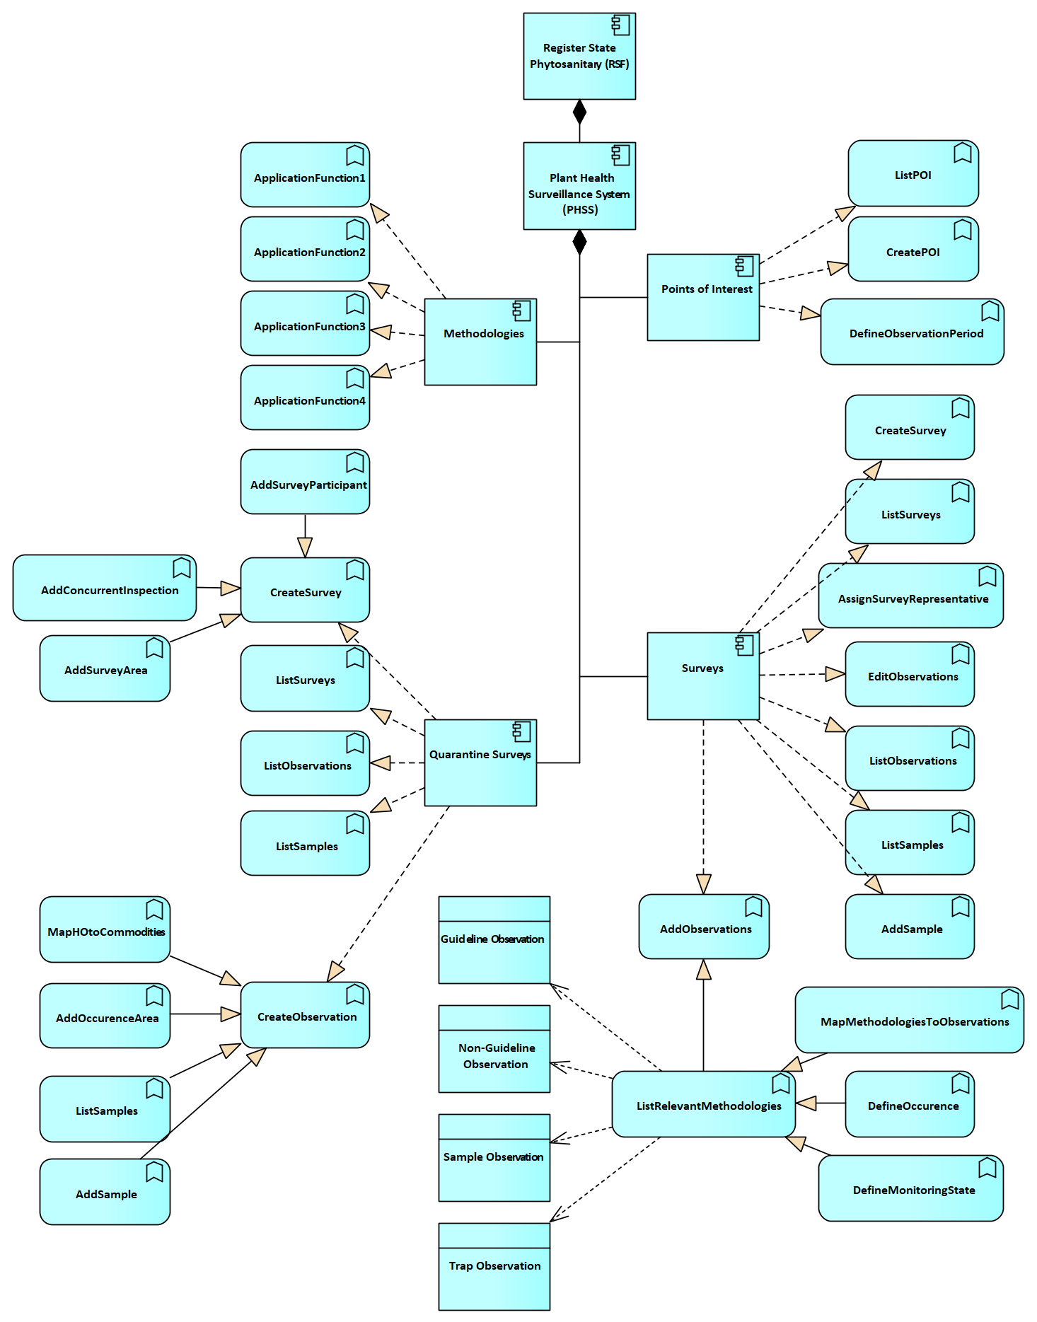

System Components and Related Data Objects
Register State Phytosanitary
The main information system that integrates modules such as operator management, applications, plant passport issuance, and phytosanitary certificates. It ensures comprehensive data management and compliance with national and international phytosanitary standards.
Plant Health Surveillance System
A core module responsible for monitoring harmful organisms through both general and quarantine surveys. It manages points of interest, methodologies, observations, and sample data to ensure effective surveillance and compliance with national and international plant health regulations. The PHSS supports traceability, reporting, and data integration across various monitoring activities to safeguard plant health.
General Monitoring
The central component responsible for managing both general and quarantine surveys aimed at monitoring harmful organisms. This component integrates all data entities related to surveys, points of interest, methodologies, and inspections to ensure effective surveillance.
Points of Interest
Component dedicated to managing locations where monitoring activities are conducted.
Data Entities:
- POI (Point of Interest): Represents a specific location (e.g., farms, warehouses, or natural habitats) where harmful organism observations are made.
- Observation Period: Defines the time frame for monitoring activities at a particular location.
Methodologies
Component for defining and managing standardized methods for observing harmful organisms.
Data Entities:
- Methodology: A set of predefined procedures and guidelines used to monitor, inspect, or sample harmful organisms at various points of interest.
Surveys
This component manages surveys aimed at monitoring harmful organisms under both general and regulatory contexts.
Data Entities:
- Survey: Represents a structured activity designed to monitor harmful organisms, including multiple locations and methodologies.
- SurveyRepresentative: An assigned representative responsible for managing and conducting the survey.
- Survey Participant: Represents individuals or organizations participating in the survey.
- Survey Area: Defines the geographical area covered by the survey.
- Observation: Records findings from survey activities.
- Sample: Physical specimens collected during surveys for laboratory analysis.
Quarantine Surveys
A specialized component for managing surveys targeting harmful organisms under quarantine conditions.
Data Entities:
- Quarantine Survey: Represents survey activities focused on harmful organisms subject to quarantine restrictions.
- Observation: Represents monitored data specific to quarantined organisms or regions.
- Concurrent Inspection: Overlapping inspection activities carried out alongside quarantine surveys.
Observation Management
A core component managing the documentation of observations made during both general and quarantine surveys.
Data Entities:
- Observation: Represents documented results of monitoring or observations, which may or may not include findings of harmful organisms, conducted during inspections or independent surveys, with or without the presence of an inspector.
- Occurrence Area: Defines the location and scope of an inspection or survey activity, which may or may not result in confirmed findings of harmful organisms.
Samples
Component responsible for managing biological or environmental samples collected during surveys.
Data Entities:
- Sample: Represents a collected specimen, such as plant material or insect traps, used for laboratory analysis.
Statistics
Component for generating reports and data analyses based on survey and observation information.
Data Entities:
- Report: Represents aggregated data generated from observations and surveys, such as compliance reports and statistical analyses.
Administration
Component responsible for maintaining the system’s structure, metadata, and reference values.
Data Entities:
- CodeTables: Stores standardized system codes, values, and metadata to ensure consistency across operations.
Document Repository
Component for storing and managing supporting documentation related to surveys and monitoring activities.
Data Entities:
- Document: A collection of relevant documents, such as methodologies, inspection reports, and observation records.

Components specific functions
F01: ListRecords – Displays all relevant data records (e.g., surveys, observation points, inspections, samples) in a structured format for navigation and review.
F02: SearchRecords – Allows full-text searches across observation and inspection records using keywords or IDs.
F03: FilterRecords – Filters displayed data based on crop, location, inspector, organism, date range, or survey status.
F04: ViewRecordDetails – Opens the full detail view for any selected record, showing linked surveys, observations, sample tracking, and inspection reports.
F05: CreateRecord – Allows users to initiate new records such as planned surveys, monitoring tasks, or quarantine inspections.
F06: SaveDraft – Enables partially completed survey or inspection records to be saved for later continuation and submission.
F07: DuplicateRecord – Copies an existing record into an editable draft, allowing for easier setup of similar surveys or inspections.
F08: UpdateRecord – Allows users to update and correct existing records while maintaining version control and audit history.
F09: PreIssuanceUpdate – Permits a final review and validation of key records (e.g., observation, inspection protocol) before they are finalized or issued for reporting.
F10: AddAttachment – Uploads documents and multimedia (e.g., photos of crop damage, protocols, field notes) to related records.
F11: CreateSurvey – Sets up new surveillance surveys, including scope (crop, area), objectives, risk level, and target organisms.
F12: AssignSurveyRepresentative – Assigns inspectors or field teams to conduct the survey based on geography and specialization.
F13: AddObservations – Allows real-time or post-survey addition of harmful organism findings (species, life stage, intensity, crop part affected).
F14: EditObservations – Updates or corrects existing observation entries if errors or refinements are needed.
F15: CreateObservation – Manually adds an independent observation entry (e.g., from alerts, border inspections, or citizen reporting).
F16: AddSample – Logs physical sample collection (e.g., leaves, soil, fruit) tied to a specific observation or inspection.
F17: ListSamples – Lists all collected and submitted samples, tracking status (pending, tested, confirmed) from LIMS.
F18: DefineObservationPeriod – Specifies the timeframe for survey activity or seasonal monitoring windows for pests and diseases.
F19: ListRelevantMethodologies – Displays applicable inspection and sampling methodologies based on crop, organism, and risk level.
F20: MapMethodologiesToObservations – Links selected methodologies to active observations, ensuring harmonized inspection and reporting standards.
F21: DefineOccurrence – Allows entry of metrics like infestation frequency, severity, crop loss estimate, and geographic extent for each harmful organism.
F22: AddConcurrentInspection – Adds inspection data conducted in parallel with a survey (e.g., border inspection overlapping with planned field monitoring).
F23: InspectionReporting – Generates formatted inspection reports summarizing organism presence, risk status, inspector remarks, and follow-up actions.
F24: ScheduleDynamicSurvey – Configures dynamically triggered surveys based on external alerts (EUROPHYT, EPPO, ePHYTO), real-time risk changes, or seasonal thresholds.
F25: MarkAsValidated – Marks records as verified after expert review or automated validation criteria are met (e.g., confirmed pest ID, completed protocol).
F26: ExportData – Exports selected datasets (surveys, observations, samples, reports) for reporting, regulatory submission, or data exchange (e.g., TRACES NT, EPPO, EUROPHYT).

Data Drafts (Entity Relationship Model)
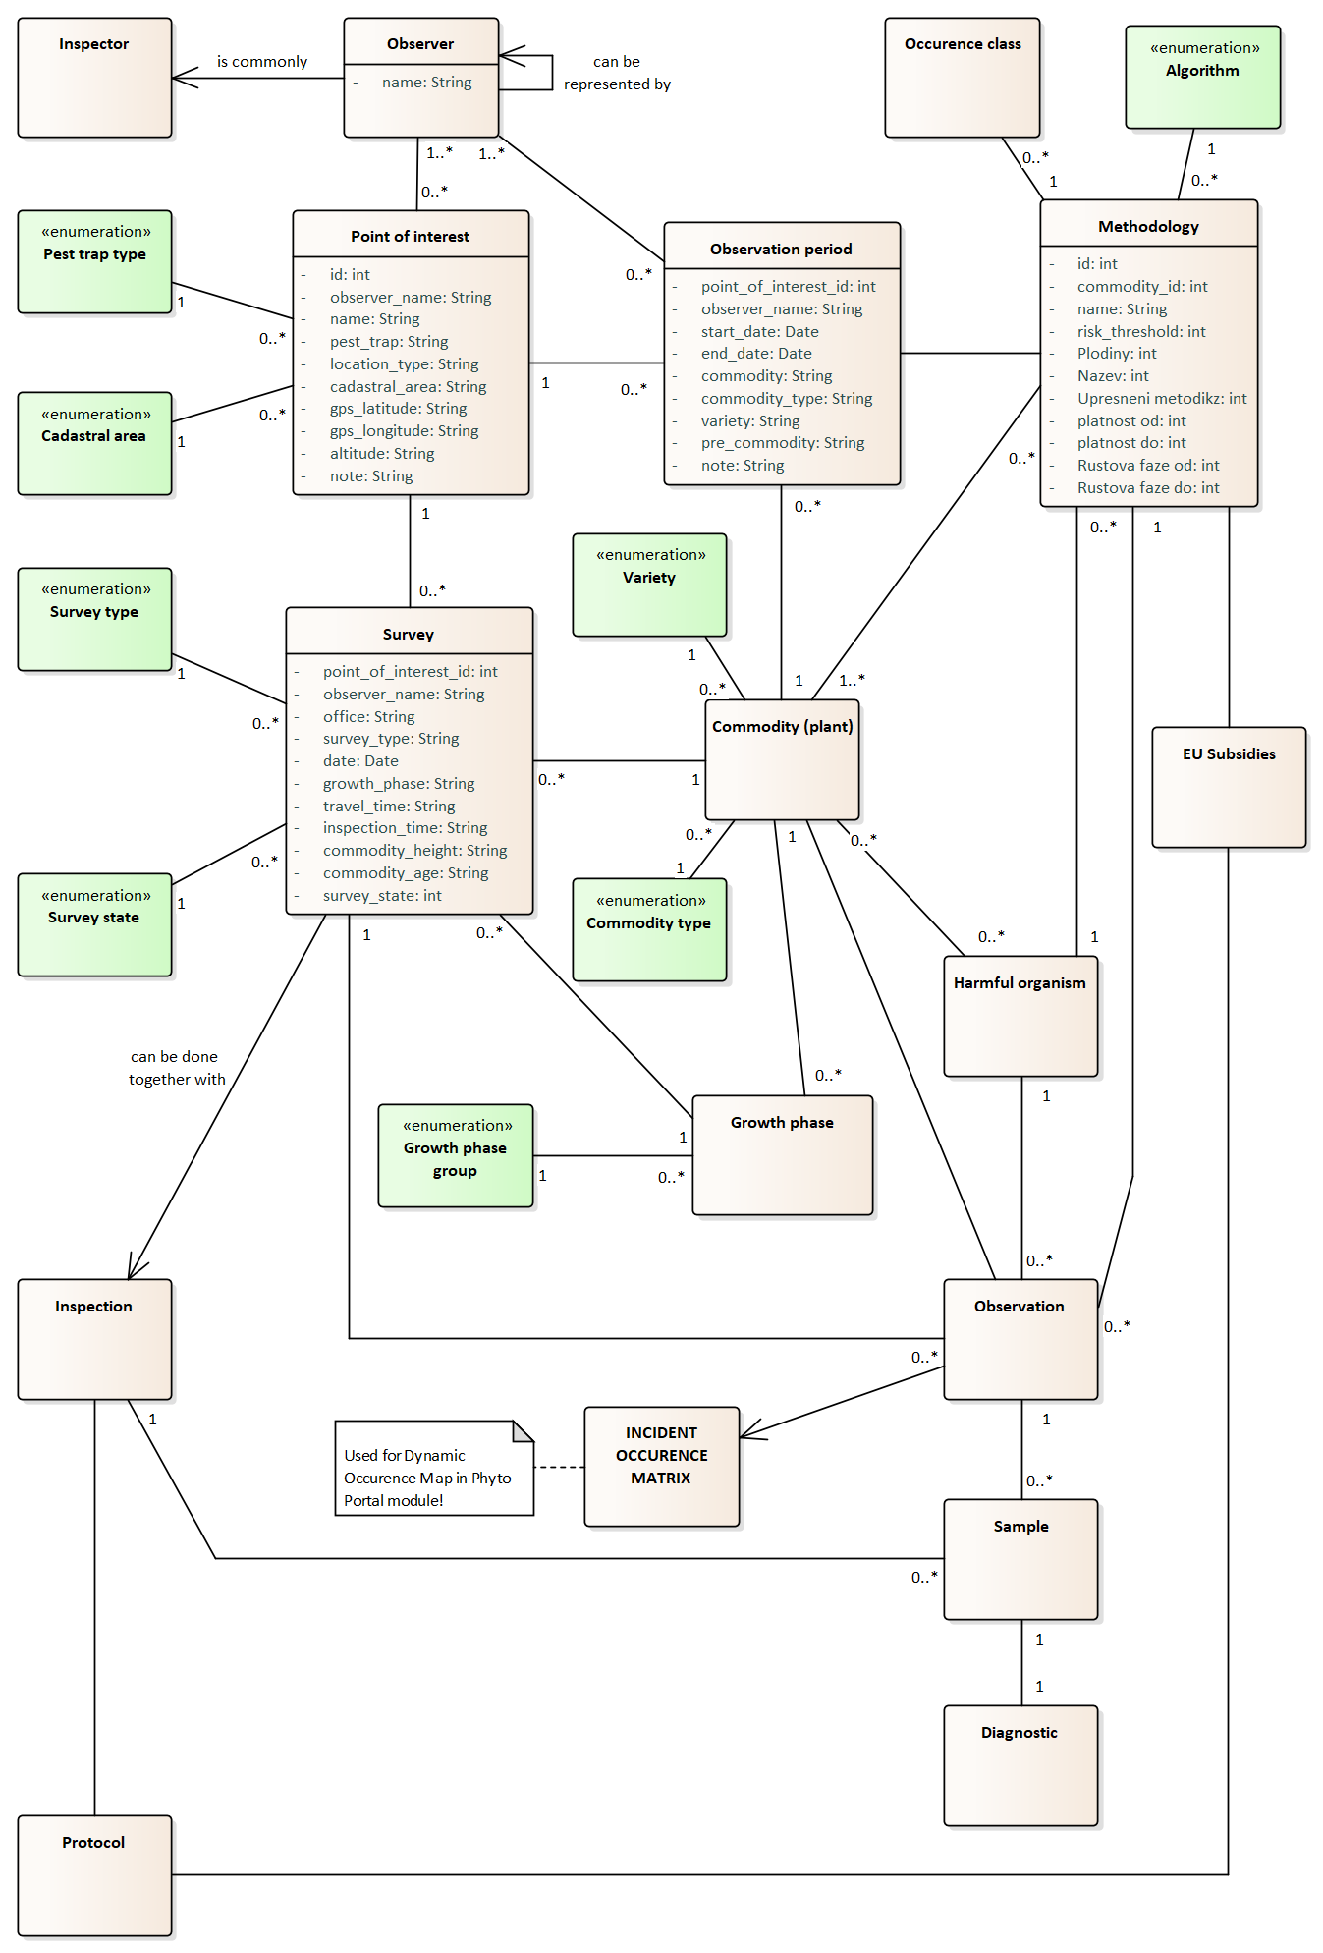

Functional Requirements
The Plant Health Surveillance System (PHSS) supports plant monitoring through standardized surveys, inspections, and dynamic methodologies. It ensures accurate data collection, traceability, incident management, and compliance reporting, enabling timely interventions and informed decision-making aligned with regulatory standards.
FR-PHSS-001: Observation Point Definition
The system must define observation points with attributes such as country, city, GPS coordinates, altitude, cadastral area, and crop details including EPPO codes. Each observation point must have a valid date scope (FROM/TO). Observation points remain valid over time, even when different crops rotate at the same location. The system must allow the definition of multiple crops per observation point within different time periods. Inspectors and representatives must be assignable to observation points for survey management.
FR-PHSS-002: Observation Point Validation
Observation points must be strictly validated to prevent data inconsistencies. Each point can monitor only one crop and must have a unique date range. Modifications to crop or timeframe require creating a new point. Surveys and inspections are restricted to the defined observation period and point attributes.
FR-PHSS-003: Observation Traps Management
The system must associate predefined traps (e.g., light traps) with observation points. Trap types must be configurable and linked to the relevant crop and location. The system must support both real-time and historical analysis of trap data to monitor harmful organism occurrences.
FR-PHSS-004: Survey Creation and Management
The system must enable creation and management of surveys linked to observation points or manually entered locations. Surveys must capture attributes such as crop, growth phase, survey type (normal/quarantine), and assigned inspectors. Surveys must also record operational details, including survey date, travel time, inspection time, and subsidy eligibility.
FR-PHSS-005: Growth Phase Enforcement
The system must enforce the selection of valid growth phases (e.g., BBCH scale) for monitored crops. Growth phases influence observation types and methodologies applicable to the survey.
FR-PHSS-006: Observation Management
Surveys must allow multiple observations, each tied to a specific harmful organism. Observations must capture intensity levels, protective measures, and first-time occurrence flags. Observations must adhere to predefined methodology rules and support dynamic creation during active surveys. Inspectors can pause or suspend surveys with documented reasons.
FR-PHSS-007: Methodology Matrix
The system must implement a methodology matrix defining valid combinations of crops, growth phases, harmful organisms, and observation periods. Observations must adhere to the combinations in the matrix. The matrix must support dynamic updates to accommodate new crops, organisms, or methodologies.
FR-PHSS-008: Methodology Compliance Enforcement
Observations must be validated against the methodology matrix, preventing unauthorized data entry. The system must enforce adherence to the matrix, blocking non-compliant observations and ensuring alignment with standards.
FR-PHSS-009: Quarantine Surveys
The system must support quarantine surveys with flexible observation entry for complex scenarios. Manual observation entry is allowed when no predefined methodology applies. Quarantine surveys must track concurrent activities to prevent subsidy misuse and provide detailed reporting on affected areas, crops, and organisms.
FR-PHSS-010: Survey Time Tracking
The system must track travel and inspection time for each survey. For long-term monitoring surveys at observation points, inspectors must be able to pause or stop surveys, documenting reasons for interruptions. However, for quarantine surveys, which are typically completed within a single day, only the total time spent must be recorded for reporting purposes. This data supports subsidy validation and compliance reporting.
FR-PHSS-011: Inspection Creation
The system must allow inspections to be managed independently from surveys, capturing critical details such as assigned inspector, inspection date, and subsidy status. Inspections must accommodate multiple crops and harmful organisms, with clear differentiation from surveys for compliance tracking.
FR-PHSS-012: Inspection Subsidy Management
The system must validate and track subsidy eligibility for inspections linked to subsidized activities. Unrelated concurrent inspections must automatically disable subsidy claims to prevent misuse. Subsidy-related data must be recorded for audits.
FR-PHSS-013: Inspection Reporting
The system must generate inspection reports summarizing findings, protective measures, and monitored organisms. Reports must distinguish between subsidized and non-subsidized activities for compliance and regulatory submissions.
FR-PHSS-014: Sample Collection
The system must link samples to observations, capturing sample type, purpose, attributes (e.g., weight, symptoms), and collection date. Samples must be traceable from collection to laboratory analysis. Integration with diagnostic labs is required for efficient result processing.
FR-PHSS-015: Sample Diagnostics
Diagnostic results must link to the associated sample and observation, capturing laboratory findings and test methods. Results must update related data and the incident occurrence matrix in real-time.
FR-PHSS-016: Incident and Protective Measures Management
The system must support the detection and classification of phytosanitary incidents, integrating diagnostics and monitoring data. High-risk or first-time detections must trigger real-time alerts. An Incident Occurrence Matrix must link harmful organisms to host plants, locations, and severity levels to support risk assessment, prioritisation, and automated notifications.
FR-PHSS-017: Emergency Phytosanitary Measures Tracking
The system must support the recording, management, and traceability of officially declared emergency phytosanitary measures, which are imposed to contain or eradicate harmful organisms.
Authorised users must be able to:
- Record whether an emergency measure has been issued (yes/no toggle).
- Enter the date and issuing authority.
- Specify the affected species, commodities, locations, and legal references.
- Link the measure to a specific incident, inspection, or bulletin.
- Upload official documentation.
- Track status (active, revoked, replaced, expired).
These measures must be linkable to inspection workflows and searchable across the PHSS. The system must be designed to meet current national practices and allow expansion to support Regulation (EU) 2016/2031 requirements in future phases.
FR-PHSS-018: Centralized Data Archiving
The system must archive survey, inspection, observation, and diagnostic data to support compliance and audit requirements. Archived data must be accessible for reporting and predictive analytics.
FR-PHSS-019: Role-Based Permissions and Substitute Management
The system must define role-based access permissions for user roles (e.g., inspectors, observers). Substitute inspectors must be assignable to take over active tasks when necessary, ensuring continuity of monitoring activities.
FR-PHSS-020: Configurable Checklists for Field Inspections
The system shall provide dynamic checklist functionality for recording structured data during harmful organism monitoring and surveillance activities. Administrators must configure the checklists for different crops and pest types. Filled checklists must be attached to inspection events and support the format and requirements described in chapter 5.3.

Non-Functional Requirements
The following non-functional requirements apply specifically to the Plant Health Surveillance System (PHSS) module. These are based on confirmed project needs and exclude speculative or overly generic technical assumptions. Only essential, stakeholder-relevant requirements have been retained.
NFR-PHSS-001: Role-Based Data Access
The system must enforce access permissions based on user roles (e.g., inspector, lab staff, admin). Observations, inspections, and samples must be editable or viewable only by authorized users. Substitution logic must preserve traceability of actions by delegated inspectors.
NFR-PHSS-002: Long-Term Observation Data Retention
The system must retain all survey, observation, inspection, and diagnostic records for at least 15 years. Data must remain queryable for longitudinal analysis and compliance audits.
NFR-PHSS-003: Mobile and Offline Inspection Capability
The system must support field access via mobile devices. When connectivity is unavailable, inspectors must be able to perform all critical operations offline, including observations and trap readings. Data must automatically sync upon reconnection.
NFR-PHSS-004: Methodology Matrix Enforcement
Observation and diagnostic data must comply with the latest active Methodology Matrix. The system must prevent submissions that violate defined organism–crop–growth phase combinations unless part of a quarantine survey.

NFR-PHSS-005: Real-Time Incident Escalation
When high-risk or first-time harmful organism detections occur, the system must generate real-time alerts to designated authorities. These alerts must be issued within 60 seconds of data submission and recorded in the Incident Occurrence Matrix.
NFR-PHSS-006: GPS Accuracy for Observation Points
The system must store GPS coordinates for observation points with a minimum precision of ±10 meters. Field staff must be able to view and verify mapped locations against cadastral references.
NFR-PHSS-007: Sample Lifecycle Traceability
Each collected sample must be uniquely identifiable and traceable from the moment of collection through diagnostic lab results and final survey closure. Each sample record must log every status update with timestamp and user ID.
NFR-PHSS-008: Configurable Checklists Enforcement
All inspection and observation events must use administrator-defined checklists, with version control and audit logs for each submitted form. Changes to checklist templates must not retroactively alter past records.
NFR-PHSS-009: Subsidy Eligibility Validation
Survey and inspection workflows must enforce subsidy eligibility rules. If conflicting or concurrent activities are logged, subsidy claims must be automatically suspended until manually resolved by an authorized supervisor.

Phytosanitary Portal

Business Structure of the System
Phytosanitary Portal is a public-facing module of the national phytosanitary information system, providing a centralized access point to official information, documents, and services related to plant health, seed certification, and phytosanitary regulation. It supports transparency, user self-service, and regulatory communication in alignment with both national and EU legal frameworks.
The portal serves as a digital gateway for public and professional users, offering structured content related to legal documents, public registers, pest notifications, plant variety information, and export requirements. It also supports selective dynamic services, such as verification of certificate authenticity, searching for registered operators or laboratories, and guidance for plant passport requirements.
The system enables the National Food Safety Agency (ANSA) and relevant authorities to publish and manage:
- Phytosanitary and seed-related legislation and procedures,
- Public registries of operators, laboratories, and certified material,
- Guides and sample forms for applications and inspections,
- Pest alerts, plant passport rules, and export/import procedures,
- Verification tools for certificate validity and laboratory accreditation, and
- Integration with other modules (e.g., NCV, PCS) for public data display.
Actors and Users
The primary users of the Phytosanitary Portal include:
- Operators (e.g., seed producers, nurseries, exporters) accessing legal requirements and document templates,
- Inspectors and ANSA staff publishing notices, alerts, and forms,
- General public (e.g., farmers, traders, researchers) seeking access to registers, alerts, and documents,
- Customs authorities and importers verifying certificate numbers and quarantine information.
Legal and Strategic Basis
The system aligns with the requirements and strategic framework defined in:
- Law No. 142/2018 on Interoperability and Data Exchange,
- Law No. 68/2013 on Seeds,
- Law No. 422/2023 on protective measures against harmful organisms to plants (transposing Regulation (EU) 2016/2031),
- Commission Implementing Regulation (EU) 2017/2313 on plant passport format and public information obligations.
The portal also contributes to Moldova’s transparency and EU integration strategy by providing multilingual, public access to structured data and supporting risk communication.
Development Approach
The module shall be developed in accordance with the architecture, structure, and component logic already implemented in the Czech Republic under the PhytoPortal system. While localized content and integration for Moldovan use will be required, the design structure, publishing logic, and interface model shall be reused directly where feasible.
This includes:
- A public Content Management System (CMS) with multilingual support,
- Dynamic document viewers and filtering interfaces,
- Certificate and register verification tools,
- Role-based publishing workflows for inspectors and administrators.
Only the components and application functions listed in the following architecture diagram (see Section 4.5.2) are required. The implementer must ensure these are fully developed, documented, and integrated as part of the Phytosanitary Portal delivery.
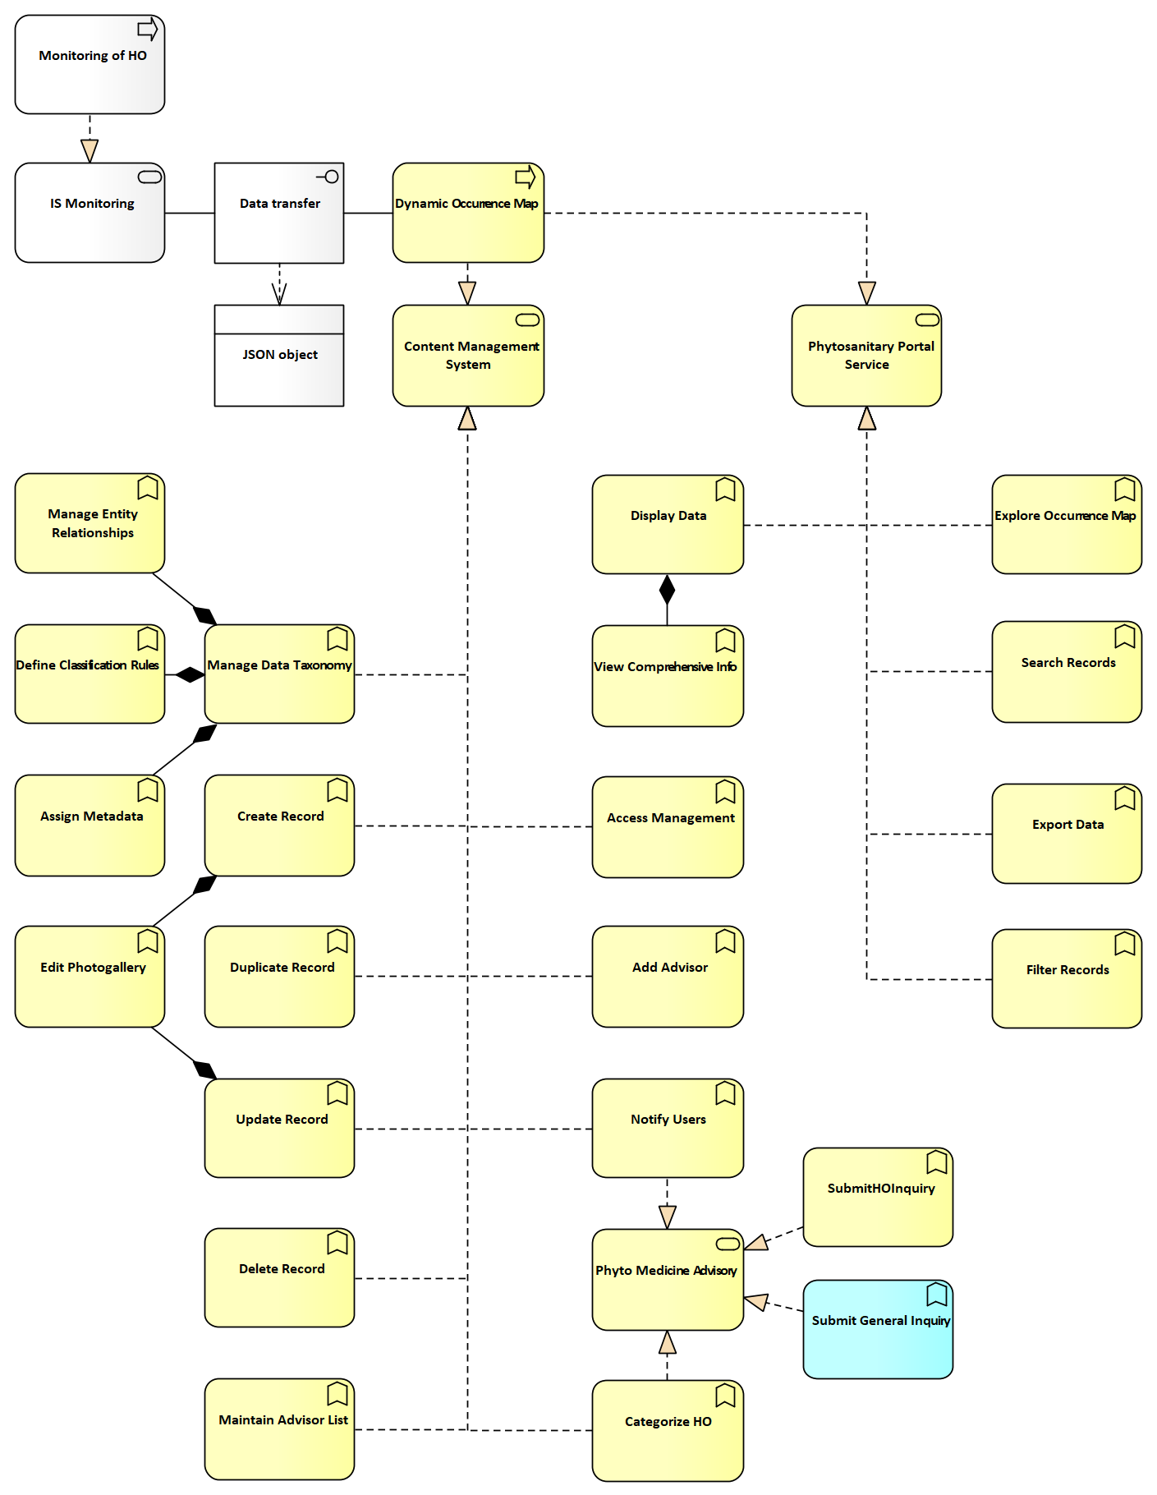

Services specific functions
F03 ManageEntityRelationships - Allows users to define and manage entity relationships within the system, including hierarchical definitions.
F04 DefineClassificationRules - Establishes rules for classifying and organizing data.
F05 ManageDataTaxonomy - Supports the creation, update, and organization of taxonomy-related data.
F06 AssignMetadata - Assigns metadata to records for enhanced search and categorization.
F07 CreateRecord - Creates new records, including taxonomy entries and metadata assignments.
F08 UpdateRecord - Updates existing records within the portal.
F09 DuplicateRecord - Duplicates records for faster data entry.
F10 DeleteRecord - Permanently removes records from the portal.
F11 EditPhotogallery - Manages and updates photographic content associated with records.
F12 MaintainAdvisorList - Keeps an updated list of advisors for phytosanitary actions.
F13 CategorizeEU - Supports the categorization of records under EU standards.
F14 CategorizeHO - Categorizes records related to the Health of Organisms.
F15 SubmitGeneralInquiry - Allows operators (e.g., farmers) to send general inquiries about phytosanitary matters or processes.
F16 SubmitHOInquiry - Enables operators to send specific inquiries about the presence or impact of Health of Organisms (HO) on their fields or crops.
F16 DisplayData - Presents data in a structured and user-friendly format.
F17 ViewComprehensiveInfo - Provides a detailed view of individual records, including their associated data and metadata.
F18 Explore Occurrence Map - Allows users to interact with dynamic occurrence maps.
F19 SearchRecords - Performs a full-text search across all relevant columns to quickly locate specific entries.
F20 FilterRecords - Applies user-defined filters to narrow down search results.
F21 ExportData - Exports selected data in various formats for external use.
F22 AccessManagement - Manages user permissions and access to specific portal functions.
F23 NotifyUsers - Sends notifications related to record updates, inspections, or advisories.

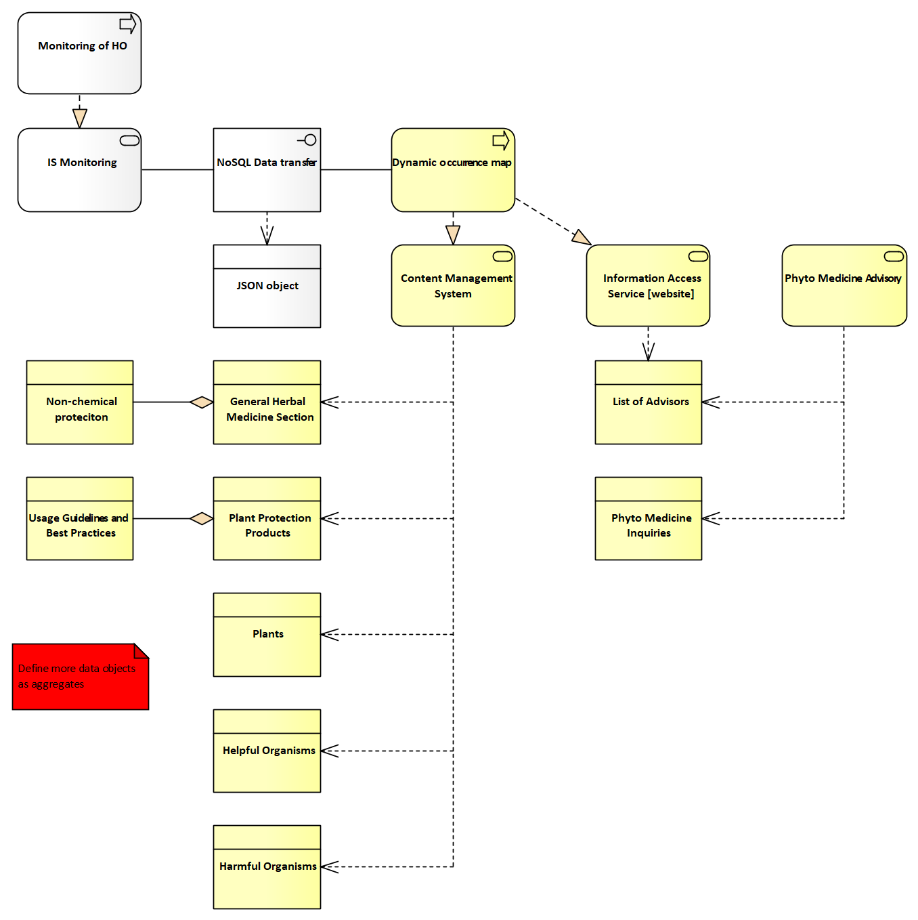

Architecture of the System
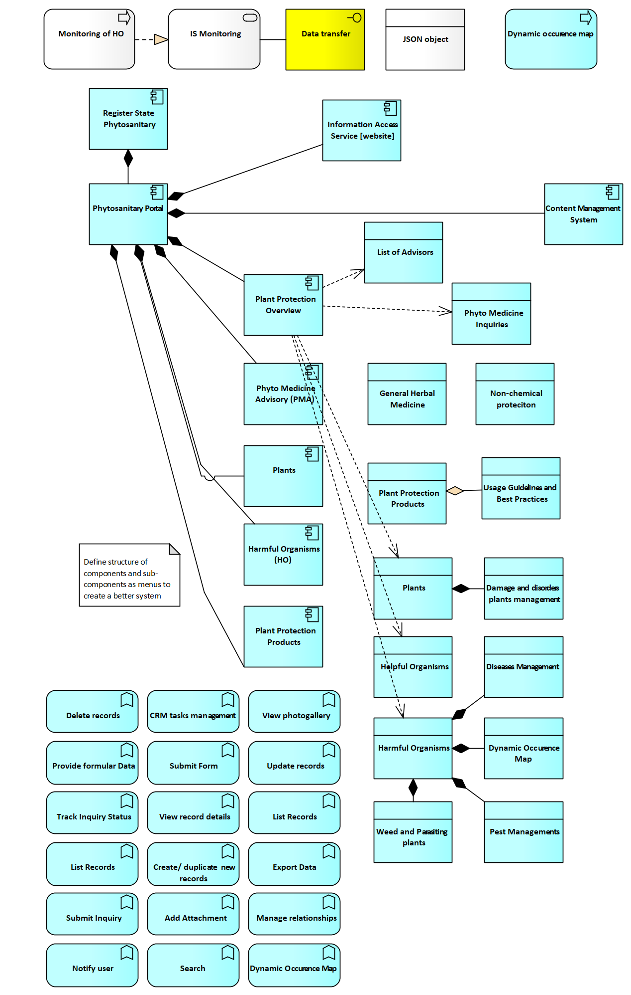

Components specific functions
F01: ManageEntityRelationships – Allows users to define and manage hierarchical or relational links between different types of records (e.g., organism types, crop categories, regional risks).
F02: DefineClassificationRules – Enables the configuration of classification schemes (e.g., by organism risk, crop type, EU regulation references) to organize published data logically.
F03: ManageDataTaxonomy – Supports structured creation and management of taxonomy-related records including crops, pests, zones, and observation types.
F04: AssignMetadata – Applies standardized metadata to records (e.g., date, source, format, language) to support advanced search and categorization.
F05: CreateRecord – Enables creation of structured records for publication in the portal, including reference content, advisories, regulations, and taxonomy elements.
F06: UpdateRecord – Edits or updates existing portal records while retaining historical versions where necessary.
F07: DuplicateRecord – Duplicates existing records to expedite data entry of similar content (e.g., related organism alerts or knowledge entries).
F08: DeleteRecord – Removes portal records from the system, subject to access rights and audit constraints.
F09: EditPhotogallery – Adds, updates, or deletes visual documentation associated with a record (e.g., pest life stages, crop damage examples).
F10: MaintainAdvisorList – Manages the list of certified advisors or experts available for user inquiries or phytosanitary advice.
F11: CategorizeEU – Assigns EU classification codes to organisms or content (e.g., quarantine pest categories, regulated zones, EU Decision references).
F12: CategorizeHO – Tags content related to harmful organisms, allowing risk-based filtering and alerting within the portal.
F13: SubmitGeneralInquiry – Allows farmers, operators, or the public to submit general questions about phytosanitary procedures or topics.
F14: SubmitHOInquiry – Captures specific inquiries related to harmful organism symptoms or threats observed in crops or regions.
F15: DisplayData – Presents structured and filtered content in table or card format, enabling browsing by pest, crop, region, or classification.
F16: ViewComprehensiveInfo – Opens the full content view of a selected record, displaying associated metadata, relationships, and related inquiries.
F17: ExploreOccurrenceMap – Displays dynamic occurrence maps based on survey and monitoring data (sourced from PHSS), visualized geographically.
F18: SearchRecords – Performs full-text search across all portal records using keywords, tags, or metadata attributes.
F19: FilterRecords – Applies filtering based on organism, risk level, date, region, or taxonomy to refine portal search results.
F20: ExportData – Allows users to export selected records in CSV, Excel, or PDF format for offline reference or integration with local tools.
F21: AccessManagement – Manages role-based access to portal editing, taxonomy maintenance, and inquiry response workflows.
F22: NotifyUsers – Sends alerts to users regarding new publications, classification changes, updated organism status, or inquiry responses.
F23: HighlightRegulatoryChanges – Flags new or changed phytosanitary legislation, EU decisions, or national procedures relevant to pests or crops.
F24: DisplayKnowledgeArticles – Presents static or dynamic educational content such as pest prevention guidelines, EU phytosanitary directives, or visual pest ID tools.
Components and Functions Matrix
The Components and Functions Matrix provides a comprehensive overview of the functionality offered by each component of the system. It highlights which functions are supported by specific components, ensuring clarity in system capabilities and user interactions.
Functions / Components | General Herbal Medicine | Phyto Medicine Advisory | Harmful Organisms | Plants | Plant Protection Products | Beneficial Organisms
F01 List Records | yes | no | yes | yes | yes | yes
F02 Search Records | yes | no | yes | yes | yes | yes
F03 Filter Records | yes | no | yes | yes | yes | yes
F04 View Record Details | yes | no | yes | yes | yes | yes
F05 Create New Records | yes | no | yes | yes | yes | yes
F06 Duplicate Record | yes | no | yes | yes | yes | yes
F07 Update Existing Records | yes | no | yes | yes | yes | yes
F08 Delete Records | yes | no | yes | yes | yes | yes
F09 Mark as Invalid | yes | yes | yes | yes | yes | yes
F10 Manage Records Relationships | yes | yes | yes | yes | yes | yes
F11 CRM Task Management | yes | yes | yes | yes | yes | yes
F12 Submit Inquiry | no | yes | no | no | no | no
F13 Track Inquiry Status | no | yes | no | no | no | no
F14 Add Attachment | no | yes | yes | yes | yes | yes
F15 Export Data | yes | no | yes | yes | yes | yes
F16 View Photogalleries | yes | no | yes | yes | yes | yes
F17 Notify User/Operator | yes | yes | yes | yes | yes | yes
F18 Monitor Occurrences | yes | no | yes | yes | no | no
F19 Localize Occurrence | no | no | yes | yes | no | no

Data Drafts (Entity Relationship Model)
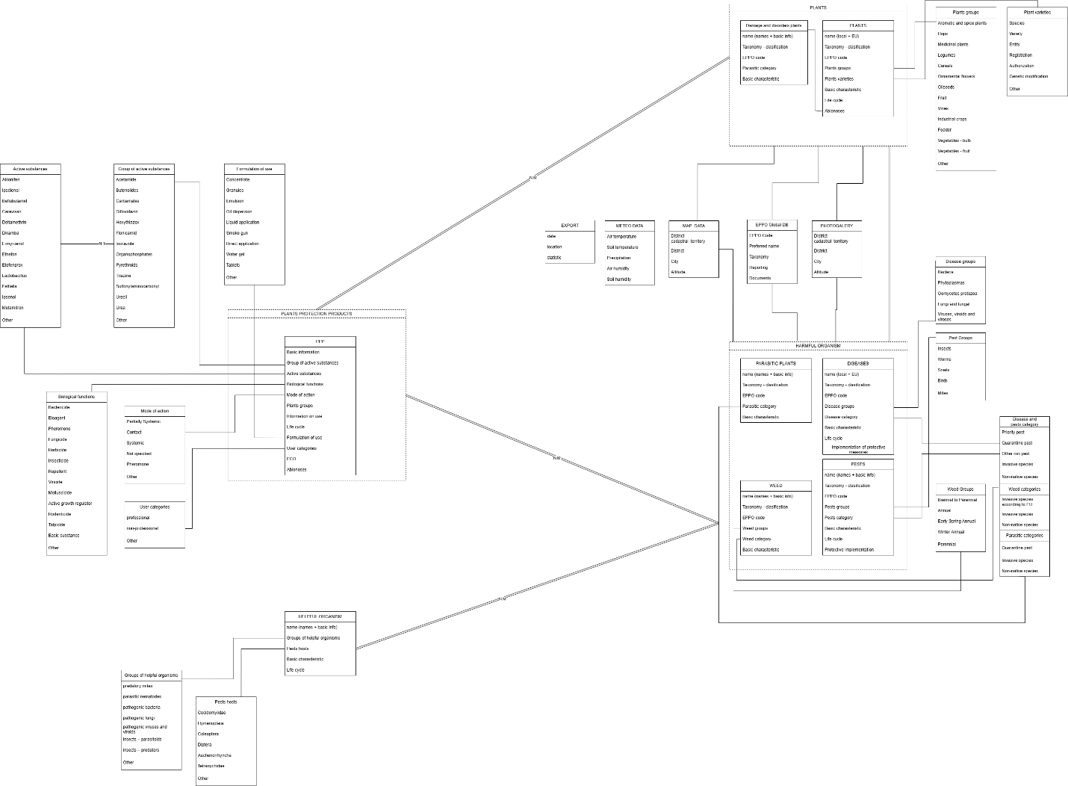
This section provides an overview of the core entities in the system, summarizing their key attributes and relationships, offering a general understanding of their roles within the domain.
1. Plants
Attributes:
Plants are characterized by their taxonomy, including group, family, and species classifications, along with lifecycle data and basic characteristics. Additional attributes include associated disorders and damages caused by pests or diseases, EPPO codes for compliance, and categorization into plant groups such as ornamental plants, industrial crops, vegetables, and fruits.
Relationships:
Plants are linked to harmful organisms, such as diseases, pests, weeds, and parasitic plants, for effective cross-referencing. They are also connected to photogalleries, which visually represent plant-specific information and disorders.
2. Plant Protection Products (PPP)
Attributes:
PPPs include active substances, biological functions (e.g., herbicides, fungicides), and modes of action such as systemic or contact applications. Other attributes cover formulation types (e.g., concentrate, granules) and regulatory details like ECO categorization and user categories (professional or non-professional).
Relationships:
PPPs are cross-referenced with plants and organisms to establish compatibility for Integrated Pest Management (IPM) and linked to diseases and plant groups for application purposes.
3. Harmful Organisms
Attributes:
Harmful organisms are categorized into diseases, pests, and weeds, each defined by taxonomy, EPPO codes, and lifecycle data. Weeds and parasitic plants are further classified based on EPPO codes and lifecycle stages.
Relationships:
These organisms are linked to plants, providing detailed insights into affected crops, and tied to regulatory data for monitoring compliance.
4. Beneficial Organisms
Attributes:
Beneficial organisms include groups such as predatory mites, parasitic nematodes, and pathogenic fungi, with attributes like host dynamics and lifecycle stages.
Relationships:
They are cross-referenced with pests and PPPs to support biological pest control strategies and linked to plant groups to provide ecosystem-based recommendations.
5. Photogallery
Attributes:
Photogalleries store high-resolution images of plants, harmful organisms, and Beneficial organisms, with metadata such as upload dates, descriptions, and classifications.
Relationships:
They are integrated with plants, harmful organisms, and weeds to support visual identification and enhance user education.
6. Map Data
Attributes:
Map data captures geographic information, including country, region, city, and altitude. It also incorporates environmental parameters like air temperature, precipitation, and soil humidity.
Relationships:
This data is associated with harmful organisms and plants to monitor occurrences and analyze geographic trends.
7. Regulatory Data
Attributes:
Regulatory data includes EPPO codes and EU categorizations for priority pests, quarantine pests, and invasive species.
Relationships:
Regulatory data is linked to harmful organisms, PPPs, and weeds to ensure compliance and streamline monitoring processes.
Entity Dependencies and Relationships
Plants and Harmful Organisms
Plants are directly connected to harmful organisms (diseases, pests, weeds, parasitic plants). This relationship allows the system to display the impact of harmful organisms on specific plant groups and lifecycle stages.
Plants and Plant Protection Products
Plant protection products are linked to plants to offer targeted protection against diseases, pests, and weeds. This relationship supports regulatory compliance and optimized application strategies.
Harmful Organisms and Regulatory Data
Harmful organisms are categorized based on EPPO standards and EU regulations. This linkage ensures proper monitoring and compliance with international standards.
Beneficial Organisms and Plant Protection Products
Plant Protection Products (PPPs) containing beneficial organisms are recommended for ecologically sustainable pest control methods. These products support biological control strategies and enhance Integrated Pest Management (IPM) approaches, distinct from PPPs designed for pesticide-based solutions against harmful organisms.
Photogallery Integration
The photogallery acts as a central repository for visual data, enabling users to cross-reference images with plants, harmful organisms, and beneficial organisms. This supports accurate identification and documentation.
Map Data and Harmful Organisms
Geographic data provides insights into the spread and occurrence of harmful organisms. This relationship enables users to monitor real-time risks and trends.
Regulatory Data and PPP
Plant protection products include regulatory data fields to ensure safe and compliant usage. The linkage with EPPO codes and EU categorization supports risk assessment and enforcement.
Complex Domain Model Main Entities and Relationships
Entity | Attributes | Relationships | Cardinalities
Plants
  Taxonomy, lifecycle, disorders, EPPO codes, plant groups
  Linked to harmful organisms (N:N), photogallery (1:N), PPP (N:N)
  Plants ↔ Harmful Organisms (N:N), Plants ↔ PPP (N:N)
  Plant Protection Products (PPP)
  Basic info, active substances, biological functions, formulation types, ECO categorization
  Linked to plants (N:N), beneficial organisms (N:N)
  PPP ↔ Plants (N:N), PPP ↔ Beneficial Organisms (N:N)
  Harmful Organisms
  Diseases, pests, weeds, parasitic plants, taxonomy, EPPO codes, lifecycle
  Linked to plants (N:N), photogallery (1:N), map data (1:N)
  Harmful Organisms ↔ Plants (N:N)
  Beneficial Organisms
  Groups, host dynamics, lifecycle stages
  Linked to pests (N:N), PPP (N:N), plant groups (1:N)
  Beneficial Organisms ↔ Pests (N:N), Beneficial Organisms ↔ PPP (N:N)

Functional Requirements
The following functional requirements define the necessary capabilities of the Phytosanitary Portal. Each requirement is directly linked to confirmed system needs, public access expectations, and expert feedback, ensuring practical utility and effective content delivery.
FR-PP-001: Content Management System (CMS)
The system must provide a centralized CMS for managing all public content, including taxonomy records, harmful organisms, diseases, pests, plant protection products, and inquiries. It must support editing, categorization, relationship linking, and image/media management by authorized users.
FR-PP-002: Inquiry Submission and Routing
The system must enable users to submit structured inquiries, including taxonomy references, geolocation, and photo uploads. Submitted inquiries must be routed to the appropriate expert groups for response and status tracking.
FR-PP-003: Advanced Search and Filtering
Users must be able to search across portal content using filters such as organism type, EPPO codes, lifecycle stages, plant types, and protection methods. Autocomplete suggestions and partial matching must be supported.
FR-PP-004: Visualization of Harmful Organisms
The portal must visualize the occurrence and geographic distribution of harmful organisms via interactive maps and graphs. Users must be able to filter by organism category, region, and time period. Data sources may include manually entered records or synchronized datasets.
FR-PP-005: Taxonomy and Categorization Management
The backend must manage taxonomies for organisms and plants according to EPPO codes and national classification standards. Entities such as diseases, pests, weeds, and beneficial organisms must be logically grouped and cross-referenced.
FR-PP-006: Photo gallery Management
Users must be able to view and search categorized photo galleries linked to organisms, plants, and diseases. Administrators must upload and maintain metadata (e.g. source, description, date) for all visual content.
FR-PP-007: Protection Measures Reference
The system must store non-chemical and chemical protection methods and link them to relevant organisms. Descriptions must include use cases, effectiveness notes, and regulatory classification where applicable.
FR-PP-008: Data Export Functionality
The portal must allow authorized users to export filtered datasets (e.g. organisms, inquiries, PPPs) in standard formats (CSV, XML, Excel) to support offline analysis and reporting.
FR-PP-009: Register of Experts
The system must include a searchable expert register, allowing users to find advisors by specialization, region, or language. Export of advisor data must be supported in Excel or CSV format.
FR-PP-010: EU-Aligned Categorization
The system must support the categorization of organisms using EU-aligned classes such as quarantine pests, priority pests, and invasive species. Classification fields must be editable by authorized users.
These requirements ensure the Phytosanitary Portal remains usable, up-to-date, and legally compliant while facilitating public education, professional outreach, and expert communication.

Non-Functional Requirements
The following non-functional requirements are essential for the reliable, secure, and user-friendly operation of the Phytosanitary Portal. These items are specifically confirmed as necessary for ensuring proper public access to relevant information, expert engagement, and system sustainability.
NFR-PP-001: Public Availability and Uptime
The portal must maintain a minimum availability of 99.5%, excluding scheduled maintenance. Public access to taxonomy, visualizations, and expert registers must remain operational at all times.
NFR-PP-002: Data Publishing Latency
All updates to public datasets (e.g., new organism data, inquiries, or image uploads) must be reflected on the portal within 30 minutes of approval by an administrator.
NFR-PP-003: Search Performance
The portal’s search and filtering capabilities must return results within 3 seconds for 95% of user queries, even under peak load conditions.
NFR-PP-004: Multilingual Content Accuracy
All content published to the public portal must support Romanian (mandatory) and English. Language switching must not impact page structure, search functionality, or data accuracy. Translations must be editable by authorized users through the CMS interface.
NFR-PP-005: GDPR and Privacy Compliance
The portal must comply with national and EU-level personal data protection standards, including the General Data Protection Regulation (GDPR). All submitted inquiries containing personal information must be stored securely and only accessible to authorized experts. Public content must not expose user-identifiable data.
NFR-PP-006: Export Function Logging
Every use of the data export feature must be logged, including user ID (where applicable), export type, timestamp, and applied filters. This log must be accessible to administrators for reporting and misuse prevention.
NFR-PP-007: Visual Media Metadata Integrity
All uploaded photos, illustrations, or graphs must be associated with metadata, including image source, upload date, and organism or topic reference. Metadata must remain immutable after initial upload, unless modified by an administrator with audit logging.
NFR-PP-008: Map Visualization Responsiveness
Interactive maps must load and respond to user filters (e.g., pest type, date range, region) within 5 seconds under standard usage conditions and support zooming, panning, and detail overlays on both desktop and mobile devices.
NFR-PP-009: Inquiry Response SLA
Expert groups must receive internal alerts when a submitted inquiry remains unanswered for more than 72 hours. The system must track inquiry status and allow public users to monitor resolution progress.

Cross-System Functional Requirements

Integration with External Systems
Overview
The State Phytosanitary Register (RSF) must ensure secure, reliable, and real-time integration with both internal and external systems. These integrations are essential for enabling end-to-end digital workflows, legal and institutional compliance, and seamless communication between national and international stakeholders.
All integrations must comply with Law No. 142/2018 on data exchange and interoperability and must use official APIs and specifications issued by the e-Government Agency (AGE). The system must be developed with a modular and API-first approach, ensuring future scalability and maintainability.
Integration Targets
The system must support integration with the following systems and platforms:
- e-ANSA Portal – Main entry point for all users (inspectors, operators, administrators), providing centralized access, authentication (via mPass), and user rights management (via mPower).
- mGov Services – All RSF modules must integrate with the following national public digital services via officially designated protocols (REST or SOAP as applicable):
  - mPass – Secure authentication (SOAP)
  - mSign – Digital document signature (SOAP)
  - mLog – Central logging and audit (REST)
  - mNotify – Notification delivery service (email, SMS, in-app) (REST)
  - mConnect – National middleware for interoperability and registry access (SOAP)
  - mPay – Electronic payment for public services (SOAP) – used if applicable per module
  - mCabinet – Citizen portal workspace for receiving signed/exported documents (REST)
  - mDelivery – Official postal/electronic delivery system (REST/SOAP)
  - mPower – Delegation and access authorization management (REST)
All mService integrations must use PKI certificates issued by STISC, and integration configurations (test & production) will be prepared by AGE. Final implementation is the responsibility of the system vendor.
- TRACES NT (EU) – System must be capable of exporting phytosanitary certificates and inspection results in XML format through mConnect, aligned with EU's IMSOC integration practices.
- ePhyto Hub (IPPC) – System must be architecturally ready to connect to the IPPC ePhyto Hub using standardized XML messages and secure transport protocols. Integration may be scoped in future project phases.
- CEFTA and other regional systems – RSF must be capable of exchanging basic certificate or operator registry data with CEFTA countries, either directly or via TRACES/ePhyto, where applicable.
- Plant Protection Products (PPP) System (Future) – Future integration with the PPP Register will allow inspectors to verify authorized plant treatments during field inspections.
- Other National Registries – RSF must be able to query or validate data from:
  - State Register of Population
  - State Register of Legal Units
  - LIMS (Laboratory Information Management System) – optional in current phase
Non-Functional Requirements for Integration
NFR-01: API Integration Protocols
All integrations must support REST or SOAP (as specified by service). Data formats must support both XML and JSON. Secure authentication must rely on PKI certificates and/or OAuth 2.0 (where allowed).
NFR-02: Retry and Timeout Mechanism
All external API interactions must implement retry logic with exponential backoff and enforce timeouts to avoid indefinite waiting states.
NFR-03: Error Logging and Notifications
All integration-related errors must be recorded in mLog and notified via mNotify or internal email alerting systems.
NFR-04: Versioning Support
APIs must support versioning to preserve backward compatibility and ensure smooth future upgrades.
NFR-05: Synchronization Modes
RSF must support both:
- Real-time synchronization (e.g., certificate exchange with TRACES)
- Scheduled synchronization (e.g., catalog updates, statistics)
NFR-06: Mandatory Routing via mConnect
All data exchanges with national systems and registries must be routed through mConnect. Direct integration with third-party systems is only allowed if explicitly approved by AGE.
NFR-07: Interface Testing and Mocking
Vendor must deliver interface mock servers and test harnesses for all external system integrations. Test results and response validation must be documented in the System Analysis & Design Documentation.
NFR-08: Use of CzechAid Logo and Visual Identity
All system outputs and project deliverables intended for public presentation—such as user interfaces, documents, certificates, manuals, reports, or communication materials—must use the CzechAid logo and visual identity in full compliance with the official CzechAid Graphic Manual (v5), available at:
https://www.czechaid.cz/file/891a0751f8ce2abed5c75215614fff9f/23942/CzechAid_logomanuál%20v5.pdf

Recommendations from AGE Regarding National Platform Integration
The Electronic Government Agency (AGE), as the coordinator of Moldova’s digital public services, has reviewed the draft Terms of Reference and provided several recommendations to consider for improving alignment with the national eGovernment infrastructure. These suggestions are non-binding and are provided as guidance to support long-term interoperability and compliance.
Vendors are encouraged to take these recommendations into account during implementation planning and system design, particularly if future integration phases are anticipated. The recommendations are as follows:
a) Public Services Portal (PSP – https://servicii.gov.md/)
No direct integration is required from the RSF system. As the managing institution, AGE confirms that the PSP automatically reflects service metadata sourced from the Platform for Development of Electronic Services (PDSE). It is recommended that the RSF system ensures accurate service metadata registration in PDSE to ensure visibility in PSP.
b) Platform for Development of Electronic Services (PDSE / FOD)
PDSE serves as a FrontOffice layer for basic-level digital services in Moldova. RSF is expected to manage BackOffice processes. While not required, AGE recommends considering a scenario where certain RSF services are exposed through PDSE (via mConnect) for simplified application submission, especially for services aimed at operators and the general public.
c) SIA GEAP
Integration with the Government Electronic Procurement System (SIA GEAP) was already foreseen in the ToR. AGE reiterates the importance of this connection to ensure administrative efficiency and transparency in procurement-related data flow.
d) Semantic Catalogue (https://semantic.gov.md/)
AGE suggests that the RSF system may include optional capabilities for querying or exposing data to the Semantic Catalogue, which provides structured classifications and reference datasets (e.g., species lists, region codes, breed types). Such integration may improve data harmonization across government systems, especially for agricultural statistics and policy reporting.
e) MDocs
AGE encourages exploring the technical feasibility of uploading finalized RSF-generated documents (e.g., inspection reports, certificates) back into PDSE/MDocs repositories. This would support broader reusability of official documents and user access via mCabinet. However, this remains an optional feature and does not imply system redesign.
f) E-learning Platform
AGE confirms that integration with the national e-learning system is not necessary for RSF. The platform serves a different audience and use case, and no justification for linking it to RSF was identified.
These recommendations are not binding and do not form part of the contractual deliverables. However, vendors are encouraged to acknowledge them in their solution approach where feasible and aligned with the system architecture.

Security, Authentication, and User Access Management
Overview
The State Phytosanitary Register (RSF) will implement robust security, authentication, and access management to protect system integrity, user privacy, and legal compliance. All access to RSF modules will be managed centrally through the e-ANSA portal, ensuring consistent role-based governance.
Authentication and authorization will be handled via national platforms (e.g., mPass, mPower) and further refined by ANSA within the e-ANSA administrative interface, which will serve as the master layer for user-role mapping and permission control.
Security and Access Requirements
NFR-08: Authentication via mPass
All user access must be authenticated via the national mPass service. Upon successful login, user identity information (e.g., name, ID, organization) will be passed to RSF.
NFR-09: Role-Based Access Control (RBAC)
RSF will enforce a modular RBAC model. Permissions to access or perform actions in each module (e.g., PRMMS, PCS) must be based on assigned roles. Role mapping will be configured and maintained in the e-ANSA administrative interface by ANSA staff.
NFR-10: Delegated Authorization via mPower
Where relevant, users will be allowed to act on behalf of legal entities (e.g., companies) through the mPower platform, ensuring traceable delegation via digital signature.
NFR-11: Session Control and Timeout
The system must enforce session expiration (default: 20 minutes of inactivity) and require re-authentication after timeout.
NFR-12: Audit Logging via mLog
All critical user actions will be tracked using mLog, including logins, form submissions, record edits, deletions, and role changes.
NFR-13: Access Management via e-ANSA
User account provisioning, deactivation, and permission configuration must be performed within the User and Role Management section of e-ANSA. Only authorized ANSA administrators will have access to this function.
NFR-14: Data Protection and Personal Information
Sensitive personal data (e.g., user names, organization affiliations) must be protected in accordance with national cybersecurity rules and aligned with GDPR principles where applicable.

Technical and Cybersecurity Recommendations from AGE
The Electronic Government Agency (AGE), in its advisory role within Moldova’s eGovernment infrastructure, has provided several non-binding recommendations related to cybersecurity and digital accessibility. These recommendations are based on international best practices and national guidelines and are intended to enhance the long-term security and inclusivity of the Register State Phytosanitary (RSF) system.
Vendors are not required to implement these measures, but are encouraged to consider them during system development, particularly where the system handles personal data, public services, or payment transactions.
Recommended practices include:
- OWASP Top 10 (2021):
Adoption of OWASP Top 10 security principles is strongly recommended. These guidelines represent internationally recognized standards for identifying and mitigating the most common web application vulnerabilities.
- Static and Dynamic Code Analysis (SAST/DAST) and Independent Penetration Testing:
Vendors are encouraged to apply both SAST and DAST techniques during development and to plan for independent penetration testing prior to production deployment. This is especially important given the RSF’s role in managing sensitive user, inspection, and possibly financial data.
- Accessibility – WCAG 2.1 Level AA:
While Moldova’s national regulations currently require only basic accessibility, it is advisable that the system also follows the WCAG 2.1 Level AA standard. Features such as screen reader compatibility, keyboard navigation, adjustable text size, and color contrast support should be included where feasible, ensuring that the system remains accessible to all users, including persons with disabilities.
These recommendations are non-mandatory and do not alter the formal scope of contractual obligations. However, incorporating them will contribute to the long-term robustness, security, and usability of the RSF platform.

Configurable Checklists for Field Inspection and Controls
To ensure flexibility and long-term maintainability of inspection workflows, the system must include a Configurable Checklist Component that supports the creation, management, and use of dynamic inspection forms ("checklists") across all modules where field inspections are performed.

Purpose and Scope
The checklist functionality enables authorized administrators to define and manage customizable forms used during field inspections conducted by ANSA inspectors. These checklists are to be used in the following modules:
- 4.1 National Catalogue of Varieties (NCV)
- 4.2 Plant Reproductive Material Management System (PRMMS)
- 4.3 Phytosanitary Control System (PCS)
- 4.4 Plant Health Surveillance System (PHSS)
This functionality ensures that changes in regulatory requirements or inspection procedures can be reflected in the system without requiring code-level changes, thereby improving flexibility, reducing development overhead, and allowing rapid adaptation to updated protocols.

Checklist Configuration and Management
Administrators must be able to:
- Create new checklists for any type of field inspection.
- Assign checklists to specific inspection types or crop types within relevant modules.
- Version and archive checklists to retain historical templates.
- Activate/deactivate checklists as needed.
Checklists should support the common field types:
- Text input (single line)
- Text area (multi-line)
- Select box (single and multi-select)
- Radio buttons
- Checkboxes
- Date picker
- Numeric input
- File attachment
- Section headings or field grouping
Field-level configuration options must include:
- Field label (with translation support)
- Help text or tooltip
- Required/optional toggle
- Validation rules (e.g., min/max, regex, numeric range)

Use in Inspection Workflows
For each inspection:
- The assigned checklist must be displayed to the inspector in a structured and mobile-friendly layout.
- The inspector must be able to fill in the checklist during the inspection (online or offline, depending on infrastructure).
- The filled checklist must be saved as part of the inspection record, with time-stamped entries, user identity, and GPS location metadata if applicable.
- Optionally, filled checklists may be exported as PDF for signing or archival purposes.

System Requirements
- Checklist definitions must be stored as structured data (e.g., JSON schema or database entries).
- The checklist engine must be integrated with role-based access control (RBAC) to ensure only authorized personnel can edit templates.
- The checklist engine must expose APIs or internal interfaces for integration with each module’s inspection process.
- Checklist responses must be linked to inspection records and auditable per Law No. 131/2012 on State Control.
- Each inspection must maintain the checklist version used at the time of inspection for audit integrity.

User Interface and Multilingual Support

Language Requirements
The system must support a multilingual user interface and documentation. The following specifications apply:
- The user interface must be available in at least Romanian (default) and English.
- Users shall be able to select their preferred language during login or while using the system via a clearly visible language switcher.
- All system-controlled text (e.g., menu labels, form field names, validation messages, tooltips, system notifications) must be externalized using a language resource file (e.g., JSON, XML, or database).
- The system must be developed with internationalization support from the outset. Adding new languages must be possible without modifying the core application logic.
- If a translation is missing, the system shall fallback to English automatically.
- Documentation, including training manuals and help texts, must be provided in both Romanian and English.

Extensibility
The language framework must allow ANSA to add additional language packs in the future, such as Russian, through configuration or administrative tools, without the need for developer involvement.

Non-Functional and System-Wide Requirements

Architecture and Hosting
Overview
The State Phytosanitary Register (RSF) will be fully deployed within Moldova’s national infrastructure, hosted on the MCloud platform managed by STISC (Special Telecommunications Service). The hosting environment will serve all system layers—development, testing, and production—and ensure compliance with national IT governance standards, security policies, and availability requirements.
The RSF is architected as a modular, service-oriented system, where each major module (NCV, PRMMS, PCS, PHSS, and Phytosanitary Portal) functions as an independent yet interoperable unit. Interactions between modules are facilitated via secure internal APIs. Users access the system through a unified e-ANSA portal to ensure consistent session management and authentication.
Centralized Access via e-ANSA
All user access to RSF modules is routed through the e-ANSA national platform, which handles:
- Authentication and session management via the mPass service
- Role-based access control for all users (e.g., inspectors, operators, administrators)
- Interface customization based on user roles and assigned permissions
No direct access to the individual RSF modules will be allowed outside this gateway, ensuring centralized control over authentication, access rights, and user experience consistency.
Hosting Environment and Infrastructure
All RSF infrastructure will be provisioned and maintained by STISC, using virtual machines hosted in MCloud. Key responsibilities of STISC include:
- Virtual server provisioning and resource allocation
- Automated daily and weekly backups with restore testing
- Centralized role-based access control integration
- Security monitoring, patching, and OS-level updates
- System-level logging and intrusion detection systems (IDS)
The infrastructure must comply with national cybersecurity frameworks and align with the government’s cloud policy standards.
System Environments
The RSF will operate across three isolated environments:
1. Development Environment (optional, subject to approval)
- Provisioned for the supplier’s pre-integration and unit testing
- Created on demand with limited access
- Data masking required if production data is used
2. Staging / UAT Environment
- Mirrors production configuration
- Used by ANSA for final validations, UAT, and training
- Accessible by authorized test users only
3. Production Environment
- Official live system accessed by real users
- Fully managed by STISC with no vendor-side direct access
- Logs and monitoring data accessible to ANSA administrators and auditors
Component-Based System Design
The RSF is designed as a modular web application, where each functional domain is encapsulated into an independent module:
- NCV: Variety registration and catalog
- PRMMS: Seed certification and traceability
- PCS: Phytosanitary certificate and passport workflows
- PHSS: Harmful organism monitoring
- PP: Public-facing portal and outreach system
Each module must:
- Use shared services for authentication, notification (mNotify), and document management
- Comply with common logging, error handling, and access control policies
- Support integration with external platforms (e.g., TRACES NT, ePHYTO, EU Variety Registers)
- Be scalable and independently maintainable
- Use containerization (e.g., Docker) only if required in future optimization or microservice refactoring phases. Initial deployment will rely on VM-based hosting

Performance and Availability
System Responsiveness and Throughput
The State Phytosanitary Register (RSF) must deliver consistent, high-speed system performance across all modules (NCV, PRMMS, PCS, PHSS, and Phytosanitary Portal), even under load conditions reflective of real-world operations.
Target Benchmarks:
Operation Type | Target Response Time
Standard operations (e.g., data entry, inspection scheduling, certificate generation) | < 2 seconds under normal load
Data-heavy operations (e.g., report generation, large form submission) | < 5 seconds
Batch operations (e.g., import/export of inspection data, mass certificate issuance) | < 30 minutes per batch

- Performance must be tested using realistic data volumes and reflect peak seasonal demand (e.g., export season surges).
- Vendors must conduct formal performance testing as part of the User Acceptance Testing (UAT) phase.
Concurrent User Load
The RSF must support high levels of simultaneous activity without performance degradation:
- Minimum: 1,000 concurrent active users
- Scalability Buffer: +20% spike tolerance during seasonal peaks
These users may simultaneously perform operations including:
- Submitting operator applications
- Scheduling and reporting inspections
- Generating or printing phytosanitary and seed certificates
- Accessing and searching public portal data
All functionalities must remain fully responsive and within the thresholds defined above.
Data Processing Capacity
The RSF must handle high daily data throughput with reliability:
- Up to 10,000 inspection records per day
- Up to 5,000 certificates per day (includes phytosanitary and seed quality certificates)
- Support for real-time validations and batch processing, including data synchronization with external platforms (e.g., LIMS, e-ANSA, TRACES NT, ePHYTO)
The system must also support:
- Automated report and export generation (CSV, XML, etc.)
- Queuing and retry logic for any asynchronous data transfers
High Availability and Uptime
The RSF must be continuously available for both internal users and external stakeholders:
- Minimum Uptime Requirement: 99.9% availability across:
  - Production modules
  - Public and internal interfaces
  - Integration APIs (e.g., TRACES, e-ANSA, mNotify)
STISC must ensure:
- Redundant infrastructure with load balancing
- Real-time monitoring and alerting
- Automated failover mechanisms for critical services
Disaster Recovery and Failover
A documented and tested Disaster Recovery Plan (DRP) is mandatory and must define:
- Recovery Point Objective (RPO): ≤ 24 hours
- Recovery Time Objective (RTO): ≤ 4 hours
- Backup frequency: At least daily, with longer retention for monthly snapshots
- Disaster escalation workflow: Clearly assigned responsibilities between STISC, ANSA, and the vendor
- Annual failover testing: To validate effectiveness and operational readiness
Backups must be stored on isolated infrastructure and tested regularly to ensure restorable system states.

Security and Data Protection
Overview
The Register State Phytosanitary (RSF) system must enforce robust, multi-layered security controls in accordance with Moldovan legislation, EU data protection frameworks (including GDPR), and ISO/IEC 27001 standards for information security. The architecture leverages national digital infrastructure (e-ANSA, mPass, mPower, mLog, MCloud) to ensure state-grade protection, traceability, and operational continuity.
Authentication and Access Control
- mPass will serve as the national authentication mechanism for all users, supporting secure, single sign-on (SSO) with unique personal or legal-entity credentials.
- Role-Based Access Control (RBAC) will be managed centrally via the e-ANSA Administration Portal:
  - Access to RSF modules (NCV, PRMMS, PCS, PHSS, Phytosanitary Portal) will be assigned based on user roles such as:
    - Inspector, Lab Technician, Operator, Certifier, Administrator
  - Permissions must be granular, configurable, and tied to module-specific workflows.
- mPower must be used to delegate authority to legal representatives (e.g., enabling company staff to act on behalf of registered seed producers or exporters). All delegated actions must be cryptographically signed and legally traceable.
Session and Identity Management
- Session Timeout: Automatically after 20 minutes of inactivity
- Re-authentication: Required to resume sessions
- Session Logs: All login attempts, IP addresses, user-agent strings, and session durations must be logged
- Identity Uniqueness: Each user must have a unique ID; shared accounts are prohibited
Data Protection
- Scope: Includes operator data, personal user data, certificate content, inspection results, lab reports, and plant health incidents
- Encryption Standards:
  - In Transit: All communications must use TLS 1.2+ (HTTPS)
  - At Rest: Sensitive data must be encrypted using AES-256 or equivalent technologies
- Data Access Restrictions:
  - Only authorized users (e.g., inspectors, administrators) may access confidential or personally identifiable information
  - All access rights must be traceable and revocable
Data Retention and Deletion Policy
- Minimum Retention Period:
  - 10 years for certificates, inspections, regulatory actions, audit logs, and operator registration records
- Archival Standards:
  - Archived data must be stored in a logically separated environment, with stricter access controls
- Deletion Requests: Must be processed according to GDPR and national legislation
- Right to Be Forgotten: Must be respected for non-regulatory (e.g., non-certified) data where deletion is legally permissible
Security Logging and Audit Trails
- All system actions must be fully logged, including:
  - Login/logout events
  - Data creation, modification, deletion
  - Export and API access activities
- Log Metadata: Must include timestamp, user ID, action type, module, and affected object
- Log Storage:
  - Centralized in the mLog service administered by STISC
  - Retained for a minimum of 10 years
- Audit Interface:
  - Authorized ANSA staff must have read-only audit dashboards to monitor system integrity and identify irregularities
GDPR and ISO/IEC 27001 Compliance
The RSF system must implement security and privacy controls aligned with the following frameworks:
Compliance Area | Requirements
GDPR | Data subject rights (access, correction, restriction, erasure), breach notification, consent where applicable
ISO/IEC 27001 | Controls for confidentiality, integrity, availability, and risk-based management
National Regulation | Compliance with Moldova’s IT governance and public data handling legislation

A Data Protection Impact Assessment (DPIA) must be prepared during implementation to identify risks and define mitigation strategies for sensitive personal and regulatory data processed within the RSF.

Auditability and Traceability
Overview
The Register State Phytosanitary (RSF) system must ensure full auditability and traceability of all actions, transactions, and data exchanges across all core modules (NCV, PRMMS, PCS, PHSS, and the Phytosanitary Portal). These capabilities are critical to:
- Guarantee legal enforceability of system outputs (e.g., certifications, lab results),
- Prevent manipulation or unauthorized access to data,
- Enable risk-based oversight by ANSA and regulatory auditors,
- Fulfill national and EU compliance obligations (e.g., GDPR, Regulation (EU) 2017/625, Law No. 142/2018).
Logging Architecture and Platform
- The RSF must use mLog, Moldova’s centralized and state-mandated logging platform, for storing and managing all audit logs.
- Logs must be:
  - Immutable and append-only, ensuring tamper resistance,
  - Digitally signed using PKI certificates issued by STISC,
  - Timestamped in UTC, to enable forensic validation.
- Temporary local logging may be permitted at the module level for performance purposes, but logs must be synchronized to mLog at defined intervals using secure, authenticated APIs.
Mandatory Logging Requirements
The system must record all relevant user, system, and integration events, including:
1. Authentication and Session Events
- Login and logout events (successful and failed)
- Session start, timeout, termination
- mPass and mPower authentication outcomes
2. Data Operations
- Creation, update, deletion of:
  - Operator profiles
  - Inspection and survey records
  - Certification entries
  - Laboratory results
  - Plant variety or batch registrations
- Bulk operations such as file imports or batch certificate issuance
3. Administrative and System Actions
- Changes to:
  - User roles, permissions, delegation assignments
  - Workflow parameters (e.g., checklist templates, fee structures)
  - System configurations (e.g., certificate formats, thresholds)
- Execution of:
  - mSign signature events
  - Certification finalization and voiding
4. External Interactions and Integrations
- Data exchange with:
  - TRACES NT, ePhyto, CEFTA, LIMS, mPay, mConnect, PPP Register
- Log each external request and response, with reference to the initiating user and action
Log Entry Metadata
Each log entry must include the following minimum metadata:
Field | Description
Timestamp (UTC) | Exact date/time of the action
User ID and Role | Unique identifier and assigned role
Source IP | Captured client or integration IP address
Module | Subsystem where the action occurred (e.g., PRMMS, NCV)
Action Type | Nature of the event (e.g., create, edit, login, sync)
Outcome Status | Result of the action (e.g., success, error, rejected)
Object Reference | Affected record or entity (e.g., Certificate ID, Lab Report ID)
Linked Integration | Any national service involved (e.g., mSign, mConnect, mPower)

Retention and Legal Requirements
- Retention Period: Audit logs must be stored for at least 10 years, in alignment with:
  - GDPR Article 5 (Accountability),
  - Regulation (EU) 2017/625 on official controls,
  - Law No. 142/2018 on interoperability and public sector IT systems.
- Backup Requirements:
  - Logs must be included in system-wide disaster recovery backups
  - Stored logs must be protected from deletion or overwriting
  - Retention must also apply to log archives and snapshots
Oversight, Access Control, and Meta-Logging
- Access to logs is restricted to authorized ANSA system auditors via a dedicated audit dashboard in the e-ANSA administration portal
- All access to logs must itself be logged, including:
  - Who accessed audit data
  - What filters or exports were applied
  - Whether data was reviewed or reported
- Dashboards must support:
  - Trend analysis (e.g., login failures, rejected applications)
  - Anomaly detection (e.g., after-hours data edits, repeated voiding)
  - Export to CSV or XML for regulatory reporting or investigation
Security and Compliance Standards
The logging and audit design must adhere to the following frameworks:
Standard / Regulation | Requirement Enforced
GDPR – Art. 5 & 32 | Accountability, traceability, secure processing of data
ISO/IEC 27001 – A.12.4 | Event logging and monitoring controls
Law No. 142/2018 | Use of mLog and national integration services
AGE Guidelines | National standards for logging platform integration

Compliance
Overview
The Register State Phytosanitary (RSF) system must strictly comply with all relevant national and EU legal frameworks, as outlined in Chapter 2.3 – Compliance with EU and National Regulations. This includes legislation on phytosanitary control, seed certification, digital government services, data privacy, and information security.
Compliance must be enforceable through technical implementation, not limited to procedural adherence.
A. Legal and Institutional Compliance (Enforced via National eGov Tools)
The RSF must integrate and operate within Moldova’s eGovernment architecture, ensuring legally binding transactions and system transparency through the following services:
Legal Function | Enforcement Tool
Secure Authentication | mPass
Delegated Legal Authority | mPower
Digital Signature | mSign
System Interoperability | mConnect (via APIs/XML/JSON)

- mPass must be used for all user logins (no separate authentication modules allowed).
- mPower must enable legally valid representation by authorized third parties (e.g. exporters or warehouses).
- mSign must be used for the issuance and finalization of:
  - Phytosanitary certificates
  - Seed certification documents
  - Inspection reports
  - Official decisions
- mConnect must handle all system-to-system integrations with:
  - TRACES NT, ePhyto, LIMS, PPP Registry, e-ANSA, and others
  - Integration must be secured through REST APIs or XML/JSON file transfer
B. Data Protection and User Privacy
The system must fulfill GDPR obligations and Moldovan data protection laws by implementing:
Principle | Enforcement
Role-Based Access Only | Configured via e-ANSA
Audit Logging for All Actions | via mLog
User Rights to Data | View, Correction (where applicable)
Encryption in Transit | TLS 1.2+
Encryption at Rest | AES-256 or national equivalent
All personal data, certification data, and operator details must be secured at all stages of the data lifecycle, including backup and archival.
C. Information Security and Traceability
All modules and components must meet ISO/IEC 27001 standards for information security:
Requirement | Implementation Detail
Immutable Audit Logging | via mLog
Logging of System Events | User sessions, data edits, admin actions
Retention Period for Logs | Minimum 10 years
Access Monitoring | Meta-logging of audit log access
Security controls must ensure non-repudiation, confidentiality, and availability of critical system processes (e.g., certification issuance, field inspection reporting).
D. Legal and Functional Operations Compliance
The RSF must natively support core legal processes, ensuring end-to-end traceability and standards-based integration:
Legal Operation | Required Compliance
Phytosanitary Certificate Issuance | EU Regulation 2016/2031
Seed Variety Registration & Certification | OECD, ISTA, and EU Common Catalogue
Import/Export Notifications | TRACES NT and ePHYTO compatibility
Field Monitoring and Pest Surveillance | Regulation (EU) 2016/2031, Articles 22–28
Data Interchange and Cross-Border Controls | mConnect, CEFTA, and national APIs

Note: No standalone or custom-built mechanisms may bypass Moldova’s mGov infrastructure. The RSF must operate as a compliant citizen within the digital government ecosystem, not an isolated system.

Implementation and Deployment Plan

System Deployment Strategy
The deployment of the Register State Phytosanitary (RSF) system will take place within the framework of the Government of the Republic of Moldova’s national infrastructure, specifically utilizing the MCloud platform, which is administered by STISC (Special Telecommunications Center for Information Security). All system environments and components will be hosted and operated under this centralized model, which is standard for all government-hosted services.

Hosting Model and Environments
The RSF system will be deployed on virtualized infrastructure provided through MCloud, with physical servers and core operations fully managed by STISC. These responsibilities include virtualization management, backups, security enforcement, and access controls. All components — both test and production — will run on MCloud and adhere to its operational and security procedures.
As of now, two system environments are supported:
- Testing Environment (TEST):
Used for validating new releases and performing acceptance checks. Hosted on MCloud and managed centrally by STISC.
- Production Environment (PROD):
The live environment used for operational activities. All deployments must be approved and executed by STISC.
Additional environments, such as Development (DEV) or Pre-Production (PRE-PROD), are not provided by default. However, they may be requested by ANSA if required for the implementation process. The provisioning of such environments is subject to STISC approval and capacity constraints.
Developers and external contractors do not have direct access to any of the MCloud environments. All system changes, including configuration updates, software deployments, or transitions between environments, must be conducted exclusively by STISC personnel following a formal request submitted through ANSA’s IT Department.

Access and Security Conditions
Access to the MCloud platform is restricted and follows strict IP-based filtering policies. Remote access can only be granted to pre-authorized static IP addresses located in Moldova. This applies particularly to external IT specialists or contractors located outside the country. If such access is required during development or deployment activities, VPN access must be formally requested and coordinated in advance with STISC.
The ANSA IT Department has limited administrative access to the MCloud management panel, but this access does not include control over underlying infrastructure such as internal network routing, virtualization layers, or automated deployment mechanisms.
At present, container-based technologies (e.g., Docker, Kubernetes) are not used in the deployment model. All services are deployed using traditional virtual machines, based on Windows Server and .NET Core technologies.

Data Migration and Validation
Overview
The migration of legacy data into the new RSF system applies primarily to the Phytosanitary Control System (PCS) module, which will replace the current Oracle-based Phytosanitary Register. Migration scope is limited and focuses only on records essential to ongoing operations during the transition period.
The responsibility for preparing and migrating data lies with STISC and ANSA, and not with the system developer.

Data Sources
- The main legacy data source is the Oracle-based RSF, maintained by STISC.
- In limited cases, paper records or Excel files may exist for some functions under the future PHSS or PhytoPortal modules. Their inclusion is not confirmed and does not impact initial deployment.
- The PCS module (phytosanitary certificates, inspections) is the only module with confirmed, structured data to be exported from an existing system.

Migration Scope
- Only ongoing or recently completed certificates and inspections will be migrated to ensure operational continuity.
- All new data must be entered natively into the RSF system from the go-live date onward.
- Historical records may be migrated later at ANSA’s discretion. The system will support manual entry or import functionality if ANSA later chooses to include them.

Migration Responsibility
- STISC is responsible for extracting the data from the legacy Oracle system.
- ANSA is responsible for preparing, reviewing, and inputting data into the new system interfaces where necessary.
- The system developer will provide standard import tools or APIs but is not responsible for extraction, cleansing, or validation of old data.

Validation Approach
- No formal validation, test migration, or automated reconciliation is required from the system supplier.
- All verification and data accuracy responsibilities lie with ANSA and STISC.
- No dual-run or cross-checking procedure is required before go-live.

Migration Timing
- The system will go live once training is completed and STISC delivers data exports.
- Ongoing processes during the switchover may still conclude on paper.
- All new processes must be initiated and completed in the new RSF system once deployed.

Access and Security Conditions
Access to Hosting Infrastructure
The RSF system is hosted entirely on the MCloud infrastructure managed by STISC. All environments (TEST, PROD, and optionally DEV or PRE-PROD) are physically secured and logically separated.
- STISC is the sole entity with access to the underlying virtualization platform, operating systems, and network configuration.
- Developers and external contractors have no direct access to system environments. All deployments, patches, and configuration changes must be:
  - Requested formally by ANSA IT staff
  - Executed by STISC engineers following internal protocolsRegister State Phytosan….
Network Access and Filtering
- Access to the RSF application and administrative tools is restricted via IP-based filtering at the MCloud network perimeter.
- Only pre-authorized static IP addresses from within Moldova may access sensitive backend functions.
- If remote access is required (e.g., for external consultants during development or support), VPN access must be formally requested and is subject to:
  - STISC approval
  - Temporary time-limited authorization
  - Use of multi-factor authentication where applicable
Administrative Access for ANSA
- ANSA’s IT Department has limited admin access through a dedicated management interface (e.g., e-ANSA administration panel).
- This access allows:
  - User and role administration
  - Monitoring of system usage
  - Approval workflows
- It does not include infrastructure-level rights, such as:
  - Virtual machine management
  - Operating system access
  - Firewall or network routing controlRegister State Phytosan…
Secure Access Enforcement
All access paths to the system must be:
- Encrypted using TLS (HTTPS)
- Audited through the mLog service
- Compliant with Law No. 142/2018 on interoperability and cybersecurity obligations

Training and Handover
Purpose
Training ensures that ANSA staff and other system users are able to use the RSF system effectively from day one. The goal is to familiarize all relevant roles with the basic system functions and workflows.
Approach
Training will be provided:
- Before system rollout
- For all key roles (inspectors, administrators, operators, etc.)
- In a simple, understandable format
The aim is practical usage, not theoretical detail.
Format
Training will be delivered through:
- In-person sessions at ANSA and regional inspectorates
- Basic manuals and quick-reference guides
- Short demonstration videos, if needed
Trainers and Support
Training will be delivered by the project team in cooperation with ANSA. After the rollout, ANSA staff will be able to train new users internally as needed.
Outcome
After completing the training, users will know how to:
- Log in securely
- Perform their daily tasks in the system
- Request help if something doesn't work

Procurement Framework and Responsibilities

Context and Procurement Framework
This Terms of Reference supports the procurement of software and services for the Phytosanitary Register in Moldova under a bilateral development cooperation project between the Czech Republic and the Republic of Moldova. The procurement is governed by Czech public procurement law and carried out exclusively by the Czech contracting authority.
The current document serves as a technical and functional guideline for bidders and future implementers but does not replace or override any official procurement rules or procedures described in the Invitation to Tender and its annexes.

Roles and Responsibilities
Procurement-related tasks, including the preparation of documentation, supplier selection, and contract administration, fall entirely under the responsibility of the Czech contracting authority. These processes are executed in accordance with applicable Czech law.
The National Food Safety Agency (ANSA) and the Electronic Government Agency (AGE) of Moldova are not involved in supplier selection or contract management. AGE has confirmed that, if needed, ANSA can issue a formal declaration to confirm that full procurement responsibility lies with the Czech-funded project team.

Legal and Communication Framework
The contractual relationship between the supplier and the Czech contracting authority will be governed by Czech law. The contract will be concluded in English and Czech, with operational communication expected in English and Romanian.

Deliverables and Follow-up
This ToR defines the expected functionalities, integration expectations, and implementation goals of the Register State Phytosanitary system. Bidders are expected to align their proposed solution with these guidelines while observing all formal obligations specified in the procurement documents.

